
+-

博士学位论文
Ph D DISSERTATION
鳇个体发育行为及其适应与实践意义探讨
ONTOGENETIC BEHAVIOUR OF KALUGA(HUSO DAURICUS) WITH COMMENTS ON ADAPTIVE AND PRACTICAL SIGNIFICANCE

研 究 生: | 李艳华
CANDIDATE: | LI YAN HUA
导 师: | 危起伟 教授
SUPERVISOR: | PROFESSOR WEI QI WEI
专 业: | 湿地资源与环境
MAJOR: | WETLAND RESOURCE AND  ENVIRONMENT
研究方向:  FIELD: | 濒危水生动物保护  CONSERVATION OF RARE AND  ENDANGERED AQUATIC ANINMALS

中国 武汉
WUHAN，CHINA
二○一三年六月
JUNE，2013
HUAZHONG AGRICULTURAL UNIVERSITY

分类号： Q178.1 密级：公开

华中农业大学博士学位论文

鳇个体发育行为及其适应与实践意义探讨
Ontogenetic Behaviour of Kaluga (Huso dauricus) with Comments on Adaptive and Practical Significance

博士研究生 | : | 李艳华
学号 | : | 2009308010001
指导教师 | : | 危起伟 教授
指导小组 | : | 危起伟 教授  Boyd Kynard 教授  张 辉 副研究员  杜 浩 副研究员

专业：湿地资源与环境 研究方向：濒危水生动物保护
获得学位名称：农学博士 获得学位时间：2013年6月

华中农业大学水产学院
二○一三年六月
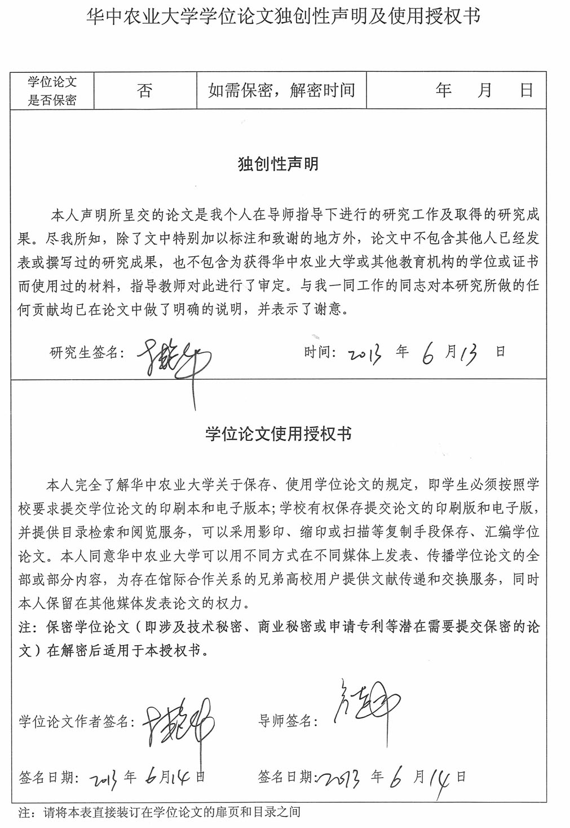
目 录
摘 要 i
Abstract v
第1章 鳇相关研究综述 1
1.1 鳇物种简介 1
1.2 生物学 1
1.2.1 外形特征 1
1.2.2 生活习性 1
1.2.3 食性 2
1.2.4 生长 2
1.2.5 繁殖习性 2
1.3 种群结构 3
1.4 栖息洄游 3
1.5 资源现状 5
1.6 鳇早期生活史个体发育行为 5
1.7 受胁因素与保护努力 6
第2章 相关概念与学科概述 7
2.1 终端因子与近端因子 7
2.2 洄游与鲟鱼类洄游类型 8
2.3 生活史与生活史型 10
2.4 鱼类早期生活史定义、特征与阶段划分 11
2.4.1 鱼类早期生活史定义及一般特征 11
2.4.2 鱼类早期生活史阶段的划分 12
2.4.2.1 早期生活史各阶段最普遍划分 12
2.4.2.2 以孵化为界限区分胚胎和仔鱼 12
2.4.2.3 以开口摄食为界限区分胚胎和仔鱼 13
2.4.2.4 稚鱼期的划分特征 13
2.4.3 鲟鱼早期生活史阶段划分 13
2.5 鱼类行为学与鱼类生态学 14
2.5.1 鱼类行为学与研究方法 14
2.5.2 鱼类生态学 16
2.6 个体发育行为学概念与相关研究 17
2.6.1 个体发育行为与个体发育行为学概念 17
2.6.2 个体发育行为学研究内容 17
2.6.3 鲟科鱼类的个体发育行为 19
第3章 栖息地要素原位观测 25
3.1 前言 25
3.2 材料与方法 25
3.3 结果与分析 26
3.4 讨论 27
第4章 胚后发育与生长 29
4.1 前言 29
4.2 材料与方法 29
4.2.1 试验鱼来源 29
4.2.2 饲养条件与日常管理 29
4.2.3 试验所需的仪器及试剂 29
4.2.4 试验方法 30
4.3 结果与分析 30
4.3.1 鳇胚后发育形态观察 30
4.3.1.1 前期仔鱼（自由胚） 30
4.3.1.2 后期仔鱼（仔鱼） 32
4.3.1.3 稚鱼阶段 33
4.3.2 鳇体长与体重生长 34
4.3.3 鳇眼径与全长比例变化 35
4.3.4 鳇早期生活史阶段的死亡率 36
4.4 讨论 36
4.4.1 仔鱼发育阶段划分 36
4.4.2 早期形态发育对其早期环境适应的意义 37
4.4.3 早期生活史生长与死亡率 38
第5章 鳇个体发育偏好性行为研究 39
5.1 前言 39
5.2 材料与方法 40
5.2.1 试验鱼与大体方法 40
5.2.2 明亮区、底质颜色及洞穴选择 41
5.2.3 底质类型选择与底部利用 43
5.2.4 游泳水深选择 44
5.2.5 数据分析 46
5.3 结果与分析 46
5.3.1 明亮区、底质颜色和洞穴选择 46
5.3.2 底质类型选择及底部利用 49
5.3.3 游泳水深选择 50
5.4 讨论 51
5.4.1 明亮区、底质颜色、洞穴及游泳水深选择 51
5.4.2 底质类型选择和底部利用 53
第6章 早期生活史洄游及影响洄游的环境因素研究 54
6.1 前言 54
6.2 材料与方法 56
6.2.1试验鱼以及大体程序 56
6.2.2 洄游与昼夜活动性试验条件 57
6.2.3 影响洄游的环境因素研究试验溪流以及条件 57
6.2.4鱼类洄游度量 60
6.2.5 发育及积温 61
6.2.6 数据分析 61
6.3 结果与分析 62
6.3.1 发育及积温 62
6.3.2 洄游与昼夜活动性 62
6.3.3 不同水流速度对洄游的影响 64
6.3.4 不同底质结构对洄游的影响 65
6.3.5 不同暂养水流条件对洄游的影响 66
6.3.6 流速影响昼夜洄游节律 68
6.4 讨论 70
6.4.1 洄游与昼夜活动性 70
6.4.2 不同水流速度对洄游的影响 70
6.4.3不同底质结构对洄游的影响 72
6.4.4不同暂养水流条件对洄游的影响 72
6.4.5流速影响昼夜洄游节律 73
6.4.6 总结 73
第7章 鳇个体发育行为特征的适应与实践意义探讨 74
7.1 鳇个体发育行为特征的适应意义探讨 74
7.1.1 鳇个体发育行为的进化适应意义 74
7.1.2 鳇个体发育行为的生态适应意义 75
7.1.2.1 孵出期（0日龄） 75
7.1.2.2 前期仔鱼（1–8日龄） 75
7.1.2.3 后期仔鱼（9–49日龄） 75
7.1.2.4 稚鱼（50日龄以后） 76
7.2 鳇个体发育行为特征的实践意义探讨 76
7.2.1 对野外栖息地保护的实践意义 76
7.2.1.1 对产卵场的保护 76
7.2.1.2 对摄食场的保护 77
7.2.1.3 对洄游通道的保护 77
7.2.2 对苗种培育的实践意义 78
7.2.3 对增殖放流的实践意义 79
7.2.3.1 关于人工放流的地点 79
7.2.3.2 关于人工放流的规格 80
图 版 81
图版Ⅰ 鳇的胚后发育 81
参考文献 83
致 谢 91
附录Ⅰ 攻读学位论文期间撰写和发表的学术论文及专利 93
附录Ⅱ 攻读博士期间主要参加的科研项目和撰写的报告 94

鳇个体发育行为及其适应与实践意义探讨
湿地资源与环境
2013届博士研究生：李艳华 指导老师：危起伟

摘 要
鳇是世界现存两种鳇属鱼类之一，主要分布于黑龙江及其支流（包括乌苏里江、松花江，俄罗斯的结雅河、布列亚河、石勒喀河、喀尔古纳河、鄂毕河、音果达河）、兴凯湖和奥列列湖。鳇存在着淡水定居型与河口半洄游型两种生活史，前者完全定居在黑龙江下游、中游以及支流的淡水中，后者在河流干道产卵并且洄游至河口摄食生长。最近几年的捕捞调查表明，鳇捕捞产量几乎集中于下游与河口，中游的产量已近枯竭，我国的捕捞江段主要在抚远江段，年产量已不足10 t。2010年，鳇被IUCN红色目录列为极危等级物种（CR）。到目前为止，黑龙江干流尚未建坝，导致鳇资源枯竭以致极危的主要原因是受鱼子酱价格刺激带来的合法与非法的过度捕捞，水域污染以及河道中食物的匮乏。
鉴于鳇的濒危状态，中国政府自2002年开始对其进行大规模人工增殖放流，到2008年止，黑龙江中游下段的抚远县已经放流1千万尾仔稚鱼。养殖的仔稚鱼也在黑龙江中游沿岸的一些城市进行了放流，如黑河、萝北、同江。在这些地方放流的鳇全长大多在7–10 cm。尽管如此，目前依然没有一整套关于鳇放流的规范，放流鱼的来源、放流地点、放流鱼的尺寸大小以及放流规模依然带有很强的随意性与不确定性。为了查清放流鱼的来源、所处发育阶段以及洄游特性，以及更好的指导今后的人工放流，本文就鳇繁殖场附近的生境、鳇的胚后发育形态以及个体发育行为和环境因子对洄游的影响进行了系列研究。具体采用的方法和获得的结果如下：
- 根据原位观测得知鳇抚远江段产卵场附近流态平缓，坡岸底质主要以沙和砂
砾构成，有少量鹅卵石，推知河床质主要以砾石和鹅卵石组成。河较宽，两岸沙洲发育较多，河中心亦有沙洲发育，两岸覆盖物以河柳居多。经过3处原位观察测量算得产卵场河道主流附近表层水的流速值在0.15–0.46 m·s⁻¹之间，平均流速0.31 m·s⁻¹，产卵场在产卵季节最大水深可达14 m。水下光照强度在水表层以下1m处衰减开始极显著，在水深3–14 m，水下照度几乎稳定在0.5 lx 左右。透明度一般在0.3–0.4 m之间。
- 样本系黑龙江野外采集的鳇（Huso dauricus）亲体经人工受精后孵出的子一
代，对刚出膜的仔鱼[0日龄，（12.08 ± 0.68）mm]到早期稚鱼[60日龄，（129.21 ± 7.69）mm]的胚后发育形态进行了观察。形态发育上看来，鳇仔鱼的胚后发育可分为2个时期：早期仔鱼，即从刚出膜（0日龄）到初次开口摄食（9日龄）；晚期仔鱼，即从初次开口摄食到各器官发育基本完成，体透明特征消失，鳍褶和颌齿彻底消失（49日龄），以后进入早期稚鱼[50日龄，（106.78 ± 9.87）mm]。早期仔鱼的形态发育和分化明显较晚期仔鱼和稚鱼阶段快，运动、呼吸、感觉和消化等器官在此期发育与分化同步协调，且速度快，使得仔鱼快速获得避敌与摄食能力，提高了成活率。晚期仔鱼主要表现为各骨板的分化和完善，鱼鳍游泳器官功能的进一步强化，鳔的发生和发育，表明此期游泳和躲避敌害能力处于进一步增强中。
- 作者对来自黑龙江中游的鳇早期生活史进行了实验室研究，来定量化其个体
发育行为和比较在相似试验条件下的鳇早期生活史行为。孵出的自由胚启动高强度的顺流洄游，洄游在1日龄达到峰值，继续高强度洄游直至3日龄，然后洄游强度在4–6日龄逐渐减弱，在第7日龄停止洄游（持续8天的洄游）。洄游的鳇喜好明亮（明亮区和白色底质）和开阔栖息地，并且高高地游泳于水面（每日离底高度众值在3.5 m）。21–22日龄仔鱼启动第二波洄游，在34–36日龄有一个洄游峰值（每尾鱼每5min洄游4次）。稚鱼继续低强度的洄游（每尾鱼每5min洄游1次），直至66日龄，暗示着早期生活史进行着长周期的洄游。当绝大多数自由胚在第9日龄发育成仔鱼，早期仔鱼是非洄游的（像晚期的自由胚一样），喜欢明亮和开阔的栖息地，游泳高高地游离底面直至35日龄。所有生活史[自由胚、仔鱼以及早期稚鱼（至观察结束的第66日龄）]喜欢白色底质，暗示着野生鳇强烈的对白色栖息地的适应需求。晚期仔鱼和稚鱼逐渐丧失对明亮区的喜好，并且游泳日渐接近底面，暗示着向底栖生活转化。自由胚、仔鱼和早期稚鱼强烈喜好开阔的底质，暗示着这三个生活史的野生鲟鱼也喜好开阔的底质。自由胚和仔鱼天生的洄游特征与以前在相似的试验条件下观察到的鳇的行为特征大体上相似，但是在具体的洄游特征上存在差异。这些结果显示在这同一河段存在着两个拥有不同早期行为的种群。因此，在养殖鳇用于增殖放流时，可能需要高度注意，防止两个种群在放流时混淆，导致产生不适应野外环境的早期生活史的鳇。
- 就四种环境因素（水流、底质、饲养水环境条件、昼夜节律）对早期生活史
的鳇（0–8日龄自由胚、9–49日龄仔鱼、50–66日龄稚鱼）洄游的影响进行了研究。试验在六个结合了各种环境因子的人工循环溪流里进行。水流速度对自由胚的洄游强度有着正相关的影响，此外，高流速还延迟了晚期自由胚停止洄游的时间。但是，在不同流速条件下的洄游的自由胚和仔鱼依然有着洄游相似距离的本能。结果还显示在启动洄游或者停止洄游时存在着一个激发流速。底质类型对早期自由胚的洄游没有影响，但是随着仔鱼日龄的不同对仔鱼的洄游有着不同的影响。与一直饲养在高流速溪流桶内同样日龄的鱼相比，饲养在静水环境下的中期仔鱼至稚鱼，当放置在高流速溪流桶内时洄游将加快，显示出补偿洄游。这种补偿洄游并未在饲养在低流速（7.2 cm·s⁻¹）桶的鱼中出现，这表明补偿洄游的出现需要一个7.2 至31.7 cm·s⁻¹的激发流速存在。流速对自由胚和稚鱼的昼夜洄游节律没有影响，但是较快的流速可能通过延迟鱼类的生长发育而间接地推迟昼夜洄游节律差异的出现。对于鳇的人工增殖放流而言，研究表明在养殖过程中必须分开饲养不同种群的鳇以免混淆，补偿洄游的出现表明放流的鱼从小饲养的水流环境并未影响其洄游本能，静水饲养的鱼照样适合于放流，只不过放流的鱼以处于洄游期的仔鱼为好，而不是非洄游或者低强度洄游的稚鱼，这样有利于最大化分散放流的鱼而减少放流鱼对食物的竞争。并且仔鱼以放流在一个底部流速超过30 cm s⁻¹，含有沙与小卵石的底质江段较好。
- 对于放流的地点与鳇苗种规格而言，我们认为要充分利用两个种群的鳇的不
同特点有针对性地进行放流。如果是非洄游性的仔鱼，我们可以将放流大的地点安排在抚远以上的勤得利、肇兴和萝北，甚至嘉荫和逊克，具体地点则安排在这些大地点的沙滩、沙洲上分散进行，减少摄食竞争的同时增殖中游的渔业资源。如果是洄游性的仔鱼，放流地点可就近在抚远县放流，具体地点可以就近选择在产卵场附近河流底部流速大于0.30 m·s⁻¹的河段进行。根据我们研究的结果，洄游性仔鱼会加速往下洄游，越早放流就越有可能使放流仔鱼加入到野生仔鱼的队伍中。但是很多时候，我们无法区分要放流的仔鱼究竟是洄游性的还是非洄游性的，这时为保险起见，我们还是建议将放流地点选择在抚远县附近河流底部流速大于30 cm·s⁻¹的河段进行，这样有利于洄游性的仔鱼在洄游过程中找到合适的摄食场。综合考虑敌害因素，养殖成本与洄游因素，我们建议选择5–8 cm（23–36日龄）的仔鱼进行放流，因为此时的仔鱼已经有较发达的骨板，这样可以大大增强对敌害摄食的抵御。并且此期的仔鱼如果是洄游性的种群还依然具备洄游特征。但放流5–8 cm的仔鱼，其成活率究竟如何，尚需人工标志放流进行效果评价。

关键词：鳇；个体发育的；行为；趋光性；洄游；水流流速；底质；环境效应
Ontogenetic Behaviour of Kaluga (Huso dauricus) With Comments on Adaptive and Practical Significance
Wetland Resource and Environment
Candidate: Li Yan Hua Supervisor: Wei Qi Wei

Abstract
Huso dauricus is one of the existing two Huso in the world, it mainly distributed in Amur river and its tributaries (including Ussuri, Sungari, Zeya river, Bureya river, Shilka river, Argun river, Ob river, and Ingoda river), Khanka lake and Orel lake. There are two kinds of life history H. dauricus, they are fresh water type and estuary half migration type. Fresh water type completely settle in freshwater of lower and middle reach of Amur river and tributaries, estuary half migration type breed in rivers artery and migrate to the estuary for forage. In recent years, fishing survey show that H. dauricus fishing production almost focused on the lower reach and estuary of the river, fishing production in middle reach has nearly exhausted, China's fishing mainly limited in the Fuyuan reach, and the annual output has been less than 10 t. In 2010, H. dauricus was listed as critically endangered species by IUCN red list (CR). So far, Amur river main stream has not been built dam, the main reason that lead H. dauricus resources to exhaustion is the legal and illegal overfishing stimulated by the caviar prices, water pollution and lack of food in river channel.
Due to its endangered status, the Chinese government has conducted large-scale population enhancement since 2002, releasing over 10 million larvae and juveniles in Fuyuan county (lower-middle reach of the Amur River) from 2002 to 2008. Cultured fish were also stocked at other places along the middle reach of the Amur River such as Heihe, Luobei and Tongjiang. The H. dauricus released in these places were 7–10 cm TL (Total Length). However, a set of standard on H. dauricus resource enhancement and releasing is still unavailable at present. The source of released fish, releasing location, the size of released fish and releasing scale are still haphazard and uncertain. In order to find out the source of the releasing fish, the developmental stage and its migration characteristics, and better guide future resource enhancement and releasing, this paper conducted a series of research on the habitat of H. dauricus spawning site, the morphological feature of H. dauricus on postembryonic developing, ontogenetic behavior and the effects of environmental factors on migration. The specific methods and the results obtained were as follows:
- According to the observation in situ, we know that the river reach near H.
dauricus spawning ground has a low flow, and substrates on banks is mainly composed of sand and gravel, there are a few pebbles on banks, so, we can infer that river bed substrates is mainly composed of gravel and pebbles. The river is wide, and both side banks have lots of sandy shoal, the center of river also have sandy shoal, the mulch in river banks is mainly composed of river willow. By three places observations in situ, we measured the surface water flow near spawning ground ranged from 0.15 m·s⁻¹ to 0.46 m·s⁻¹, and averaged 0.31 m·s⁻¹. We also measured the maximal water depth near spawning ground was 14 m, the underwater illumination 1 m below the water surface decayed very much, in the depth of 3–14 m, underwater illumination almost stable in 0.5 lx or so. Transparency is almost stable at 0.3–0.4 m.
- The morphological observation during postembryonic development of first filial
generation of H. dauricus were studied under rearing conditions, whose parents were captured from the Amur river. New born prelarval [0-day age, (12.08 ± 0.68) mm] was conducted till the early juvenile [60-day age, (129.21 ± 7.69) mm]. According to morphological development, postembryonic development of kaluga was divided in to two different phases, the prelarval stage between hatching (0-day age) and first feeding (9-day age), and the postlarval stage between the initiation of external feeding and organ development completed, the body transparent features disappear, and fins folds anterior to the anus and oral teeth were completely absent (49-day age), then, fish develop into early juvenile[50-day age, (106.78 ± 9.87) mm]. The morphological development and differentiation of prelarvae is obviously faster then postlarvae and juvenile, and all kinds of swimming, respiratory, sensorial and feeding organs during prelarval stage were rapidly developed of the synchronous coordination. Rapid development of those functional organs enabled prelarvae to forage and avoid predator, which contributed to its survival. The differentiation and improvement of bone plate, improvement of fins swimming organs, and occurrence and development of swim bladder were conducted during the postlarval stage, showing that the capability of this stage fish for foraging and avoiding predator was futher improving.
- We conducted laboratory experiments with early life stages of H. dauricus, from
the middle reach of the Amur River to quantify ontogenetic behavior and compare their behavior with similar laboratory data collected previously on young kaluga from the Amur River. Hatchling free embryos initiated an intense downstream migration that peaked on day 1, and continued strongly to day 3, and then, decreased strikingly during days 4– 6, and ceased on day 7 (8-day migration). Migrants preferred a bright habitat (illuminated and white bottom), open not cover habitat, and swam-up far above the bottom (daily median distance, 3.5 m). On days 21–22, larvae initiated a second downstream migration of similar intensity (four passes per fish per 5 min), with a peak at 34–36 days. Juveniles continued a slow intensity migration (one pass per fish per 5 min) until day 66, indicating a long-duration migration style by early life stages. When most free embryos developed into larvae on day 9, early-larvae were non-migrant (like late-free embryos), preferring bright and open habitats, and swimming-up far above the bottom until about day 35. All life stages (free embryo, larva, and early-juveniles (to day 66 when observations ceased) preferred a white colored bottom, indicating a strong adaptive need for this habitat feature by wild fish. Later-larvae and juveniles gradually lost their preference for illuminated habitat and also swam nearer the bottom, indicating a shift to a benthic life. Free embryos, larvae and early-juveniles also strongly preferred open habitat, suggesting a similarity in open habitat use by wild individuals of these three life stages. The innate migration pattern of free embryos and larvae was similar in general pattern, but different in some ways from young kaluga previously observed in similar experiments. This result suggests there are at least two breeding stocks with different early behavior in the river. Thus, great care must be taken when culturing fish for stocking during stock enhancement programs to insure the breeding stocks are not mixed, which would produce non-adapted early life stages.
- Four environmental factors (water velocity, substrate, rearing water velocity
condition, and diel rhythm) were examined for their influence on migration of H. dauricus early-life stages (free embryos, age 0–8 day fish; larvae, age 9–49 day fish; and juveniles, age 50–66 day fish). Experiments were conducted in six artificial circular-endless-streams creating various combinations of environmental factors to test hypotheses. Velocity regime had a positive effect on migration intensity by free embryos, and further, high velocity delayed the stopping or resting period by late-free embryos and early-larvae. However, migratory free embryos and larvae in different velocity streams still showed they had the drive to migrate a similar distance. Moreover, results suggest a trigger velocity may be needed to initiate or to cease migration. Substrate type had no effect on migration by early free embryos, and had a different affect on larvae depending on age of larvae. Mid-larvae to juveniles reared in a still water tank migrated faster when placed in a high velocity stream tank, showing a compensatory migration, compared to same age fish reared in a high velocity stream tank. This compensation didn’t occur in fish reared in a tank with low velocity (mean, 7.2 cm·s⁻¹), indicating a trigger velocity may exist between 7.2 to 31.7 cm·s⁻¹ for compensatory migration. Velocity regime had no effect on diel rhythm of free embryos and juveniles. A fast velocity regime may have indirectly retarded the occurrence of the diel migration rhythm by larvae by retarding fish growth and development. For population enhancement stocking of H. dauricus, the study indicates great care should be taken to insure populations are not mixed during culture. The emergence of compensation migration indicate that the rearing water velocity condition has no effect on the migration of H. dauricus, and the fish reared in still water is still suitable for population enhancement. It is the migrating larvae, not non-migrating or slow migrating juveniles, are stocked to maximize the downstream distribution of stocked fish and reduce competition for foraging resources, and larvae should be released in a river reach with a bottom velocity ≥ 30 cm s⁻¹ that contains sand–small pebble substrate.
- For the location and size of the fish released, we think it is better to distinguish
two stock before specific population enhancement. If larvae are non-migratory, we can release the fish above Fuyuan county, such as Qideli, Zhaoxin and Luobei, even Jiayin and Xunke. The specific location is arranged in the sandy beach and sandy shoal of these above places for reducing feeding competition and enhancing the fishery resources in middle reaches. If larvae are migratory, we can release the fish near Fuyuan county, The specific location is arranged in river reach of Fuyuan county that bottom velocity is greater than 30 cm·s⁻¹. According to our study results, migratory larvae will accelerate to migrate, so, fish is release earlier the more likely they are added to the wild fish team for migrating. But most of the time, we can't distinguish larvae are non-migratory or migratory, so, for safety's sake, we suggest releasing location is arranged in river reach of Fuyuan county that bottom velocity is greater than 30 cm·s⁻¹, so that migratory larvae can migrate and find suitable feeding sites. Comprehensively consider of the predator, culturing cost and migration factors, we suggest 5–8 cm (23-36 day age) are suitable to release, because this period larvae has well-developed bone plate, enhancing their anti-predator ability, and if this period larvae are mogratory stock, they are still show a migration characteristics. However, a tagging and releasing for effetiveness evalustion is needed to know the survival rate for releasing 5–8 cm larvae.

Keywords: Huso dauricus; ontogenetic; behaviour; phototaxis; migration; water velocity; substrate; environmental effect

第1章 鳇相关研究综述

1.1 鳇物种简介
鳇英文名Kaluga、Siberian Great Sturgeon，其它中文名达氏鳇、达乌尔鳇。鳇是一种分布于Amur河（黑龙江）的淡水鲟科鳇属鱼类，也是世界现存两种鳇属鱼类之一，CITES附录Ⅱ保护物种，目前处于极危（CR）状态。

1.2 生物学

1.2.1 外形特征
鳇与欧洲鳇并列为世界现存两种鳇，成鱼个体很大，体重可达1 000kg以上。全身被以5列骨板，吻长占头长的70%以下，吻须4根；吻端锥形，两侧边缘圆形，头部有喷水孔；嘴大，呈星月形，开口向前，吻须平扁，左右鳃膜相互连接；吻须不呈叶状，身体最高点在第一背骨板处，第一背骨板最大，有背鳍后骨板，身体背部呈黑绿色至浅灰色，体侧呈淡黄色，腹部呈白色（图1.1）。此外，鳇早期形态与施氏鲟较为相似。
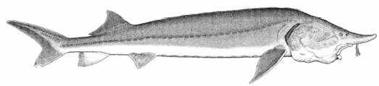
图1.1 鳇外部形态
Fig. 1.1 External form of kaluga, Huso dauricus
(自陈细华，2007)
背骨板11–17枚，腹骨板8–13枚，侧骨板31–46枚，背鳍条33–35，臀鳍条22–39，鳃耙数16–24。性成熟个体全长为头长的3.55–6.04倍，为体高的6.05–10.60倍，为尾柄长的13.9–23.1倍。尾为歪型尾，上叶大，向后方延伸（石振广，2008）。

1.2.2 生活习性
鳇最初被认为是淡水定居种群，随着捕获地域的扩大，现通常认为存在着半洄游性和河道定栖型两个种群（Shmigirilov et al.，2007）。河道定居型种群产卵后不作降海洄游，就近摄食栖息。另一种群为半洄游性种群，该种群在河口及黑龙江河口海边咸水一带育肥，产卵季节进入黑龙江河道产卵，幼鱼作降海洄游；鳇是底层性鱼类，性情很凶猛，喜欢分散活动，成年个体较少进入浅水区，幼鱼则在河道浅水区及附属湖﹑泡育肥，平时则栖息在江岔、江心洲等水流较缓慢的砂砾底质的地方。它的活动受外界环境影响较大，如遇大风、涨水的时候，觅食游动活跃，反之行动迟缓。冬季在大江深处越冬，初春开始向产卵场洄游（任慕连，1981）。

1.2.3 食性
全长大于40cm的个体摄食底栖鱼类和浮游鱼类，并且直接有赖于浮游生物和底栖生物的丰度进行摄食（Polyaninova et al.，1999）。1龄以下的鳇主要摄食无脊椎动物，但也吞食鱼类幼体（如蛇鮈仔鱼、鲇鱼仔鱼）； 3–4龄的鳇开始捕食蛇鮈、七鳃鳗、圆腹雅罗鱼、大麻哈鱼、鲤、鲫等。在河口和海岸水域鳇捕食鳕和鲈鱼。在冬季和产卵洄游期间，鳇停止摄食。鳇种内相残现象也时有发生（陈细华，2007）。

1.2.4 生长
鳇耐低温与高温，一年四季在自然界均摄食生长，生长适宜温度为15–22℃。在人工环境下饲养，生长优势特别明显。在18–22℃，鳇苗经三个月培育，体重可达100g；经6个月的饲养，其体重可达900g；在12–22℃的水温条件下，养殖的一龄鱼体重可达5kg；二龄可达15kg；3龄可达30kg；四龄鱼体重可达50kg；五龄鱼体重可达70kg（石振广，2008）。

1.2.5 繁殖习性
鳇河口种群雄性14–21龄达性成熟，雌性17–23龄达性成熟。雄性每3–4年繁殖一次，雌性每4–5年繁殖一次。水温影响着雌性成熟的时间：同一年代的雌鲟，温暖年份早于寒冷年份提前进入性成熟。雌鳇的平均绝对怀卵量为977 000（范围186 000–4 225 000），相对怀卵量为 3 300–15 100 粒·kg⁻¹。鳇中游种群比河口种群较早进入性成熟，雌性初次性成熟年龄在11–16龄。中游种群平均绝对怀卵量238 000–4 868 000，相对怀卵量5 000–11 000粒·kg⁻¹。
产卵从5月底至7月初，水位略有增加，水温为12–21℃时进行。产卵高峰通常发生在六月中旬，产卵场底质往往为卵石，带有大的侧槽江段。河口种群往往在产完卵后离开产卵场返回河口摄食（Krykhtin and Svirskii，1997），这一特征大体上类似于中华鲟（危起伟，2003）。
在14–22℃情况下，胚胎发育耗时82–112h，初孵自由胚到初次摄食的仔鱼历时7.5–14d。河口种群的自由胚和仔鱼从产卵场向下漂移散布，抵达黑龙江的下游和河口。一些稚鱼依然停留在下游江段直到2–4龄，在那里与下游种群的稚鱼汇聚在一起摄食。

1.3 种群结构
鳇一直被认为是黑龙江流域最大的淡水鱼类，最长可达5.6m，重量超过1 000kg，寿命高达80龄。它栖息于从河口到上游的整个黑龙江流域，包括几大支流和湖泊（Nikolskii，1960；张觉民，1994；任慕连，1981）。但其幼鲟在夏季也进入鄂霍次克海、日本海等水域而被捕获，近十年来，鞑靼海峡北部以及库页岛海湾西南部的种群数量有了稳定的增长（Krykhtin and Svirskii，1997）。因此，也有学者认为其属于淡咸水两栖生活型（Zhuang et al.，2003）。
Krykhtin and Svirskii（1997）认为鳇存在着河口、下游、中游和上游四个种群。河口种群生活在河口以及鄂霍次克海和日本海的沿岸咸水地带；下游种群生活在黑龙江下游；中游种群生活在黑龙江中游；上游种群生活在黑龙江支流结雅河与布列亚河的下游。鳇河口种群又分为淡水和咸水两种生态类型，其中淡水型占75%–80%。淡水型鳇只在河口的淡水地带摄食。咸水型鳇在淡水地带中越冬，6月中下旬至7月初便洄游至盐度为12–16‰的河口咸水水域以及鞑靼海峡北部、库页岛西南部水域中摄食，秋季河口水域盐度增加时又迁回淡水水域与淡水型一起越冬。
Shmigirilov et al.（2007）根据Krykhtin and Svirskii（1997）的结果以及一些旧有研究结果认为鳇分为两个明显不同的种群。其中一个种群在河流干道产卵并且洄游至河口，而另一种群是一个完全定居在黑龙江下游、中游以及支流的淡水种群。它们二者因为各自摄食淡水鱼类和洄游性鲑鱼而表现出两个明显不同的洄游行为。不少一线生产科研者（王云山等，2001；石振广，2008）同意这一类群划分，我们也倾向于他们的这种观点，认为鳇存在着淡水定居型与河口半洄游型两种生活史。

1.4 栖息洄游
鳇主要分布于黑龙江及其支流（包括乌苏里江、松花江，俄罗斯的结雅河、布列亚河、石勒喀河、喀尔古纳河、鄂毕河、音果达河）、兴凯湖和奥列列湖。其幼鲟在夏季也进入鄂霍次克海、日本海等水域（图1.2）。
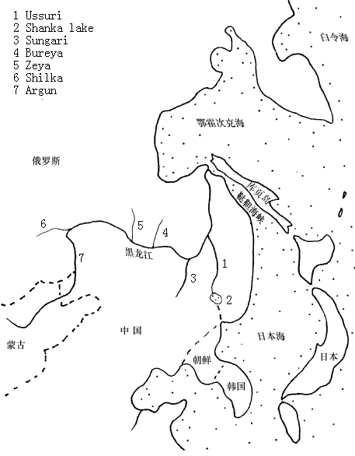
1 Ussuri（乌苏里江）
2 Khanka lake（兴凯湖）
3 Sungari（松花江）
4 Bureya river（布列亚河）
5 Zeya river（结雅河）
6 Shilka（石勒喀河）
7 Argun（额尔古纳河）
图1.2 鳇地理分布示意图
Fig. 1.2 Sketch map of geographical distribution of kaluga, Huso dauricus

河口鳇种群的大部分个体溯河50–150km产卵，少部分个体上溯500km以内产卵，有些个体甚至上溯到黑龙江中游的Khaborovsk（距离河口1 000km，中国抚远县附近）产卵。河口鳇种群中大部分亲鲟的产卵活动开始于秋季和冬初（称为“冬季型”），亲鲟在河流中越冬后，于次年产卵；少部分（5%）亲鲟于春季进行产卵洄游（称为“春季型”），达到产卵场后立即产卵。黑龙江下游鳇种群主要在黑龙江下游江段摄食，产卵场和产卵时间与河口鳇种群相同。黑龙江中游鳇种群栖息在距离河口约900km的江段内，包括下游上部和中游下部。5月至6月中上旬进行产卵洄游，主要产卵场位于中游下部俄罗斯与中国的边界水域，在松花江和乌苏里江也存在一些小型产卵场。结雅河–布列亚河鳇种群栖息在黑龙江中游上部、黑龙江上游以及结雅河、石勒喀河、额尔古纳河的下游，5月中下旬至6月进行产卵洄游，产卵场位于黑龙江上游。

1.5 资源现状
近100年以来，鳇各种群的资源量明显减少。俄罗斯方面，鳇年捕捞量于19世界末达到高峰，为595 t以上。自那以后，产量逐渐下降，1948年下降到61 t。自1958年起，俄罗斯基本关闭了鳇渔业捕捞。但自1991年起，黑龙江下游及其他地区又相继开始了鳇的渔业捕捞。据俄罗斯的官方记录，1991年鳇和施氏鲟的年捕捞产量总计64.4 t，1992年为62.6 t，1993年为47.8 t；但由于允许自由贸易，1991–1993年每年被偷捕的鳇和施氏鲟估计至少200 t。在中国方面，1952–1956年黑龙江中游鳇和施氏鲟的年捕捞量总计70–80 t，1981年为141 t，1987年达到200 t（Wei et al.，1997）。
据科学评估，黑龙江河口鳇种群资源量在20世纪80年代末约为7万尾（1龄以上），其中14%的为体重达100 kg以上的性成熟个体；由于黑龙江下游的非法捕捞，到1993年，这些成熟个体减少了30–35%。黑龙江下游鳇种群资源量约为4万尾（2龄以上）。黑龙江中游鳇种群资源量约为3万尾（2龄及2龄以上）。结雅河–布列亚河鳇种群资源量很小，估计只有0.09–1.03 t（陈细华，2007）。自从2000年以来，大于10龄的鳇在非产卵季节未有捕获，这暗示着定居种群成体在黑龙江已经消失。根据我们的实地调查及石振广（2008）的调查资料显示，鳇捕捞产量几乎集中于下游与河口，中游的产量已近枯竭，我国的捕捞江段主要在抚远江段，年产量已不足10 t。而这极可能是强烈的非法捕捞以及黑龙江河道食物缺乏所致（Shmigirilov et al.，2007）。

1.6 鳇早期生活史个体发育行为
通过室内行为研究来确证早期生活史型，一直是鲟鱼类早期生活史个体发育行为的主要研究目的之一。Zhuang et al.（2003）就鳇的明亮栖息地喜好、穴居性、游泳水深、洄游及其昼夜节律进行了研究，发现0–30日龄鳇一直喜欢开阔地不穴居，除了3–5日龄外，其它日龄全部明显喜好明亮栖息地。1–3，6–11日龄游泳离底水深超过30 cm外，其它日龄游泳离底水深都小于30 cm。自由胚在0–3日龄迎来首次顺游洄游高峰，随后沉底滞留7天，在第11日龄迎来第二波夜间的顺流洄游，一直持续到28日龄，但由于在18–28日龄仔鱼的白天顶游活动，使得18–28日龄总体上处于微弱的溯流洄游状态。

1.7 受胁因素与保护努力
到目前为止，黑龙江干流尚未建坝，导致鳇资源枯竭以致极危的主要原因是受鱼子酱价格刺激带来的合法与非法的过度捕捞，俄罗斯和中国都存在这个问题（陈细华，2007；Shmigirilov et al.，2007）。此外，黑龙江水域的环境污染由于影响着亲鱼的繁殖也是造成资源衰竭的另一个重要原因（Novomodny et al.，2004）。
20世纪50年代，黑龙江省政府为保护和管理鲟鱼出台了专门的法规，1982年，法规得到了更新。目前的法规由于管理不充分而没有执行。此外，一些法规的出台还源自对种群的认识不够。由于鲟鳇鱼种群的下降，1988年，还在勤得利建立了一个增殖放流站（董崇智和姜作发，2004）。从1988年到1991年，总共向黑龙江放流90万尾仔鱼（体重0.2–0.4 g）和16.8万尾稚鱼（体重1.5–2.0 g或20–30 g）。通过放流，幼鲟的数量在当时似乎有了增长（Wei et al.，1997）。1994年，中俄两江议定书明确规定两国都有放流的责任和义务。2001年开始， 黑龙江省相继建立了萝北鲟鳇鱼试验站、省特产鱼类研究所中试基地、抚远县鲟鳇鱼放流站、同江市鲟鳇鱼放流站（闫新刚等，2008）。此外，越来越多的商业化养殖与繁育技术也可以视作对该物种的间接保护（李波和王云山，2003；辛玉文，2005；李文龙和刘建魁，2007；石振广，2008；Li et al.，2011；万年春，2011）。

第2章 相关概念与学科概述

2.1 终端因子与近端因子
终端因子（ultimate factors）与近端因子（proximate factors）之间的区别已经成为社会生物学，行为生态学，乃至进化生物学适应性架构的标志特征。在动物行为分析中，究竟何时使用终端或是近端原因照样困扰着社会生物学家。一般而言近端因子关系到机体生活史的整个表型过程的现时因子（Near，in time or space），而终端因子则涉及到历史上的（Farthest；most remote in space or time）这些过程（主要是自然选择）所形成的染色体组（Francis，1990）。近端原因伴随有机体生活史发生，它包含有有机体遗传信息的表达，并受环境所调控。终端原因早于机体生活史发生，贯穿于整个物种进化史，它包括物种成员最终为何拥有这一遗传信息的原因（Beatty，1994）。Fretwell and Lucas（1968）则认为行为的终端因子是那些在自然选择过程中固化为行为的遗传基础的那些环境因子。近端因子是促使行为发生的刺激因素。
对终端因子和近端因子作很好诠释的莫过于对繁殖策略和繁殖技术的理解了。繁殖策略（reproductive strategies）简单说来，指的是每一个物种的繁殖特性（何姗，2011）。包括该物种的繁殖时间、繁殖方式、繁殖地点、亲体护幼以及两性系统等在繁殖过程中所表现的一系列的特征（殷名称，1995；黄权等，2001）。鱼类每一个个体都有其特定的繁殖特性，而且每个个体的繁殖特性是由该个体的基因型决定的，并且经由该个体所属的基因库（gene pool）的进化历史所增强，属于同一个基因库的个体所专有的繁殖特性的联合，即可以看作是这些个体共同拥有的繁殖策略（熊飞，2003；李红敬，2009）。鱼类的繁殖策略是在漫长历史的自然选择中形成的，它保证物种及其子代对所生存的周围环境有最大的适应性。因此，想要了解鱼类每一物种的繁殖策略，就应当了解该物种的演化史，了解自然选择过程。在这一自然选择过程中，物种对某些环境因子产生反应而逐渐形成某种繁殖特性。这些在历史上对构成物种繁殖特性起作用的因子，可以称作终端因子。
个体对于繁殖特性的表达，往往称为表现型，其范围是由个体遗传型所决定的（王炬光，2011）。某些特性可能有较大的弹性，所以个体表达这一特性的表现型范围就宽广；另一些特性也许是不可变动的，几乎看不到任何变异。Wootton（1984）提出，由于个体所处环境变化引起的繁殖特性表达的变动，是该个体对于这些环境变动的技术性反应（tactical response）。个体的这种技术性反应，就称作它的繁殖技术（reproductive tactic）。个体的繁殖技术只能在物种繁殖策略所规定的范围内变动，就有如经济学上的价格围绕价值规律的变动一样。这种技术是鱼体内部通过调节达到某种平衡的一种外在反应，以保证个体在完成一系列繁殖特性的表达的前提下，对环境变化所支出的能耗抵达最小程度。因此，要了解个体繁殖技术的变动，就在于识别在个体一生中能引起变动的那些环境因子。这种能使个体繁殖技术发生变动的因子，可以称为近端因子。

2.2 洄游与鲟鱼类洄游类型
洄游是一些水生动物在一定季节或发育阶段沿一定路线有规律地往返迁移。鲟形目鱼类的洄游有两个基本的目的：摄食和繁殖。鲟鱼的降河洄游都是为了摄食，溯河洄游通常是为了产卵繁殖（Bemis and Kynard，1997）。鲟形目鱼类的洄游包括四种基本类型：淡咸水洄游型、江海洄游型、河流河口生活型和河川洄游型。
（1）淡咸水洄游型（Diadromous / Diadromy）是指鱼类在淡水和咸水之间的洄游类型（Myers，1949；McDowall，1988；McDowall，1992）。很多鲟鱼但并非所有鲟鱼是淡咸水洄游型的。
（2）江海洄游型（Anadromous / Anadromy）是指那些大多数时间生活在海洋里，但是要周期性地返回至淡水进行繁殖的淡咸水洄游鱼类（Myers，1949；McDowall，1988；McDowall，1992）。大多数鲟属鱼类是江海洄游型的，两种鳇属鱼类也是一样。但是关于鲟鱼在咸淡水之间随意穿梭的生理机制却缺乏有效信息（McEnroe and Cech，1985；McEnroe and Cech，1987）。
（3）河流河口生活型 （Amphidromous/ Amphidromy）是那些并非以繁殖为目的，在任一生活史中出现的定期定点的在淡水与海水间来回迁移的淡咸水洄游鱼类（McDowall，1988，1992）。McDowall（1992）界定了两种河流河口生活型鱼类，一种为咸淡水迁移型，鱼类向海水洄游过程中长大，返回在淡水中繁殖。另一种是淡咸水迁移型，鱼类在向淡水洄游中长大，返回在海水中繁殖。所有的鲟鱼在淡水中产卵，所以鲟鱼只有咸淡水迁移型。鲟鱼中能让人信服是咸淡水迁移型的很少，短吻鲟是其中之一（Kynard，1997），这些都需要很多标志、重捕、超声波遥测追踪工作来实现辨别。
（4）河川洄游型（Potamodromous / Potamodromy）是那些在淡水河流系统内部迁移进行摄食和繁殖的鱼类（McDowall，1988，1992）。所有的铲鲟、拟铲鲟、匙吻鲟，还有鲟属中的小体鲟、施氏鲟都属这类。
如果着重从洄游的目的划分，鲟鱼的繁殖洄游可分为以下三种类型（Bemis and Kynard，1997；张辉，2009）：
- 一步洄游型（One step spawning migration）：是指那些直接上溯抵达产卵
场产卵、产卵完后降海的鱼类。根据鱼类生物能量储备的多少，洄游可长可短，洄游可发生在冬季或者春季。尽管现有的少量数据存在相互冲突，但这种洄游类型通常被认为是最为普通的类型。这一洄游类型对应为Gerbilskiy（1957）描述的洄游类型Ⅰ，这种洄游类型的鱼类在洄游开始时卵母细胞就已经发育成熟，精巢也已发育完成。和生殖器官相连的组织和肌肉沉积的脂肪已经耗尽，胃和消化道为且未出现酶激活状态，这些表明在洄游开始前摄食已经停止一段时间。这种洄游类型比较典型地利用河流下游或者中游产卵的产卵场。
- 短距离两步洄游型（Short two step spawning migrations）：是指那些通常
在秋季上溯洄游，然后在产卵场附近越冬，于第二年春季洄游很短一段距离至产卵场产卵的鱼类。这一类型鱼类需要动用在夏季摄食时储备的生物能用于其启动长距离上溯洄游，大致对应于Gerbilskiy（1957）所描述的洄游类型Ⅱ。此型鱼类后期卵巢正在发育，卵母细胞仍然充满了脂肪组织。精巢生精作用正处于第一波分化。在相连的组织和背部肌肉存在着丰富的脂肪，因为脂质填充肝细胞很大。胃和消化道内的食物表明摄食刚好发生在洄游开始前。此型鱼类典型地发现于很多河流的中游以及上游产卵，譬如伏尔加（Volga）、乌拉尔河（Ural）、多瑙河（Danube）、哈德孙河（Hudson）、康乃狄克河（Connecticut）。
- 长距离两步洄游型（Long two step spawning migrations）：指的是那些一开始进行溯河洄游，紧接着在河流中越夏、或越冬、或既越夏又越冬，最后再进行长距离溯河洄游到达产卵场的鱼类。这种类型的鱼类在淡水中停止摄食可能长达12–15个月之久，这有效排除了那些中小个体的鲟鱼归为此类，因为它们缺乏充足的生物能储备。只有那些很大个体的种类，譬如欧洲鳇以及中华鲟似乎可以归为此类。该型鱼类或多或少对应于Gerbilskiy（1957）所描述的洄游类型Ⅲ，这型鱼类大的特征是洄游初始卵子处于发生后期，脂肪填充与卵巢与组织和肌肉之间。此型洄游的特征是在一些长河流拥有大个体的种类，比如多瑙河（Danube）、伏尔加（Volga）、黑龙江（Amur）和长江（Yangtze）。此型在北美的唯一地方可能就是哥伦比亚河（Columbia River），历史上，个大的高首鲟（A.transmontanus）曾在上游产过卵。

2.3 生活史与生活史型
生活史又称为生物一生所经历的生长、发育、繁殖和迁移等全部过程的整体格局。生活史型就是这些全部过程格局的特征。鲟形目包括四种生活史型（Bemis and Kynard，1997）：
（1）淡咸水洄游型（Diadromous / Diadromy）：在咸淡水之间洄游，如里海地区的俄罗斯鲟、闪光鲟和欧洲鳇。
（2）江海洄游型（Anadromous / Anadromy）：在淡水河流中产卵，一生大部分的时间是在大陆架海水中度过的，如欧洲鳇、俄罗斯鲟、大西洋鲟、闪光鲟、中吻鲟、中华鲟等。淡咸水洄游型经常被合并到江海洄游型中。
（3）河流河口生活型（咸淡水迁移型 Freshwater amphidromous / Freshwater amphidromy)，在淡水河流中产卵，向咸水洄游的过程中生长，目前确定有短吻鲟、纳氏鲟和白鲟是这种生活史型。按照McDowall（2007）的定义，咸淡水迁移的特征是：在淡水河流中进行繁殖，新生仔鱼入海洋，在海中生长数月，幼鱼回到淡水中继续进行摄食生长。属于这种生活史类型的水生动物物种不多。
（4）纯淡水生活型（河川洄游型 Potamodromous / Potamodromy），在淡水河流中洄游，完成整个摄食和产卵，如小体鲟、匙吻鲟、铲鲟、拟铲鲟、湖鲟、达氏鲟（见图2.1）。有些鲟鱼能同时具备2至3种生活史型，如高首鲟同时具有河流河口和江海洄游型，俄罗斯鲟、闪光鲟和欧洲鳇同时具有淡咸水两栖型和江海洄游型，而西伯利亚鲟则同时具有江海洄游型、河流河口生活型和纯淡水生活型（Bemis and kynard，1997；Rochard，1990）。
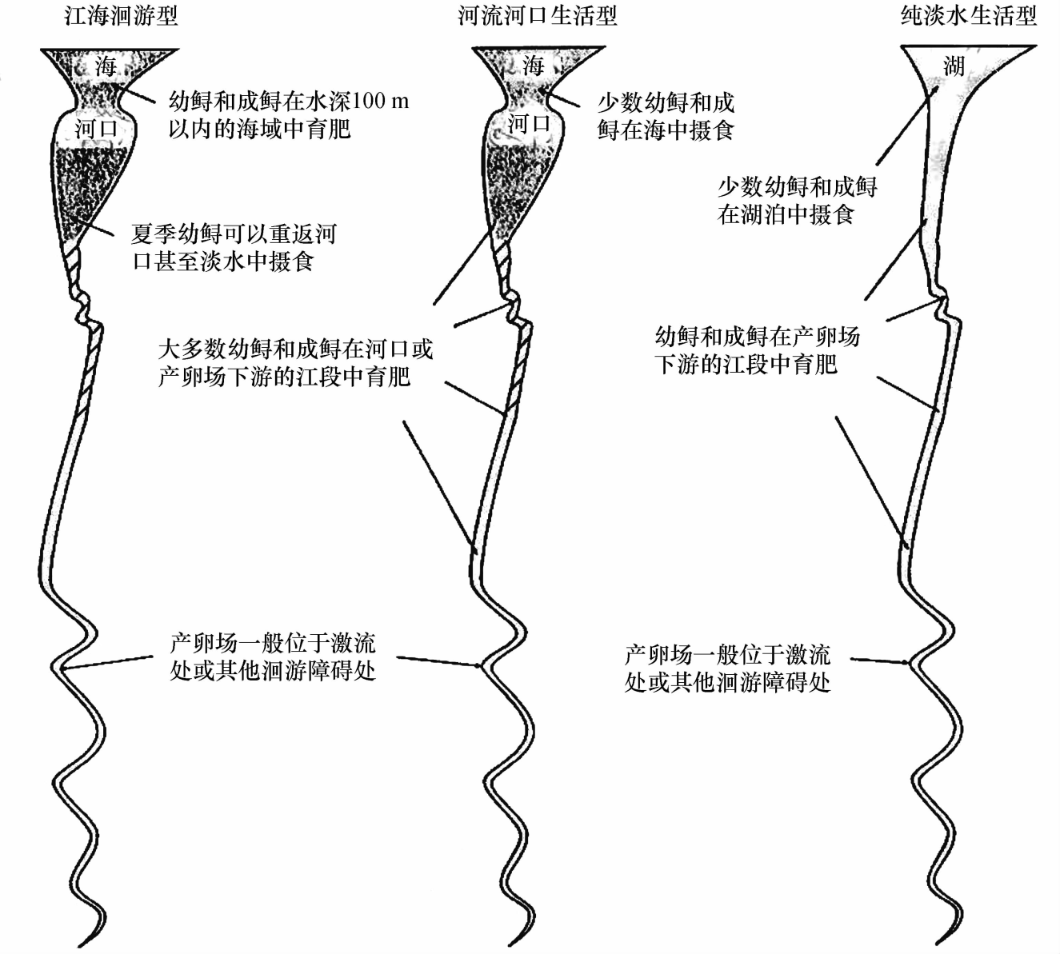
图2.1 鲟形目鱼类生活史类型示意图
Fig. 2.1 Sketch map of the life history type of sturgeons
(自 Bemis and Kynard，1997)

2.4 鱼类早期生活史定义、特征与阶段划分

2.4.1 鱼类早期生活史定义及一般特征
鱼类早期生活史是指鱼类由精卵结合到幼鱼起始之间的整个生命过程。其所涉及的范围尚无统一的标准，一般包括胚胎期（或卵），仔鱼期和稚鱼期（殷名称，1991）。
早期生活史阶段鱼类一个重大特征就是死亡率高，通常在自然条件下不到1%的鱼能渡过这一关，这是造成鱼类物种补充量变动的一大重要因素（殷名称，1995）。这也使得关于早期生活史的各种研究成为上世纪乃至本世纪的中心论题。关于引起鲟鱼类早期存活的因素了解得不多，然而早期生活史的前面几周显然是各种鲟鱼死亡的高峰期（Gross et al.，2002；Parsley et al.，2002）。关于鱼类早期生活史高死亡率有各种各样的假说与观点、现象与研究方法和理论问题。突出地体现在以下7个方面（殷名称，1996）：
（1）内源和外源自然死亡
（2）致死生理压力和物理损害
（3）有害和有毒藻类
（4）污染
（5）疾病和寄生
（6）饥饿和海洋学因子
（7）敌害捕食

2.4.2 鱼类早期生活史阶段的划分
鱼类早期生活史阶段是一个在外形形态、行为和生理上变化非常大的时期，无论在外在的和内在的都有明显的阶段特征，各国的学者在划分鱼类早期生活史阶段的标准上各异，但基本上是卵（胚胎）、仔鱼和稚鱼这三个阶段，下面概括了几种常见划鱼类早期生活史阶段的基本观点。

2.4.2.1 早期生活史各阶段最普遍划分
胚胎期为从受精卵从分裂开始到仔鱼孵化出膜为止的时期，此期处于内源营养期；仔鱼期为仔鱼自卵膜中孵出到各鳍鳍条初步形成，体透明特征消失，特别是鳞片开始形成的时期，此期既有内源营养期又包括混合营养期，还包括外源营养期；稚鱼期为鳞片开始出现到全身披满鳞片为止，此期单纯地处于外源营养期（殷名称，1995；郑怀平，1999；李孝珠，2011）。

2.4.2.2 以孵化为界限区分胚胎和仔鱼
该方法将“孵化出膜”视为一个重大事件，重点强调胚胎从卵中孵化出膜这个环节。认为胚胎出膜前后有本质上的区别，出膜前毫无主动行为特征，出膜后尽管还是内源营养，但已具备主动行为特征。早期的学者大多接受或主张这一划分方法，在这一方法中有些研究者将孵化出膜前统称为卵，也有些研究者统称为胚胎，还有些研究者将孵化前细分为卵和胚胎两个时期。同时将出膜后的仔鱼也分为卵黄囊仔鱼（Yolk-sac larva）、前期仔鱼（Prelarva）、早期仔鱼（Early-stage larva）、初期仔鱼、中期仔鱼及后期仔鱼（Postlarva）、晚期仔鱼（Late-stage larva）和变态仔鱼（Transformation larva）。

2.4.2.3 以开口摄食为界限区分胚胎和仔鱼
这一划分方法强调开口摄食这个环节，认为开口摄食、主动索饵在其生活史中具有极为重要的意义，而将孵化视为一个相对不太重要的环节，并认为鱼类从内源营养向外源营养变化这一过程要克服发育上的诸多障碍。将“开口摄食”之前统称为“胚胎”，这一方法相对于前者简化了许多，自70年代后，欧美学者大多都采用了这种方法，同时为了区分孵化前后的胚胎与这个“胚胎”，还特别提出了自由胚（Eleutheroembryo和Free living embryo）这一概念，即把孵化出膜之后，开口摄食之前，这一时期可以自主运动的胚胎称之为自由胚。

2.4.2.4 稚鱼期的划分特征
仔、稚鱼期之间的区分相对胚胎与仔鱼期之间的区分要简单得多，学术上也没有太大的分歧。一般以鳞片的出现作为重要特征来划分仔鱼和稚鱼，稚鱼期是鱼体体形迅速接近成鱼的时期，消化器官不仅在质上向成鱼的类型发育，而且，胃、肠、幽门垂等均达到了“种”所固有的数量和类型，鳞片形成完全和变态的完成标志着稚鱼期的结束，这一时期还有集群明显增强这一显著特征（庄平，1999）。

2.4.3 鲟鱼早期生活史阶段划分
鲟科鱼类个体发育行为学实验研究的时间是从胚胎出膜开始一直到研究对象的个体发育行为特征基本稳定为止，也就是行为的变迁期已过。但由于鲟鱼是一类只有骨板没有鳞片，生长发育快，又比较原始的鱼类，因此，一些学者认为它有自己的早期生活史阶段划分依据（庄平，1999）。
（1）前期仔鱼（自由胚期）：从出膜直到开口摄食前，仔鱼颌齿出现。
（2）后期仔鱼（仔鱼期）：已开口摄食，其摄食和游泳的主要器官已充分发育，吻须突起，嗅窝延伸并分为两部分，神经丘和罗伦氏囊形成，背鳍和臀鳍已分化。
（3）稚鱼：鳍条骨出现，腹部表面平坦，口部明显前突，颌齿消失。
鉴于国际上个体发育行为文献都采纳自由胚和仔鱼作为早期生活史阶段的划分标准，除第4章与第7章采用前期仔鱼（自由胚）和后期仔鱼（仔鱼）作为早期生活史阶段的划分标准外，其它章节我们都采用自由胚和仔鱼作为早期史生活阶段的划分标准。

2.5 鱼类行为学与鱼类生态学

2.5.1 鱼类行为学与研究方法
鱼类行为是指鱼类进行的各种行动或者运动，是鱼类对内外界环境变化的外在反应，包括摄食、呼吸、生殖、游泳等运动；此外，求偶、避敌、攻击时改变体色等非运动形式也列入了行为的范畴。鱼类行为学一般从鱼类的信号系统、定向、各种器官的结构和功能、复杂的行动方式以及高级神经作用等物种的特性出发，研究各种鱼类的适应性、鱼类及其特性之间的生态关系以及鱼类行为各种适应性产生的机制（柴毅等，2006；冯春雷等，2009）。
鱼类的行为具有两种基本类型，一种是以神经系统遗留下来的“天生的行为”；另一种是在后天生活过程中通过学习模仿和经验而发展起来的“获得性行为”。先天性行为包括本能行为、反射行为、趋性行为等；获得性行为中有学习行为、适应行为、社群行为等（Brown et al.，2006；朱存良，2007）。
鱼类行为学研究最为基本的研究方法有以下四种（何大仁和蔡厚才，1998）：（1）现场观察法 （2）渔获试验法（3）水槽试验法（4）数学模拟法。
（1）现场观察法：现场观察法是研究鱼类行为最为现实和直接的方法，而且是验证实验室试验结果的重要手段。其优点是它的现实性及能够直接联系生产。然而，其观察结果要受到现场复杂环境因素的影响。此外，现场观察通常还需配备各种昂贵、精密的仪器设备，如潜水设备、水下观测仪器、水平探鱼仪、录像设备、专用船只等，所以成本较高。现场观察法可分为仪器观察法和直接观察法两大类。由于水域的不透明特性，直接观察往往较为困难。进几十年来，仪器观察手段有了较大的发展。由于不断采用各种新技术、新仪器，如探鱼仪、潜水器、潜水箱、潜水球、潜水艇、声纳、水下电视、电子闪光水下摄影等，大大扩展了观察鱼类在水下活动的范围。但是，观察和摄影的视野和真实性还受到一定的限制。在80年代，日本、英国、前苏联等国家均已能够有潜水员、潜艇应用自动摄影、摄像设备对鱼类的行为进行综合观察研究。特别是水下机器人的应用，使一些较深水域及难以潜水水域的鱼类行为观察成为可能。同时，随着聚焦射束高频探鱼仪、电子扫描声纳、多性能网位仪和微光电视系统、水下遥测系统、地球卫星遥感技术等的发展和应用，大大地增加了在微光和混浊水域中以及大范围内研究鱼类行为的能力，使我们对鱼类行为规律的认识有了新的飞跃。
（2）渔获试验法：渔获试验法是应用渔具的渔获比较对鱼类行为进行间接地探究的方法。可以在不同的时间、季节或不同的水深、海区等使用同一渔具进行渔获比较，也可以使用不同的渔具或渔法对同一渔场进行渔获比较。这种方法虽然不像水槽实验那样详细了解鱼的行为，但便于生产者的实际使用，对于改进渔具与渔法，判明渔获过程及机制，提高渔获的效率，增进鱼类资源管理等都有实效。试验时要按照研究目的来选择渔具、鱼种，应主要考虑常用渔具及主要经济鱼类。为了进行渔获比较，对渔具的结构特征和作业特点必须有足够的认识。
（3）水槽试验法：水槽实验法是研究鱼类行为的常用方法，一般在实验室内一定条件下进行。该方法的优点是简便易行，易于定量观测，可在较短的时间内得出实验结果，经过多次重复实验可以比较并及时再现实验结果，且能了解鱼类行为的基本特性。但水槽实验规模较小，需要有专用的实验室设备，较难进行三维空间观测。水槽实验的观察方法由目视、照相、录像等，最近还用电子计算机对观测资料进行分析处理。实验时应对环境光照度、实验水槽的流速、水温、透明度等加以控制，以便研究某单一因子对鱼类行为的影响。从实验要求来说，选用的实验鱼要适合于研究的目的。当无法直接用目的鱼类进行实验时，可以取用行为特性相似的鱼类来代替。实验鱼的体长一般为1–20 cm，参加实验的鱼尾数从1尾到数千尾不等，但群体实验至少需要3尾以上。为了防止鱼类产生适应，对同一尾鱼最好不作重复实验，或经过休息后再作实验。实验前要先进行实验设计，对实验数据要进行统计分析。
（4）数学模拟法：数学模拟法是一种尚不太成熟的方法。本方法的主要思路是按照研究目的选出对鱼类行为产生影响的主要因子，建立数理模型，然后再从模拟的结果判断模型的准确性，或根据实验得到的数据对模型进行统计检验，再根据判断结果来修正模型，并不断重复进行准确性检验，直至产生合适的模型。使用该方法可使实验结果得到综合的概括。模拟大体可分为两种方法。一种是由经验方法和物理法则确定系统的内部结构，由实验数据来推定未知参数，这种方法建立起来的模型称为物理模型，这里各个体被看成质点。建立物理模型时可以将过去已知信息输入，其中，参数具有物理意义，这一点容易被人接受。另一种方法是对系统内部机理缺乏足够了解的情况下，根据实验数据来建立最适模型的方法，这样的模型称为黑箱模型，比如，概率模型。这种方法仅从总体上研究鱼受到各类外界刺激后的行为反应，而对鱼的内部生理过程如肌肉、感觉、神经系统等机能状态不加考虑。无论采用何种模拟方法，模型的建立都是以实验数据为基础，而模拟结果的准确性尚需通过实验或现场观察来验证，因此必须辅以其他各种研究方法以获取所需的资料。

2.5.2 鱼类生态学
鱼类生态学是研究鱼类的生活方式，研究鱼类与环境之间相互作用关系的一门学科。也就是说，它不仅研究环境对鱼类生长、年龄、呼吸、营养和摄食、早期发育和繁殖、感觉、行为和洄游、分布、种群数量消长以及种内和种间关系等一系列生活方式和生命机能的影响，它的作用规律和机理，而且研究鱼类对环境的要求、适应和所起作用（殷名称，1995）。
鱼类生态学是在传统鱼类学（Ichthyology）和普通生态学，特别是动物生态学基础上发展形成的。其研究内容首先是从物种开始的，包括种的年龄、生长、摄食、繁殖特性和生长史，以及各种环境因子的影响，这一类研究，通常称为个体生态学。此外其研究还包括种群生态学和生态系统生态学。总之，鱼类生态学涉及面很广，内容很多。但是从当前渔业生产实际需要考虑，其研究重点可以归纳为以下几点：
- 鱼类各种生命机能和环境条件的关系
- 鱼类种群数量变动规律
- 鱼类群体空间位置的变更
- 人类活动对水域环境和鱼类资源的影响
- 以鱼类为主要食物生产的水域生态系的结构和功能
现代科学技术和理论的应用在鱼类生态学的研究中日益广泛和深入，突出的体现在以下几个方面：
- 应用质谱仪、气相层析、原子衍射分光光度计、氨基酸分析仪以及颗粒和辐
射计数器，或其他测定气体和离子的精密而轻便的仪器来分析物理环境因子。
- 运用船用、机载或人造卫星叶绿素遥感遥测装置来测定水域，特别是海洋初
级生产力。再根据食物链中各营养阶层之间能量转换效率的测定和研究，甚至可以进一步推算和预报鱼类、浮游动物和底栖生物等水产品的总蕴藏量，从而制订处水域资源合理开发和利用的方案。
- 雷达、声纳、微波及红外线感觉系统的采用，还有密闭线路的水下电视，在
鱼类群体行为研究中，特别在侦察鱼类群集、行动和洄游方面起了重要作用。卫星遥感装置也被用来遥测海面水温，确定等温线的变化和渔场、渔期的关系。
- 在探讨个生物群营养水平上的物质和能量转换方面，放射性同位素与其它示
踪者，以及各种最新的生化分析方法给了很大帮助。
- 采用数学方法来概括某些生态现象，在20世纪30年代已经开始，而20世纪60
年代以来，由于电子计算机的广泛应用，这方面的工作与日俱增。

2.6 个体发育行为学概念与相关研究

2.6.1 个体发育行为与个体发育行为学概念
个体发育（Ontogeny或ontogenesis）是指多细胞生物体从受精卵开始到成体为止的整个生长发育过程。每个有机体在其独特的生活史中有其特定的行为，个体发育行为基于个体生活史中发生的重大行为事件，使得这些行为事件对应于个体发育某一阶段而发生，从而形成个体发育阶段与行为事件一一对应的关系。针对这样的行为，我们称之为个体发育行为，关于这一学科，称之为个体发育行为学。这是一门很崭新的学科，它既是鱼类行为学的范畴，也是早期生活史的范畴，因此个体发育行为学是较为重要的一门新兴交叉学科（庄平，1999）。

2.6.2 个体发育行为学研究内容
鱼类个体发育行为和鱼类行为发育有许多共同之处，它们共同的研究范围涉及到早期生活史和鱼类行为学研究两个领域。其研究对象的生活史时期是处于早期发育阶段，但研究方法和原理是行为学的范畴。这一时期鱼类行为的最大特征在于行为是在不断地“变迁”的（Miller，1993；Richmond and Kynard，1995）鱼类行为模式在快速动态的变化，变化的时间是以天或小时计算（Nechayev，1992）。刚受精的卵是不会有行为活动的，而成鱼的行为是经过一系列复杂的过程对环境作出反应，是一些适应性的行为模式（Dawkins，1983）。鱼类个体发育行为学就是要解释在这两个生活史时期之间，行为是何时发生的，如何发生的；社会关系式如何和何时建立的，以及他们在鱼类早期生活史中又有怎样的作用；外部的刺激是如何影响不同发育阶段的行为的；如何和何时承担具有成鱼特征的、与动机有关的行为模式的（庄平，1999）。想要回答这些问题，人们还必须了解从卵开始的每一个发育阶段幼鱼准确的行为方式，同时人们还应了解不同性别、不同个体和不同种类之间明显不同的行为反应是怎样产生的。这就需要我们了解是哪些因子，它们又是怎样影响行为发育的次序的（Huntingford，1986）。鱼类个体发育行为的最大特征在于其行为是随着发育阶段而动态变化的，围绕着解释鱼类个体发育行为“变迁”这个特征，鱼类个体发育行为学所涉及的研究内容有一下几个方面（庄平，1999）：
- 行为的变迁与外部刺激条件变化关系
有些研究者认为鱼类行为的变迁与外部不同的刺激有直接的关系（Jonsson，1980；Jobling，1995）。有一个例子能很好地说明这个问题，小丽鱼会随着父母身体分泌粘液的减少而减少游向父母身边的次数，并逐渐增强其独立性。反过来，父母接受小丽鱼游近的刺激的减少，也加速可其分泌粘液的减少，幼鱼的行为自然而然地起了变化。此外，丽鱼幼鱼游泳能力的增强也与它同伴体色开始发育也有关系。以上连个因素是引起丽鱼幼鱼行为变化的两个外在刺激因子，至于为什么粘液开始减少和体色出现变化还需要进一步的研究。
- 行为的边区域神经系统发育的关系
尽管对于鱼类早期发育阶段神经系统的研究还十分有限，但可以肯定的是，鱼类早期发育阶段的行为与神经系统是有关系的（Peter，1979；Hoar，1988）鱼类最早的心跳和背部肌肉挛缩发生在神经系统分化之前，可以肯定它只是肌原性的。随着胚胎的发育，主要的运动系统便出现于脊髓，以后运动神经系统便逐步完善。最初躯干的运动是自发的，当胚胎（受精卵至出膜孵出这一阶段）发育到一半时，感觉系统开始出现，这时胚胎可因触觉刺激发生抽动。当视觉中脑的功能性联系建立以后，眼中的视觉干细胞和视锥也相应发育，通过视觉来控制运动已成为可能。在发育晚期，胸鳍基部附近可以发现较大的中间神经元，三叉神经也已形成，以后便出现了协同的和独立的鳍条和颌部运动（Babiker and Gideiri, 1966）。
- 行为的变迁与形态发育的关系
鲑鱼出膜后其体态姿势的迅速变化是与卵黄囊的收缩相关的（Huntingford，1986），鲟鱼出膜后其体态姿势与行为变迁也是与卵黄囊的收缩相关的（Gisbert and Ruban，2003），这些都是行为与形态发育关系的最好例证。另外研究者还发现鱼类摄食和呼吸的协同运动与头部结构的发育关系紧密（Grande et al.，1991；Grande et al.，1992）。
- 行为的变迁与非神经性生理变化相关
注射甲状腺素或甲状腺素提取物到银大麻哈鱼和鲑鱼的幼鱼体内，会导致幼鱼在降河过程中的形态变化，同时也降低了幼鱼的好斗性和诱发它们进行降河洄游。这说明与神经系统无关的激素等的变化也可导致鱼类行为的变化，同时研究也证明了银大麻哈鱼幼鱼在降河之前的1个月血液中的甲状腺素浓度有一个升高的现象。而这就是非神经性激素与行为之间的关系。
- 行为的变迁与发育过程中经历的关系
对于哺乳类和两栖类，已经证实了光照可以影响视觉系统及由视觉系统所引导的行为的发育过程（Immelmann，1980）。在洞穴无眼的鱼类中，视觉的发育在没有任何刺激下进行，普通鱼类能够形成影像的视网膜便丧失了感觉输入功能，大脑的这一区域便被侧线系统有关的神经元所补偿，结果是，盲鱼对水流的反应十分敏感。

2.6.3 鲟科鱼类的个体发育行为
已有的鲟科鱼类的个体发育行为有趋光性、黑白底质选择、穴居性、栖息地选择、摄食的社群关系、集群、越冬洄游、游泳水深偏好性研究以及洄游起始与洄游强度几个方面，但集中地体现在对其趋光性、黑白底质选择、穴居性、游泳水深偏好性研究以及洄游起始与洄游强度问题的研究（Kynard and Horgan，2002；Kynard and Parker，2004；Kynard and Parker，2005；Kynard et al.，2005）。一般而言，洄游性的自由胚鲟鱼往往伴随着趋光、趋向白底质以及避免穴居行为的产生，如施氏鲟（Zhuang et al.，2003）、西伯利亚鲟（黄晓荣，2003）、俄罗斯鲟（Kynard et al.，2002b）、中华鲟（Zhuang et al.，2002）、鳇（Zhuang et al.，2003）、密苏里铲鲟和密西西比铲鲟（Kynard et al.，2002a）；而非洄游性的自由胚鲟鱼往往伴随着避光，趋向黑底质以及选择穴居行为，如短吻鲟（Kynard and Horgan，2002；Richmond and Kynard，1995）、大西洋鲟（Kynard and Horgan，2002）、墨西哥湾鲟（Kynard and Parker，2004）、中吻鲟（Kynard et al.，2005）。但是，情况也不全然如上述，情况特殊的有，如达氏鲟自由胚不洄游，但它在其早期生活史阶段总体上都趋光且总体上喜好白色底质，偶尔也不穴居（Kynard et al.，2003；黄晓荣，2003）。还有情况更为特殊的当属高首鲟，其库特奈河种群和萨克拉门托河种群自由胚分属非洄游型和洄游型，且前者不选择穴居，后者反而喜欢穴居（Kynard et al.，2010）。关于鲟科鱼类个体发育行为具体见表2.1。
表2.1 鲟科鱼类个体发育行为
Table 2.1 Ontogenetic behavior of Acipenseridae
日龄  项目 |  | 0 | 1 | 2 | 3 | 4 | 5 | 6 | 7 | 8 | 9 | 10 | 11 | 12 | 13 | 14 | 15 | 16 | >16d | 参考文献
短  吻  鲟 | 亮暗区之亮区选择 | A |  |  |  |  |  |  |  |  | P |  |  |  |  |  |  |  | P：17-66 | (KynardHorgan，2002)，  (RichmondKynard，1995)
短  吻  鲟 | 黑白底质之白底质选择 |  |  |  |  |  |  |  |  |  | P |  |  |  |  |  |  |  | P：17-50 | (KynardHorgan，2002)，  (RichmondKynard，1995)
短  吻  鲟 | 洞穴与开阔地之洞穴选择 | P |  |  |  |  |  |  |  |  |  |  |  |  |  |  |  |  |  | (KynardHorgan，2002)，  (RichmondKynard，1995)
短  吻  鲟 | 游泳水深选择 | B |  |  |  |  |  |  |  |  |  |  |  |  |  | M |  |  |  | (KynardHorgan，2002)，  (RichmondKynard，1995)
短  吻  鲟 | 洄游 | R（M：18-20，27-40） |  |  |  |  |  |  |  |  |  |  |  |  |  |  |  |  | R：21-26，58，68 | (KynardHorgan，2002)，  (RichmondKynard，1995)
大  西  洋  鲟 | 亮暗区之亮区选择 |  |  |  |  |  |  |  |  | P |  |  |  |  |  |  |  |  |  | (KynardHorgan，2002)
大  西  洋  鲟 | 黑白底质之白底质选择 |  |  |  |  |  |  |  |  | P |  |  |  |  |  |  |  |  |  | (KynardHorgan，2002)
大  西  洋  鲟 | 洞穴与开阔地之洞穴选择 | P |  |  |  |  |  |  |  | A |  |  |  |  |  |  |  |  |  | (KynardHorgan，2002)
大  西  洋  鲟 | 游泳水深选择 |  |  |  |  |  |  |  |  |  |  |  |  |  |  |  |  |  |  | (KynardHorgan，2002)
大  西  洋  鲟 | 洄游 | R |  |  |  |  |  |  |  | M |  |  |  |  |  |  |  |  | M：17-24，R：25-58 | (KynardHorgan，2002)
墨  西  哥  湾  鲟 | 亮暗区之亮区选择 | A |  |  | N |  | P |  |  |  | N |  |  |  |  |  |  |  |  | (KynardParker，2004)
墨  西  哥  湾  鲟 | 黑白底质之白底质选择 | N | A | N |  | P |  |  | N |  | P | N | P |  |  |  |  |  |  | (KynardParker，2004)
墨  西  哥  湾  鲟 | 洞穴与开阔地之洞穴选择 | P |  |  |  |  |  |  |  |  | N |  | A |  |  |  |  |  | A：17-47 | (KynardParker，2004)
墨  西  哥  湾  鲟 | 游泳水深选择 | B |  |  |  |  |  |  |  |  |  | M |  | U |  |  |  |  |  | (KynardParker，2004)
墨  西  哥  湾  鲟 | 洄游 | R |  |  |  | M |  |  |  |  |  |  |  |  |  |  |  |  | M：69-82，168-171 | (KynardParker，2004)
中  吻  鲟 | 亮暗区之亮区选择 | P | A |  |  |  | N | A |  |  |  |  |  |  |  |  |  | N | A：17-18，N：19-50 | (Kynard et al.，2005)
中  吻  鲟 | 黑白底质之白底质选择 | N |  |  |  |  |  | A | N |  | A | N（N：17-18） |  |  |  |  |  |  | A：19-20，N：21-42 | (Kynard et al.，2005)
中  吻  鲟 | 洞穴与开阔地之洞穴选择 | A |  | P |  |  |  |  |  |  |  |  |  |  |  |  |  |  | P：17-18，N：19-35 | (Kynard et al.，2005)
中  吻  鲟 | 游泳水深选择 | B |  |  |  |  |  |  |  |  |  |  |  |  |  |  |  |  | B：17-21 | (Kynard et al.，2005)
中  吻  鲟 | 洄游 | R |  |  |  |  |  |  |  |  |  |  |  | M |  |  |  |  | M：17-24 | (Kynard et al.，2005)

日龄  项目 |  | 0 | 1 | 2 | 3 | 4 | 5 | 6 | 7 | 8 | 9 | 10 | 11 | 12 | 13 | 14 | 15 | 16 | >16d | 参考文献
达  氏  鲟 | 亮暗区之亮区选择 | P |  | N |  |  |  | P |  |  |  |  |  |  |  |  |  |  | P：17–32(N：19) | （黄晓荣，2003）  （Kynard et al.，2003）
达  氏  鲟 | 黑白底质之白底质选择 | N | P | N | P | N |  | P |  |  |  |  |  |  |  |  |  |  | P：17–32(N：24) | （黄晓荣，2003）  （Kynard et al.，2003）
达  氏  鲟 | 洞穴与开阔地之洞穴选择 | P | N |  | P |  |  |  | N |  |  | P | N | A |  | N | A |  | N：17–23，A：24–32 | （黄晓荣，2003）  （Kynard et al.，2003）
达  氏  鲟 | 游泳水深选择 | B |  |  |  |  |  |  |  |  |  |  |  |  |  |  |  |  | B：17–32 | （黄晓荣，2003）  （Kynard et al.，2003）
达  氏  鲟 | 洄游 | R |  |  |  |  |  |  |  |  |  |  |  |  |  |  |  |  | R：17–47，M：48–76 | （黄晓荣，2003）  （Kynard et al.，2003）
库特  奈河  高首  鲟 | 亮暗区之亮区选择 | A |  |  |  | N | A |  |  | N | P |  |  |  |  |  |  |  | P：17–40 | （Kynard et al.，2010）
库特  奈河  高首  鲟 | 黑白底质之白底质选择 | N |  | P | A | N | P | N |  | P | N |  |  |  |  |  |  | P | P：17–26，N：28–35，P：38 | （Kynard et al.，2010）
库特  奈河  高首  鲟 | 洞穴与开阔地之洞穴选择 | N |  |  |  |  |  |  |  |  | A |  |  |  |  |  |  |  |  | （Kynard et al.，2010）
库特  奈河  高首  鲟 | 游泳水深选择 | B |  |  | M |  |  | B |  | M | U |  |  |  |  |  |  |  |  | （Kynard et al.，2010）
库特  奈河  高首  鲟 | 洄游 | R |  |  |  |  |  |  |  |  |  |  |  |  | M |  |  |  | M：17–42，50–73 | （Kynard et al.，2010）
萨克  拉门  托河  高首  鲟 | 亮暗区之亮区选择 | A | N | A | N | A | N | A | N |  |  |  |  |  |  |  |  |  | N：18–24 | （Kynard and Parker，2005）
萨克  拉门  托河  高首  鲟 | 黑白底质之白底质选择 | N |  |  |  |  |  |  |  |  |  |  |  |  |  |  |  |  | N：18–24 | （Kynard and Parker，2005）
萨克  拉门  托河  高首  鲟 | 洞穴与开阔地之洞穴选择 | P |  |  |  |  |  |  |  |  |  |  |  |  |  |  |  |  | N：17–18，A：19–30 | （Kynard and Parker，2005）
萨克  拉门  托河  高首  鲟 | 游泳水深选择 | M |  | B |  |  | M |  |  | B | M | U | M | U |  |  |  |  | M：18–23(B：19) | （Kynard and Parker，2005）
萨克  拉门  托河  高首  鲟 | 洄游 | M |  | R |  |  |  |  |  |  |  |  |  |  |  |  |  |  | R：17–30，M：50–60 | （Kynard and Parker，2005）

日龄  项目 |  | 0 | 1 | 2 | 3 | 4 | 5 | 6 | 7 | 8 | 9 | 10 | 11 | 12 | 13 | 14 | 15 | 16 | >16d | 参考文献
史  氏  鲟 | 亮暗区之亮区选择 | P |  |  |  | A |  |  |  |  |  |  |  |  |  |  |  |  | A：17–120 | （Zhuang et al.，2003）
史  氏  鲟 | 黑白底质之白底质选择 | P |  |  |  | N |  |  |  | P |  |  |  |  |  |  |  | N | N：20–39 | （Zhuang et al.，2003）
史  氏  鲟 | 洞穴与开阔地之洞穴选择 | A |  |  |  | P |  | A |  |  |  |  |  |  |  |  |  |  | A：17–30 | （Zhuang et al.，2003）
史  氏  鲟 | 游泳水深选择 | U |  |  |  | B |  |  | B |  |  |  |  | M | B |  |  |  | B：17–30 | （Zhuang et al.，2003）
史  氏  鲟 | 洄游 | M |  | R |  |  |  | M |  |  | R |  |  | M |  |  |  |  | M：17–34，R：35–42 | （Zhuang et al.，2003）
西  伯  利  亚  鲟 | 亮暗区之亮区选择 | P |  |  |  |  |  |  |  |  |  |  |  |  |  |  |  |  | P：17–30 | （黄晓荣，2003）
西  伯  利  亚  鲟 | 黑白底质之白底质选择 | P |  |  |  |  |  |  |  |  |  |  |  |  |  |  |  |  | P：17–30 | （黄晓荣，2003）
西  伯  利  亚  鲟 | 洞穴与开阔地之洞穴选择 | A |  |  |  |  |  |  |  |  |  |  |  |  |  |  |  |  | A：17–30 | （黄晓荣，2003）
西  伯  利  亚  鲟 | 游泳水深选择 | U |  |  |  |  | M |  |  |  | U |  |  |  |  |  |  |  | U：17–27(M：24)，M：28–30 | （黄晓荣，2003）
西  伯  利  亚  鲟 | 洄游 | M |  | R |  |  |  |  |  |  |  |  |  |  |  |  |  |  | R：17–29，M：38–70 | （黄晓荣，2003）
俄  罗  斯  鲟 | 亮暗区之亮区选择 | P |  |  |  |  |  | N |  |  |  |  | P |  |  |  |  |  | P：17–26 | （Kynard et al.，2002b）
俄  罗  斯  鲟 | 黑白底质之白底质选择 | P |  |  |  |  |  |  | N |  | P |  |  |  |  |  |  |  | P：17–26 | （Kynard et al.，2002b）
俄  罗  斯  鲟 | 洞穴与开阔地之洞穴选择 | A |  |  | N |  |  |  | P |  | A |  |  |  |  |  |  |  | A：17–26 | （Kynard et al.，2002b）
俄  罗  斯  鲟 | 游泳水深选择 | M | U |  |  | B |  |  |  |  |  |  |  |  |  |  | M |  | M：17，B：18–26 | （Kynard et al.，2002b）
俄  罗  斯  鲟 | 洄游 | M |  |  |  |  |  |  |  | R |  |  |  |  |  |  |  |  | R：17–29 | （Kynard et al.，2002b）
中  华  鲟 | 亮暗区选择 | P |  |  |  |  |  |  | N |  | P |  |  |  |  |  |  |  | P：17–20 | （Zhuang et al.，2002）
中  华  鲟 | 黑白底质选择 | P |  |  |  |  | N | P | N |  |  |  | P |  |  |  |  |  | P：17–20 | （Zhuang et al.，2002）
中  华  鲟 | 洞穴与开阔地选择 | A |  |  |  |  |  |  |  | P |  |  | N |  |  | A |  |  | A：17–30 | （Zhuang et al.，2002）
中  华  鲟 | 游泳水深选择 | U |  |  |  | M |  |  |  |  | B |  |  |  |  |  |  |  |  | （Zhuang et al.，2002）
中  华  鲟 | 洄游 | M |  |  |  |  |  |  |  | R |  |  |  |  |  |  |  |  | R：17–30 | （Zhuang et al.，2002）
日龄  项目 |  | 0 | 1 | 2 | 3 | 4 | 5 | 6 | 7 | 8 | 9 | 10 | 11 | 12 | 13 | 14 | 15 | 16 | >16d | 参考文献
达  氏  鳇 | 亮暗区之亮区选择 | P |  |  | N |  |  | P |  |  |  |  |  |  |  |  |  |  | P：17–30 | （Zhuang et al.，2003）
达  氏  鳇 | 黑白底质之白底质选择 | P |  |  |  |  | N |  |  | N |  |  |  |  |  |  |  |  | P：17–30 | （Zhuang et al.，2003）
达  氏  鳇 | 洞穴与开阔地之洞穴选择 | A |  |  |  | N |  | A |  |  |  |  |  |  |  |  |  |  | A：17–30 | （Zhuang et al.，2003）
达  氏  鳇 | 游泳水深选择 | M | U |  |  | B |  | M |  |  |  |  |  |  | B |  |  |  | B：17–20 | （Zhuang et al.，2003）
达  氏  鳇 | 洄游 | M |  |  | R |  |  |  |  |  |  |  |  | M |  |  |  |  | M：17，R：18–28 | （Zhuang et al.，2003）
密  苏  里  铲  鲟 | 亮暗区之亮区选择 | N | P |  |  |  |  |  |  |  |  |  |  |  |  |  |  |  |  | （Kynard et al.，2002a）
密  苏  里  铲  鲟 | 黑白底质之白底质选择 | N |  |  | P |  |  |  | N |  |  |  |  |  |  |  |  |  |  | （Kynard et al.，2002a）
密  苏  里  铲  鲟 | 洞穴与开阔地之洞穴选择 | A |  |  |  |  |  |  |  |  |  |  |  |  |  |  |  |  |  | （Kynard et al.，2002a）
密  苏  里  铲  鲟 | 游泳水深选择 |  |  | M | B |  |  | M | U |  |  |  |  |  |  |  |  |  |  | （Kynard et al.，2002a）
密  苏  里  铲  鲟 | 洄游 | M |  |  |  |  |  |  |  |  |  |  |  |  | R |  |  |  |  | （Kynard et al.，2002a）
密  西  西  比  铲  鲟 | 亮暗区之亮区选择 | N | P |  |  |  |  |  |  |  |  |  | N |  |  |  |  | A | N：17–18，A：19–20 | （Kynard et al.，2002a）
密  西  西  比  铲  鲟 | 黑白底质之白底质选择 | N | P |  |  |  | N |  |  | P |  |  |  | N |  |  |  |  | N：17–20 | （Kynard et al.，2002a）
密  西  西  比  铲  鲟 | 洞穴与开阔地之洞穴选择 | A |  |  |  |  |  |  |  |  |  |  |  |  |  |  |  |  |  | （Kynard et al.，2002a）
密  西  西  比  铲  鲟 | 游泳水深选择 |  | M | B |  |  | M |  | U |  |  |  |  |  |  |  |  |  |  | （Kynard et al.，2002a）
密  西  西  比  铲  鲟 | 洄游 | M |  |  |  |  |  |  |  |  |  |  |  |  | R |  |  |  |  | （Kynard et al.，2002a）

注：亮暗区之亮区选择、黑白底质之白底质选择及洞穴与开阔地之洞穴选择行中A =避免，N =没有偏好，P =偏好；游泳水深行中B =底层，M =中层，U =上层；洄游行中M =洄游，R =静止休息（停止洄游）；洄游行中“R：17–47”，“M：48–76”对应的意思分别为17–47日龄静止休息，48–76日龄洄游，其它以此类推。
Note: In the line of illumination choice, white substrate choice and cover choice, A means avoiding, N means no preference, P means preference; In the line of water depth choice, B means benth, M means middle, U means upper; In the line of migration, M means migration, R means resting, and“R: 17–47”means days 17–47 rest, “M: 48–76”means days 48–76 migration, others and so on.

第3章 栖息地要素原位观测

3.1 前言
河流生物栖息地在空间尺度上可大致分为宏观栖息地（Macro-Habitat）、中观栖息地（Meso-Habitat）和微观栖息地（Micro-Habitat）三种类型（Frissell，1986），其中，宏观栖息地包括流域和整体河段（Segment）两个层次，中观栖息地包括局部河段（Reach）和深潭/浅滩（Pool/Riffle）序列两个层次，微观栖息地指流态、河床结构、岸边覆盖物等局部状况（图3.1）。我们着重从水流流速与流态、水深、水下光照强度、透明度、坡岸河床质与坡岸覆盖物五个方面来描述鳇产卵场附近的微观栖息地。
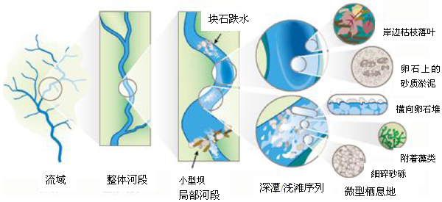
图 3.1 河流生物栖息地尺度示意图
Fig. 3.1 Sketch map of river organisms habitat
自The Federal Interagency Stream Restoration Working Group（2001）

3.2 材料与方法
在鳇产卵季节，流态、坡岸河床质与坡岸覆盖物均采用原位观察，并拍照。水流流速根据秒表显示时间和漂浮物漂流距离测算表层流速，测量时，雇佣一艘渔船开至河中心偏中国抚远一侧（界河接受国际管制）抛锚固定，从船首扔下一小团泡沫，记录下这团泡沫到达船尾的时间，用渔船身长除以这个时间就可以得到表层水的流速，取样点设3处，每处3次测量取其平均值。水下照度计采用上海嘉定学联仪表厂生产的ZDS–10W–2D型水下照度计测得，测量选在晴天的下午15:00–16:00，测量时，固定渔船，从船尾扔下坠有石头沉子的水下照度计，从水表层开始往下测量0.1 m、0.5 m、1 m、2 m、4 m、6 m、8 m、10 m、12 m、14 m深处的水下照度，测量3个地理位置，取各个水深层的平均值，并绘制水下照度随水深变化的曲线图。测量水下照度时，以渔民平时认为水最深的地方进行测量，如此亦可获得产卵场附近的最大水深。透明度则用透明度盘在水下照度测量的地方进行同步测量。

3.3 结果与分析
根据原位观察得知鳇抚远江段产卵场附近流态低缓，坡岸底质主要以沙和砂砾构成，有少量鹅卵石（图3.2），推知河床质主要以砾石和鹅卵石组成。河较宽，两岸沙洲发育较多，河中心亦有沙洲发育，两岸覆盖物以河柳居多（图3.3）。
经过3处原位测量算得产卵场河道主流附近表层水的流速值在0.15–0.46 m·s⁻¹之间，平均流速0.31 m·s⁻¹。产卵场在产卵季节最大水深可达14 m。水下光照强度在水表层以下1m处衰减极显著，在水深3–14 m，水下照度几乎稳定在0.5 lx 左右（图3.4），水下照度与水深的关系式为y = 40.761x^{-2.161}（y为水下照度值，x为水深；R² = 0.9257）。透明度一般在0.3–0.4 m之间。
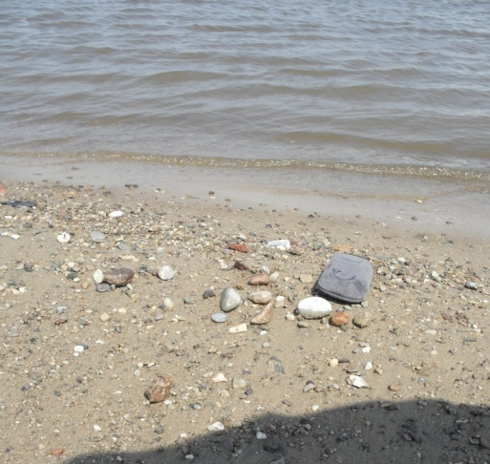
10cm
图 3.2 河岸底质图
Fig. 3.2 Map of substrates in river bank

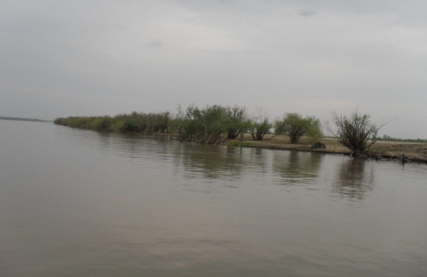
图 3.3 河流流态、河中心沙洲与坡岸河柳图
Fig. 3.3 Map of river flow regime, sandbar in river and willow in river bank

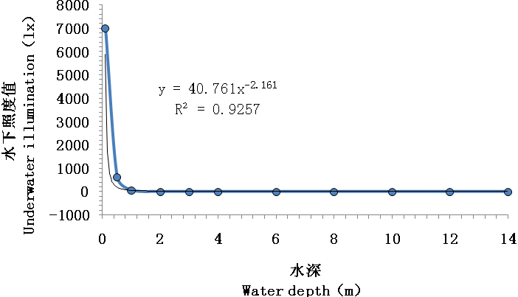
图 3.4 水下照度随水深变化图
Fig. 3.4 Map of underwater illumination change with water depth

3.4 讨论
原位观测是获取栖息地信息最为原始却颇为有效的方法。经原位观测表明：鳇早期生活史阶段在产卵场附近（抚远）江段已经有摄食栖息的有利条件—沙洲、沙坝。而且透明度和水下照度测量也表明，河流中层、特别是底层是较为黑暗的，不太适合鳇利用视觉进行摄食。14m的水深表明对于越冬期的鳇，产卵场附近存在有足够深的越冬场。与中华鲟等鲟鱼不同，平缓的水流是否是诱使鳇产卵发生的条件之一，值得更为深入的调查。

第4章 胚后发育与生长

4.1 前言
胚后发育与生长研究是早期史阶段行为研究中的重要方面，通过胚后发育与生长的研究可以获知行为发生与变化的具体时期，得出行为的稳定期与变迁期，从而为人类更好地保护早期生活史阶段的鱼类提供科学依据。已有的诸多鲟鱼早期生活史行为研究文献都在关注胚后发育的分期与生长的积温问题（Richmond and Kynard，1995；Zhuang et al.，2002；Kynard et al.，2010），但似乎在其它的器官发生与生长上关注太少，为了深入研究的需要，我们将细致地对鳇的胚后发育与生长进行研究。

4.2 材料与方法

4.2.1 试验鱼来源
鳇受精卵为2010年6月2日从黑龙江抚远县（N 48°）充氧托运至湖北荆州太湖（N 30°）中华鲟增殖放流基地，放在孵化框上进行孵化，孵化温度控制在（20± 1）℃，孵化1天后开始出膜。

4.2.2 饲养条件与日常管理
试验期间暂养池为直径为1.8m的圆桶，水深保持0.5m左右，笛式供水，中央排水。试验用水为曝气后的地下井水，每天采用试剂盒测量溶解氧为6.0～7.5mg/l，PH为7.0–8.5。仔鱼8日龄开口，开口饵料为剁碎的水蚯蚓，23日龄开始转食伴有水蚯蚓汁的S6升索颗粒料，10天后转食成功，33日龄完全投喂升索颗粒料。刚开口阶段每天投喂6次，转食阶段每天投喂5次，转食成功后每天投喂4次。试验过程中每天排污一次，采取24小时溢流式换水，试验期间水温保持在（21± 1）℃。

4.2.3 试验所需的仪器及试剂
试验仪器：暂养池、Leika-Mz75解剖镜、解剖盘、剪刀解剖刀、电子天平、电子游标卡尺、纱布、培养皿、镊子、探针、标本瓶、温度计、相机等。
试验试剂：10%中性福尔马林试剂、40ppm甲磺酸三卡因（MS–222）麻醉剂等。

4.2.4 试验方法
仔鱼出膜当日记为0日龄，从0日龄开始每天随机抽取20尾，用Olympus体视显微镜观察10尾样本的外形特征及呼吸和循环系统。初步观察后用40ppm甲磺酸三卡因（MS–222）麻醉剂麻醉，测量全长和体重之后，用10%中性福尔马林保存日后备察。用Leika–Mz75解剖镜对保存的12日龄以前样本进行观察，并用Leica DFC 300FX图像采集软件采集图像，12日龄及12日龄以后的样本由于体积太大，用解剖镜无法全身拍照，故用佳能EOS 5D markⅡ相机进行拍照。鱼体固定前，体色发展变化采用Hype’s Color for Netscape v. 3.进行描述；全长及眼径用500–196系列MITUTOYO数显游标卡尺测量（日本生产，精度0.01mm）；体重用BS124S型电子分析天平进行称量（赛多利斯科学仪器北京有限公司生产，精度0.1mg），称量时，用滤纸擦干鱼体体表的水分。

4.3 结果与分析

4.3.1 鳇胚后发育形态观察

4.3.1.1 前期仔鱼（自由胚）
0日龄：初孵仔鱼全长（12.08 ± 0.68）mm、体重（21.11 ± 1.22）mg（图版Ⅰ-1），头部细小、勾向卵黄囊弯曲；仔鱼体透明、卵黄囊背面呈浅灰色（Lightgray）、腹面淡黄（Lemonchiffon）、形似椭圆形或鸭梨，上面布满毛细血管，血液淡黄；口凹出现、前方有孵化腺黑色素颗粒密积，瓣肠开始分化；鳃原基出现，可见3–4片鳃弓（图版Ⅰ-1-a，BA）突起；眼囊（图版Ⅰ-1-a，E）已出现、有少量黑色素沉积但轮廓不清晰；嗅囊（图版Ⅰ-1-a，O）出现，鳃后方胸鳍原基（图版Ⅰ-1-a，PF1）出现，整个躯干和尾部鳍褶透明且并连一体，尾部鳍褶宽大钝圆，为初孵仔鱼主要的运动器官，卵黄囊后端上方躯干有12–18对V型肌节（图版Ⅰ-1-a，ME）出现。
1日龄：仔鱼体形与体色未有明显变化，口凹加深，孵化腺消失，卵黄囊腹面分化成肝脏细胞团，螺旋瓣开始出现，瓣肠内有灰色纤细胎粪贯于中；第一鳃弧出现，鳃丝完全外露，血液颜色很淡，但循着血液流动可见卵黄囊前方的管状心脏，侧面前1/3处有一对粗血管为主静脉，血液由心脏经由腹大动脉进入鳃瓣，另经背大动脉流入尾部，然后经由尾下静脉、肠下静脉和卵黄囊毛细血管网与总主静脉汇合注入心脏，但此时鳃未见血液循环，即仔鱼呼吸仍通过体表的毛细血管网进行。眼部中央晶状体（图版Ⅰ-2-a，LE）隐约出现，视网膜（图版Ⅰ-2-a，R）外圈也逐渐开始有黑色素沉积，听囊（图版Ⅰ-2-a，H）凹陷，吻须芽（图版Ⅰ-2-a，B）出现；整个躯干和尾部鳍褶透明且仍连一体，脊索末端开始向上弯曲，肌节由躯干中后部向两端发展，数目在55–65对（图版Ⅰ-2）。
2日龄：卵黄囊开始分为上前方和下后方两半，前半大后半小；体透明，少数个体近尾端躯干有少数黑色素颗粒沉积，个别呈淡灰色斑块（gray 91），脊索末端继续向上弯曲；口裂开始打开，并出现口腔气泡，胎粪由灰变黑，盘绕在瓣肠中后段，卵黄囊前端心脏后方白色肝脏明显；未见鳃呼吸，但血液颜色加深，呈淡红色；眼部黑色素继续增多，两对吻须芽清晰可见，胸鳍芽肉眼清晰可见、扩展为半月形；脊索末端继续向上弯曲，肌节数61–66对（图版Ⅰ-3）。
3日龄：1/5个体近尾端躯干黑色素颗粒继续沉积；口裂（图版Ⅰ-4-a， M）完全打开，口腔气泡减少，卵黄囊两侧凹陷继续加深，肠螺旋瓣有6～8个，黑色胎粪明显变粗增多，十二指肠开始分化；血液淡红，鳃丝露出鳃盖，可见鳃中血液循环，即鳃已开始行使呼吸机能；眼部增厚，眼晶体明显，眼周有黑色素颗粒沉积；嗅囊增大，清晰可见，嗅囊中间部位出现哑铃状鼻孔（图版Ⅰ-4-a，N）；吻须增长呈椭圆形，胸鳍增大，向外扩展；肌节超过68对；肛门上方偏后背鳍鳍褶略微隆起、隐约可见支鳍条8–13条，肛门后面有臀鳍鳍褶隆起，肛门至卵黄囊之间的肠中段位置镜检下可见腹鳍芽，尾鳍褶开始上翘，进行上下叶分化，下叶鳍褶扩大（图版Ⅰ-4）。
4日龄：卵黄囊背部灰黑、腹面淡黄，头部有黑色素沉积，近1/3个体近尾端躯干黑色素颗粒沉积、个别成深灰色斑块（Grey11）；口腔气泡消失，十二指肠清晰，胃开始分化，肠螺旋瓣达到8个，黑色胎粪贯串其中；血液淡红，大部分鳃丝仍露出鳃盖，鳃中血液循环加强；眼睛明显增大，视网膜着色进一步扩展加深，整个眼部黑色素沉积多且均匀，变为浓黑；哑铃状鼻孔中间部分逐渐变细，胸鳍增大并向鳃后方进一步靠拢；肌节呈W型；背鳍、臀鳍与尾鳍最终从奇鳍褶中分化出来，但奇鳍褶仍保留残余物，背鳍支鳍软骨已经达到13–14条，腹鳍明显（图版Ⅰ-5）。
5日龄：卵黄囊背部黑色、腹面淡黄，头部黑色素增多，近1/2个体近尾端躯干黑色素颗粒沉积、个别成灰黑色斑块（Grey 41）；仔鱼鼻孔中间部分逐渐愈合，嗅板上仅留下两个鼻孔；仔鱼上下颌开始张合，鳃盖也随之张合，两者张合次数接近，每分钟平均张合126次，鳃呼吸明显增强；仔鱼对外界震动开始变敏感；胸鳍增大呈扇形并由鳃盖后方移至腹面，游动能力增强；背鳍支鳍条17–19，臀鳍支鳍条出现，隐约可见8～9根（图版Ⅰ-6）。
6日龄：仔鱼头部黑色素继续增多，90%个体近尾端躯干有黑色素颗粒沉积，尾呈灰色（Grey71）或黑色（Grey41）；淡黄色肝脏（图版Ⅰ-7-a，L）明显分化为两叶，胎粪向肠后段开始聚集，胃（图版Ⅰ-7-a，S）分化几近完成；背鳍支鳍条18–21条，背鳍、臀鳍与尾鳍可以明显区分（图版Ⅰ-7）。
7日龄：身体头、躯干背面黑色素明显增多，仔鱼明显分为黑尾与灰尾两种类型；陷器（图版Ⅰ-8-a，P）开始在吻板腹面前端出现，前颌齿（图版Ⅰ-8-a，T）已出现7–9颗，下颌齿隐约要穿出下颌皮肤；胃分化完成，肠内有金黄色油滴，少数个体胎粪开始排出体外，投喂水蚯蚓未见摄食；胸鳍明显增大、变厚；背鳍支鳍条20–22，胸鳍支鳍条出现，隐约可见4–5条，臀鳍支鳍条出现11–13条，腹鳍支鳍条隐约可见4–5条（图版Ⅰ-8）。
8日龄：10%左右个体开始摄食水蚯蚓，仔鱼开始进入混合营养期；黑尾和灰尾两种仔鱼分别仍明显；胎粪排出个体逐渐增多至1/5；鳃盖增长，仅少量鳃丝露出鳃盖，心跳变慢，每分钟平均跳动83次；胸鳍软骨5–6条，腹鳍软骨5–6条，臀鳍和尾部完全形成（图版Ⅰ-9）。

4.3.1.2 后期仔鱼（仔鱼）
9–22日龄：9日龄，仔鱼全长（22.09 ± 0.83）mm、体重（58.35 ± 7.03）mg（图版Ⅰ-10），积温（CTU）=190.7℃/d；卵黄囊消失仔鱼个体达到50%，90%左右个体开口摄食，仔鱼处于混合营养期；腹部开始变扁平，身体背面颜色浅灰（Grey71），腹面浅黄色（Lemonchiffon），仔鱼尾部大都为灰色；80%个体胎粪排出体外，靠近背鳍后端的背骨板处骨质开始沉积，进入后期仔鱼阶段。10日龄，卵黄囊全部消失（图版Ⅰ-11），仔鱼进入外源营养阶段；仔鱼尾部都为灰色，自背鳍后端起，隐约可见4–9块骨质沉积物，为背骨板原基，越靠近背鳍骨质沉积愈多，观察愈清晰。11日龄，仔鱼肝脏与胃几乎占据了整个腹腔，十二指肠很短。13日龄，仔鱼体重与体长增长明显，腹部明显变平，体色逐渐加深，变为浅灰色（Grey81）；梅花陷器在吻须附近及吻前腹面分布较多，吻须之间的吻板中间很少；头部骨质已经开始沉积，背骨板出现9–10枚，侧骨板自头部往尾端开始出现1–3枚。15日龄，仔鱼背骨板9–11，侧骨板7–15，胸鳍位置由侧面移向了腹面，向两边水平扩展；腹部肌肉较薄，透过腹部的皮肤可以清晰地看到仔鱼的内脏器官。17日龄，仔鱼头部疣刺出现，头部侧线处的疣刺尤为明显，背骨板11–12，侧骨板16–20，腹骨板自腹鳍起从后往前生长出3–4块。21日龄（图版Ⅰ-11），仔鱼头部疣刺很多，嗅窝及里面的嗅板与梅花陷器肉眼清晰可见；背骨板12–13，侧骨板28–29，腹骨板5–7。
23–33日龄：23日龄，鱼体色加深，变为浅灰色（Grey71）；背骨板基本发育完善，各骨板已经套合，侧骨板和腹骨板发育基本成型，只是骨板数目还处于增长中。25日龄，仔鱼肝脏、胃与幽门盲囊仍然占据着整个腹腔，十二指肠依然短小，解剖未发现鳔，颌齿发达；胸鳍和腹鳍更为发达，水平地伸向两侧，奇鳍进一步得到发育，腹部明显变扁平且腹部皮肤逐渐增厚；但腹部脏器仍可见；尾鳍连接背鳍和臀鳍处的的鳍褶退化，尾柄最终形成，鱼体的运动能力随之增强。27日龄，仔鱼背骨板11–15，侧骨板29–39，腹骨板6–8；胸鳍鳍条23–27。30–33日龄，五行骨板之间的体表也出现微小的骨质疣刺沉积，肛前鳍褶逐渐变窄小。
36–45日龄：36日龄仔鱼体色继续加深为灰黑（Grey51），颌齿逐渐退化；胃、肝脏和幽门盲囊与带7个螺旋的瓣肠几乎充满整个腹腔，鳔开始出现，呈彗星状，与胃前面的食道相连，末端直抵后背的腹腔膜；体表疣刺明显增多，腹中线附近略为透明，仍可见肠等内脏；肛前鳍褶逐渐消失。39–45日龄，前颌齿与下颌齿逐步退化；背骨板12–14，侧骨板37–40，腹骨板7–9；背鳍鳍条47–53，胸鳍鳍条27–37，臀鳍条28–32。

4.3.1.3 稚鱼阶段
50日龄，鱼全长（106.78 ± 9.87）mm、体重（6203.15 ± 1396.71）mg（图版Ⅰ-12），积温（CTU）=1 100.3℃/d。体表布满小疣刺，体色继续加深（Grey41）；背骨板11–13，侧骨板36–41，腹骨板7–9；背鳍鳍条48–52，胸鳍鳍条42–47，各鳍（胸鳍：PF1；腹鳍：PF2；背鳍：DF；臀鳍：AF；尾鳍：CF）基本发育完善；前颌齿与下颌齿退化消失，肛门前腹部的奇鳍褶消失，腹部明显增厚，腹条纹肌逐渐成型肉眼可见，腹中线附近不再透明，各器官形态均酷似成鱼，发育进入稚鱼阶段。至60日龄，稚鱼全长（129.21 ± 7.69）mm、体重（10 021.47 ± 1 477.89）mg，稚鱼仅体色增黑（Grey31），形态未有明显变化（图版Ⅰ-13）。

4.3.2 鳇体长与体重生长
鳇的全长在整个试验期间随着日龄增长几乎成直线增长，但是在11日龄有一个生长拐点出现，拐点以前全长增长较为缓慢，拐点以后全长增长较为迅速（如图4.1），其体重在整个试验期间随着日龄增长几乎成指数函数增长（如图4.2），但是在11日龄也有一个拐点出现，拐点以前体重增长较为缓慢，拐点以后增长较为迅速。但是
生长模拟发现，多项式显然更符合其逻辑生长方程，因为此时R²达到最大。
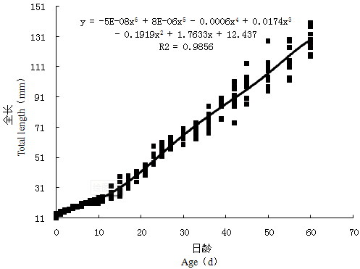
图 4.1 鳇全长随日龄增长变化
Fig. 4.1 The total length of kaluga by day age

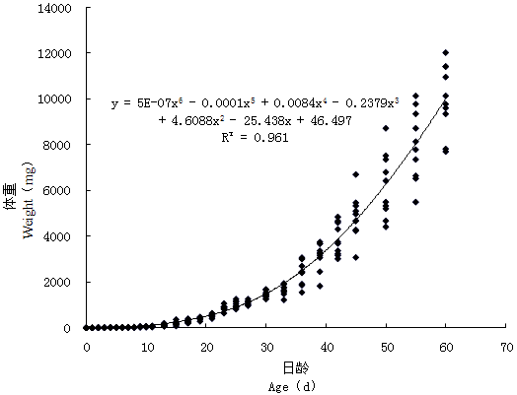
图 4.2 鳇体重随日龄增长变化
Fig. 4.2 The body weight of kaluga by day age

4.3.3 鳇眼径与全长比例变化
鳇眼径与全长比例先是1日龄有明显增大，之后随着日龄增长而变小，在第6日龄又有增长，随之又减小。至第9日龄，大多数已开口时，眼径与全长比例又增大，直至第10日龄达到最大值，之后随着日龄增长呈快速下降趋势，在30日龄下降趋势达到缓慢态势，眼径与全长比例的缓慢下降态势直至60日龄（图4.3）。
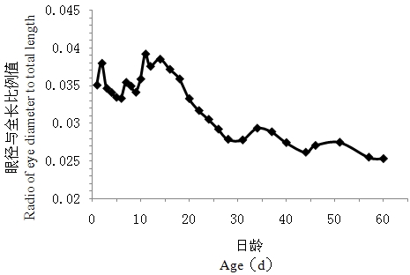
图 4.3 鳇眼径与全长比例随日龄增长变化
Fig. 4.3 The ratio of eye diameter and total length of kaluga by day age

4.3.4 鳇早期生活史阶段的死亡率
鳇早期生活史阶段大量死亡发生在开口一周后的15–17日龄（图4.4），表明开口后一周是仔鱼的不可逆点，仔鱼若在开口阶段得不到合适的开口饵料，它将在一周后迎来不可逆点，达到死亡的高峰期。
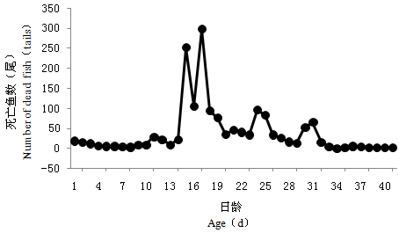
图 4.4 鳇早期生活史死亡情况
Fig. 4.3 Death of early-life-history of kaluga Huso dauricus

4.4 讨论

4.4.1 仔鱼发育阶段划分
目前，一般将鱼类早期生活史划分为卵（胚胎）、仔鱼和稚鱼三个基本发育期。早期史研究的对象主要就是这三个发育时期，有时也包括当年幼鱼，但重点是仔鱼（殷名称，1991）。对于仔鱼的划分，多数学者主张以“孵化”作为卵和仔鱼期的划分界限，但也有使用词“胚胎”一词，包括从受精卵到仔鱼初次摄食的整个期间，而将“孵化”作为一个相对不重要的环节。为了区分孵化前后的仔胚，提出了“自由胚”（Eleutheroembryo）的概念，但是这一观点并未获得广泛的认可。目前一般将仔鱼又划分为前期仔鱼（或卵黄囊期仔鱼）和后期仔鱼两个阶段，但是其划分是以卵黄吸收完毕为界限的。对于鲟鱼前期仔鱼与后期仔鱼的划分，有学者（章龙珍等，2009）提出以初次开口摄食为界限，本文也沿用这一划分标准。
一般认为，当仔鱼发育到体透明等仔鱼特征消失，各鳍鳍条初步形成，特别是鳞片形成过程开始，便是仔鱼进入稚鱼期的标志（殷名称，1991；1995）。对于鲟鱼类，有学者（庄平，1999）将鳍条骨出现，腹部表面平坦，口部明显前突，颌齿消失视为稚鱼期的开始。本文根据对胚后个体的实际观察结合了二者的划分，认为各鳍鳍条初步形成，腹中线不再透明，肛门前鳍褶彻底消失，颌齿消失作为划分的依据。

4.4.2 早期形态发育对其早期环境适应的意义
刚孵出的0日龄仔鱼具有宽大、相连一体的鳍褶，这是其垂直运动的主要器官；眼囊作为视觉器官已经出现，并且在其垂直运动中起着趋光向水体上层游动的作用（Zhuang et al.，2003）；嗅囊可能在其早期气味印痕中已然发挥着作用。1日龄仔鱼眼睛进一步发育，已出现晶状体和视网膜，吻须作为触觉器官也开始发育。0–2日龄仔鱼卵黄囊硕大，且表面布满毛细血管，此期毛细血管在表皮呼吸中起着重要作用。
2–3日龄发现口腔气泡，4日龄口腔气泡消失，这与施氏鲟（刘洪柏等，2000）中观察到口腔气泡消失的时间不太一致，口腔气泡出现与消失的原因似乎与3日龄口裂的打开有关，但具体原因尚待进一步查明。3日龄，仔鱼鳃已行使呼吸功能，嗅囊进一步发育并已形成鼻孔，腹鳍芽的出现使仔鱼在水流湍急的环境中增加了一大平衡器官。至第4日龄，背鳍、臀鳍与尾鳍也最终从奇鳍褶中分化出来，至第5日龄，胸鳍增大呈扇形并由鳃盖后方移至腹面，仔鱼的运动与平衡能力进一步加强。第5日龄，仔鱼上下颌开始张合，鳃盖也随之张合，鳃呼吸明显增强，能量向物质转化速度加快。
至第6日龄，肝脏和胃分化几乎完成，标志着消化系统完成等待着摄食的来临。至第7日龄，陷器开始在吻板腹面前端出现，颌齿出现，胃分化完成，这些意味着感觉器官与消化器官相继完成发育。至第8日龄，仔鱼胎粪开始外排并开始开口摄食，意味着开始其外源营养的摄取。
第9日龄，90%左右个体已开口摄食，仔鱼进入晚期仔鱼阶段。至第10日龄，仔鱼卵黄囊全部消失，其营养完全来自外界。为了提高生存率，除了营养上的快速转变，仔鱼也在第9日龄开始了其背骨板骨质的沉积，以期通过锋利的骨板来恐吓外界的掠食。同时9日龄也是开口的关键期，此期倘若开口不成功，仔鱼将在随后的一周迎来不可逆点，达到死亡的高峰期。
至第23日龄，背骨板基本发育完善，各骨板已经套合，侧骨板和腹骨板发育基本成型，只是骨板数目还处于增长中，表明其敌害防御机制基本建成，此期仔鱼颌齿发达，肝脏、胃与幽门盲囊占据着整个腹腔，表明消化机能发达，仔鱼处于快速生长之中，仔鱼正是通过快速的生长来躲避敌害追击的。至36日龄，解剖稚鱼发现鳔开始出现，这表明仔鱼开始通过鳔来调节自身比重来调节在水层中的位置。
至第50日龄，各鳍发育完全，腹面扁平，腹中线不再透明，肛前鳍褶消失，颌齿消失，这一系列特征表明仔鱼进入稚鱼阶段，其环境适应能力有了大大增强，成活率也大大增加。

4.4.3 早期生活史生长与死亡率
鳇在开口摄食（9日龄）前全长和体重的生长都较为缓慢，这是与其内源性营养相关的，因为此期，内源性营养非常有限，其内源营养要供各个器官协调生长发育使用。在开口摄食两天后（11日龄）其全长与体重生长都较为迅速，这表明其在外源营养得到充分供应情况下，迎来生长的高峰，仔鱼正是通过快速生长来躲避敌害追击的。在生长迅速的情况下，其野外成活率也大大增加。然而，养殖情况下，我们却发现仔鱼在开口一周后迎来了死亡的高峰，这显然是与开口不良有关，说明每天6次的开口投食量还是不够的，投食次数有待增加，在具体实施中可以每两个小时投饵一次，一天投喂12次，这样方可使仔鱼度过不可逆点，避免死亡高峰的出现。

第5章 鳇个体发育偏好性行为研究

5.1 前言
鳇是一种可以达到5.6m全长，1 000kg重，寿命能达到80年的大鲟鱼（Krykhtin and Svirskii，1997）。它是黑龙江流域四种鲟鱼之一，也曾是黑龙江经济鱼类之一，但是由于过度捕捞，资源急剧下降，现在被列为极危保护级别。
鳇至少有两个种群——其中一个种群在主河道产卵并游向河口摄食育肥，另一个种群终身生活在除了河口的下游或中游以及支流（Krykhtin and Svirskii，1997；Shmigirilov et al.，2007），包括结雅河（Zeya）和布列亚河（Bureya）。Krykhtin and Svirskii（1997）甚至识别出四个种群：第一个种群来自河口和鄂霍次克海（Okhotsk）以及日本海的近岸咸水区域，第二个种群来自黑龙江的下游，第三个种群来自黑龙江中游，第四个种群来自结雅河和布列亚河的下游。各个种群生活史中的洄游并不知晓，但一些鳇是利用淡水和咸水的海淡水两栖性鱼类（Zhuang et al.，2003）。
尽管鳇仔鱼处于急剧下降中，但不同种群生活史研究还是很少。Zhuang et al. （2003）使用黑龙江中游采集的亲鱼经人工繁殖产生的幼苗进行了室内早期生活史行为研究。他们发现除了3–5日龄的前期仔鱼，0–30日龄的前期仔鱼和后期仔鱼偏好明亮、开阔栖息地和白色底质。0日龄前期仔鱼启动强烈的顺流向下洄游一直持续4天，之后停止洄游6天，10日龄仔鱼启动第二次主要在白天发生的顺流向下洄游，持续7天，然后仔鱼继续在白天进行的微弱的顺流向下洄游，在夜间更为强烈的向上顶游洄游行为，这样仔鱼总体上表现出微弱的顶游向上洄游，这样一直到28日龄观察截止的时间。
影响鲟鱼早期生活史存活的因子研究得很少，然而生活史的前面几周显然是大多数死亡发生的时期（Gross et al.，2002；Parsley et al.，2002）。要评估自然和人为因素对早期生活史存活的影响，了解个体发生行为，特别是洄游和栖息地偏好以及摄食的启动就显得尤其重要。要在一条河里捕获鲟鱼的早期生活史是可能的（Auer and Baker，2002；Fuller et al.，2008；Caroffino et al.，2009；Wei et al.，2009；Braaten et al.，2010），但是要研究大多数行为却并不可能，因为小鱼苗在偌大的河流里面。这样，实验室方法就成为研究个体发育行为的唯一手段（Kynard and Parker，2005）。
个体发育行为绝大部分是天生的，因此，在人工溪流里观察早期生活史的行为能给野生的鲟鱼带来暗示（Richmond and Kynard，1995；Kynard and Horgan，2002；Zhuang et al.，2002；Kynard and Parker，2005）。很多鲟种的野外研究已经重复地证明在人工溪流里的鲟鱼的活动能准确反映野外鲟鱼的活动（Kynard et al.，2002a；Kynard and Horgan，2002；Zhuang et al.，2002；Zhuang et al.，2003）。
本研究致力于栖息地亮度选择（高亮度与白色栖息地）、穴居性与开阔地选择、底质种类与底部利用、游泳水深选择。这些偏好性研究可以为野外早期生活史鲟鱼栖息地识别提供必需信息，并且给我们一次了解不同亲鱼组合的后代的个体发育行为的机会。如果我们的鲟鱼后代与Zhuang et al.（2003）研究的鲟鱼后代之间存在较大的行为差异，那么这就提供了不同种群后代拥有不同的早期生活史适应性行为的早期生活史证据。

5.2 材料与方法

5.2.1 试验鱼与大体方法
试验方法大体与Zhuang et al.（2003）相同，个体发育行为的研究内容大体上与Richmond and Kynard（1995）和 Kynard et al.（2010）相一致。2010年6月2日，我们从抚远县鲟鳇有限责任公司获得5 000颗受精卵运至长江水产研究所荆州太湖养殖基地，在这个基地我们开展了所有的试验。受精卵是从黑龙江中游下段抚远（N48°）江段捕获的一雌一雄的后代。2天后，90%孵化出膜。这样，6月4日为大多数鱼的起始日龄即0日龄。鱼苗暂养和试验用水是从一口井抽上来经曝气后的井水，水温维持在22±1°C（用水温数据记录仪每小时记录一次）。暂养桶与试验桶内的水温相似（±1°C），鱼类经历着荆州（N 30°）的自然光照。
孵出后，我们将5 000颗自由胚均匀地放于两个1 400-L圆形饲养桶内，桶内底部放置几块卵石供仔鱼掩蔽用，当我们发现自由胚一直不寻求掩盖，在第9日龄，我们将卵石全部撤除。
当鱼类发育成开口仔鱼，它们用水蚯蚓每隔4小时饲喂一次，这样持续饲喂15天。23日龄以后，仔鱼饲喂伴有水蚯蚓的商品颗粒饲料（山东升索渔业养殖饲料研究中心），每天5次。混合的水蚯蚓经历10天后逐渐减少到无，这样，从33日龄开始，仔鱼只饲喂商品颗粒料。较大的仔鱼和早期稚鱼每天饲喂4次。我们每天或隔几天（视发育期的不同）从暂养桶中取一些鱼用于发育期的观察，这些观察样本被保存在10%的福尔马林液中以供后期更为详细的形态和摄食观察。
为了将行为和发育相联系起来，我们计算鲟鱼的发育日龄和积温（CTU）。圆形桶内的水温是通过水温数据记录仪每隔一小时记录的，这些数据将被用于计算关键发育期的积温。积温是用每日的平均水温计算，比如，0日龄累积了0°C，1日龄累积了第一天的平均水温，2日龄累积了第一天与第二天的平均水温。
在所有的每日试验中，我们混合暂养桶内的2 000–2 500尾鱼，随机的选择一些用于试验。试验结束后，我们将试验鱼又放回暂养桶。这样，没有鱼在同一天内被测试两次，但是有较小的可能一些鱼被用于以后的试验。随机选择是通过一个小网筛进行无选择捕捉进行的。

5.2.2 明亮区、底质颜色及洞穴选择
我们使用同样类型的塑料试验水族箱（棕褐色，不像Zhuang et al.，2003里面的蓝色）用于明亮区、底质颜色及洞穴选择试验。所有三个水族箱被黑布包隔着，所以，外界的光线被消除了。用于底质颜色和洞穴选择行为研究的水族箱都是60 cm长，40 cm宽，水深15 cm；用于明亮区选择的水族箱长95 cm，宽33 cm，水深15 cm。一个18 w的日光灯分别悬挂于底质颜色与洞穴选择水族箱上方，提供一个13–25 lx的水下照度。在明亮区选择、底质颜色选择和洞穴选择试验中，我们每天测试10尾鱼。在试验中，我们定期交换水族箱里面的水以保证水温与暂养桶里的水温相差在1℃以内。
对于明亮区选择试验，一个18 w的日光灯位于水族箱一端的正上方，并且用两块黑色挡光板将水面划分为三个面积相等的明亮区（160–380 lx）、过渡区（13–105 lx）和暗区（5–9 lx）（图5.1）。试验时，不断调换水族箱的摆放方向以防止方位效应产生。单尾鱼从容器中取出从水族箱中央水面放入，每尾鱼适应2 min后，连续记录它的活动位置（明亮区vs.暗区）5 min。每尾鱼试验结束后，我们将它放于另一个暂养池桶中，并且引入一条新鱼。在明亮区的时间被转换成总测试时间百分
比，我们利用这个时间百分比用于所有的数据分析。

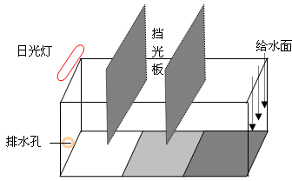
图5.1 明暗区选择装置示意图
Fig. 5.1 Sketch map of the device for illumination choice test
注：长95cm，宽33cm，水深15cm
Note: length 95cm, width 33cm, water depth 15cm
对于底质颜色选择，水族箱的底部铺了一块白瓷砖和一块黑瓷砖将水体均匀地分成两等份（图5.2）。我们不断地调换黑白瓷砖的位置以避免试验中的方位效应。试验中，单尾鱼从容器中放入水族箱正中央的水面。适应时间和观察同明亮区选择试验。
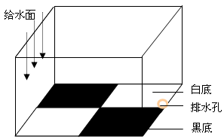

图5.2 黑白底质选择装置示意图
Fig. 5.2 Sketch map of the device for white substrate choice test
注：长60cm，宽40cm，水深15cm
Note: length 60cm, width 40cm, water depth 15cm

对于洞穴选择试验，我们在水族箱底部像棋盘格式般地铺上10堆卵石（直径4–8 cm，每堆面积约100 cm²），保持洞穴和开阔地的面积相同（图5.3）。试验中，我们将单尾鱼从水族箱的正中央放入，适应和观察时间同明亮区选择试验。

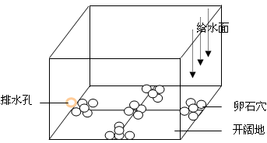
图 5.3 穴居选择装置示意图
Fig. 5.3 Sketch map of the device for cover use test
注：长60cm，宽40cm，水深15cm
Note: length 60cm, width 40cm, water depth 15cm

5.2.3 底质类型选择与底部利用
六种类型的底质被安放在一个直径为1 m的圆形桶内（图5.4）。各种底质类型的大小直径见下：粗卵石（平均8 cm，范围6–12 cm），小卵石（平均2.2 cm，范围1.4–3.2 cm），白色开阔底部，砾石（平均3.1 mm，范围1.9–5.2 mm），沙（平均0.16 mm，范围0.09–0.25 mm）和以上四种底质四等份均匀混合的混合底质。试验桶内供以一股微弱的水流（1–5 cm·s⁻¹），水深保持在35 cm。试验桶四周遮盖一层黑布以防止观察时造成的人为干扰，一盏40 w的日光灯在试验桶的正上方，提供一个20–35 lx的水下照度环境。观察者站在黑布以内来记录鱼类的位置。
试验鱼在8:00饲喂，在9:00被引入试验桶。在10:00用肉眼开始观察（三个观察者同时观察，每个人观察两种底质区的鱼类数量），以后每隔2 h观察一次，这样一直到20:00。在每日的试验里，试验鱼一直不被饲喂以防止摄食干扰。我们每天使用30尾鱼试验从3日龄一直到51日龄，由于鱼体增大，自52日龄起，我们每天使用20尾鱼试验，这样一直到60日龄。
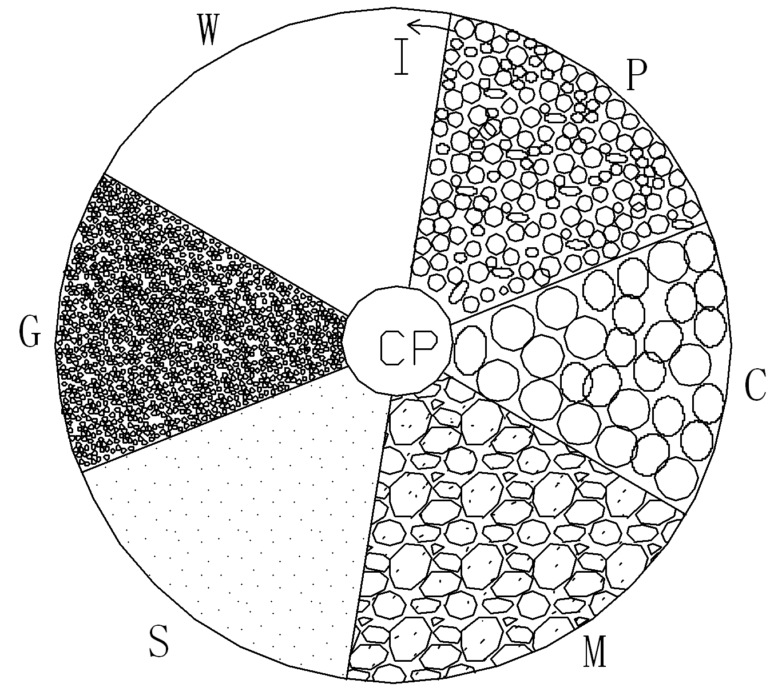

图 5.4 底质类型选择装置示意图
Fig. 5.4 Sketch map of the device for substrate type choice test
注：C= 鹅卵石，F= 白色平坦底，G= 砾石，M= 混合底质，P= 小卵石，S= 沙，I= 进水，CP= 标准管
Note: C=Cobble, F= White and flat bottom, G= Gravel, M= Mixed substrates, P= Small pebble, S= Sand, I= Inflow, CP= Control pipe

5.2.4 游泳水深选择
在河流中，流速在水体上层最大，在水体底层最小。我们使用一个垂直溪流水柱来模仿天然河流的水流情况，来观察试验鱼随日龄变化在水柱中离底的距离。这个透明塑料水柱直径40 cm，高380 cm，水柱外表从底部至顶部标有5 cm间距的刻度，以此来记录试验鱼的位置（图5.5）。
水柱底部的一半铺有一层暗黑色的扁平石头（直径6–10 cm），另一半底部保持开阔没有铺任何东西。一块黑布安置在水柱的外部，在水柱顶部安装有一个105 w的日光灯，给水柱从上至下提供一个950–11 lx的水下照度。一个梯子靠在水柱一边用来肉眼观察试验鱼的位置。垂直水柱的垂直流速模拟如下（离底高度–水流速度）：0.3 m – 1.3±0.1 cm s⁻¹；1 m – 3.5±0.7 cm s⁻¹；2.2 m – 6.2±1.6 cm s⁻¹；3 m – 5.3±2.8 cm s⁻¹；和 3.5 m – 3.7±0.7 cm s⁻¹。试验过程中水深始终维持在3.65 m；我们始终保持部分换水，以此来保证水温和暂养桶里的水温相差不到1°C。
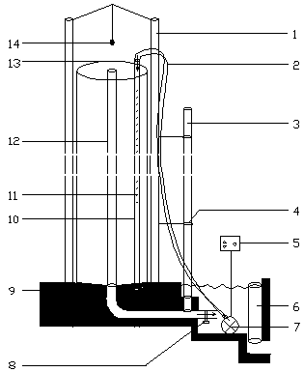
图 5.5 水深选择装置示意图
Fig. 5.5 Sketch map of the device for water depth choice test
注：1= 支撑柱，2= 软管，3= 标准管，4= 固定桩，5= 变频器，6= 标准管，7= 潜水泵，8= 阀门，9= 水泥墙，10= 铁管，11= 孔洞，12= 筛管，13= 透明塑料管，14= 日光灯；圆筒高3.8m， 直径0.4m。
Note: 1= iron support stand, 2= flexible plastic pipe to introduce water, 3= water depth control pipe, 4= fixed mount, 5= AC voltage converter, 6= control pipe to provide water to pump, 7= submersible pump, 8= valve, 9= concrete wall, 10= iron tube, 11= holes in water supply tube to create a horizontal flow, 12= sieve pipe for fish barrier, 13= clear plastic tube, 14= fluorescent lamp; tube height= 3.8m, diameter= 0.4 m.
我们每天通过一个小碗引入5尾鱼至垂直水柱的底部。试验鱼可以在任何水深游出小碗。如果实验鱼到达垂直水柱的底部还不游出小碗，我们将通过提拉小碗来驱逐试验鱼，最后将小碗拉出垂直水柱。为了防止鳇在试验操作及试验中受到惊吓，我们参照密苏里铲鲟的试验（Kynard et al., 2007），即让试验鱼在垂直溪流柱中适应2 h后再记录它们的位置。我们在10 min内每隔2 min记录5尾试验鱼的位置（每天测试可以得到25个水深值）。测试结束后，试验鱼随水流被排出水柱，并被放入暂养桶。

5.2.5 数据分析
为评估鱼类对明亮栖息地、白色底质以及洞穴的偏好性，我们计算鱼类在这些栖息地的时间百分比，并且绘制成每日的时间序列图。所有的实验数据均采用STATISTICA 6.0统计软件进行分析处理，处理前先把所有的平均值转换成反正弦函数值，计算每个日龄的中值和95%的置信区间，再转换成正弦函数值后，看50%是否在此区间内（Sokal and Rohlf，1981），以此来分析在不同的日龄对某一趋性是否有显著性喜好（置信区间包含50%的差异不显著）。
底质类型选择与底部利用试验，我们采用单因素方差分析对其选择性进行分析。对于游泳水深试验，我们计算每日25个水深值的中值、25%–75%置信区间以及最大值和最小值，并且将这些值绘制成每日时间序列图。

5.3 结果与分析

5.3.1 明亮区、底质颜色和洞穴选择
鳇在0–34日龄强烈喜好明亮区，35–56日龄微弱喜好明亮区（差异不明显），57–60日龄完全不喜好明亮区或暗区（图5.6）。
从0–60日龄，鳇始终喜好白色底质（图5.7）。
0–2日龄自由胚只利用开阔地，洞穴利用率最高是3–6日龄，但是喜好程度依然没有达到明显的程度。7日龄及更大自由胚、所有仔鱼以及稚鱼都强烈喜好开阔栖息地（图5.8）。
图5.6 鱼类随着日龄变化在亮区的时间百分比
Fig. 5.6 Percent of time fish were on the illumination side vs. the dark side by age (day)
注：每日的置信区间包含50%（用虚线在0.5%处显示）的表示时间百分比不显著，每天测试的样本N= 10。
Note: Daily confidence intervals that include 50% (indicated by dashed line at 0.5 %) indicate the percent is not significant, N= 10 for each day.

图5.7 鱼类随着日龄变化在白色底质区的时间百分比
Fig. 5.7 Percent of time fish were on white vs. black substrate by age (day)
注：每日的置信区间包含50%（用虚线在0.5%处显示）的表示时间百分比不显著，每天测试的样本N= 10。
Note: Daily confidence intervals that include 50% (indicated by dashed line at 0.5%) indicate the percent is not significant, N = 10 for each day.

图5.8 鱼类随着日龄变化在洞穴的时间百分比
Fig. 5.8 Percent of time fish were in or under cover by age (day)
注：每日的置信区间包含50%（用虚线在0.5%处显示）的表示时间百分比不显著，每天测试的样本N= 10。
Note: Daily confidence intervals that include 50% (indicated by dashed line at 0.5%) indicate the percent is not significant, N = 10 for each day.

5.3.2 底质类型选择及底部利用
3–8日龄的自由胚（除了6日龄）及9–15日龄仔鱼强烈地喜好白色开阔底、沙以及粗卵石底（F>5.92，P<0.0025）；16–20日龄仔鱼喜欢白色开阔底、沙以及砾石底（F>7.14，P<0.0021）；21–31日龄仔鱼（除了24、26和27日龄）喜欢白色开阔底和沙（F>14.22，P<0.0017）；32–60日龄仔鱼与稚鱼喜好白色开阔底、沙以及砾石底（F>26.67，P<0.0012）。当鱼类从自由胚成长为仔鱼（7–11日龄），它们对底部利用出现一个明显的峰值（42.2%）；随着仔鱼发育到27日龄，底部利用率下降，底部利用率仅为5%左右，之后又逐渐升高，从5%一直升到70%，直到60日龄——观察截止的时间（图5.9）。

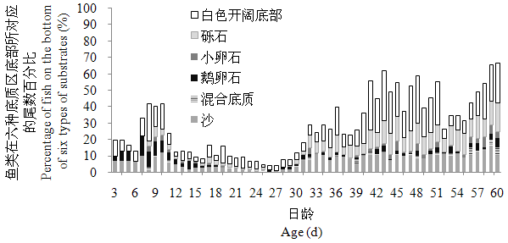
图5.9 鱼类随日龄变化在六种底质区底部的尾数百分比
Fig. 5.9 Percentage of fish on the bottom of six types of substrates by age (day)
注：鱼类在每个柱子的百分比依次为白色开阔底部、砾石、小卵石、鹅卵石、混合底质以及沙，群体试验尾数每天= 20-30尾。
Note: The percent of fish for every bar were white open bottom, gravel, small pebble, cobble, mixed substrate, and sand orderly, Group N = 20-30 for each day.

5.3.3 游泳水深选择
自由胚对水深的选择变异很大，但每日游离底部的高度都大于2.6 m。9–11日龄早期仔鱼游离底部的高度都大于3.3 m，然后游离底部的高度大都在1.5 m甚至更高，直至20日龄。在仔鱼洄游高峰的早期，仔鱼游离底部的高度最高。在仔鱼洄游高峰过后，37日龄以后的大龄仔鱼游泳离底高度小于1 m。稚鱼游泳离底高度众值在0.5 m甚至更低。这样，整个趋势就是游泳离底高度随着日龄增长越来越接近底部（图5.10）。
图5.10 鱼类随日龄变化在垂直水柱内的游泳高度
Fig. 5.10 Swimming height of fish above the bottom in the vertical stream tube by age (day)
注：群体试验尾数=5尾；每尾鱼观察5次，总共25次观测值。
Note: Group N = 5 fish; five observations on each fish, Total observation value = 25 observations each day.

5.4 讨论
图5.12 随着日龄变化鱼类顺游强度与昼夜活动图
Fig. 5.12 Graph of downstream movement intensity and diel activity with increasing age
of fish
注：a图显示的是鱼类每日昼夜净洄游次数(±95%置信区间)。正数=顺游活动；负数=顶游活动。b图显示的是鱼类昼夜总洄游次数(作为活动性测量指标)。
Note：Panel a shows the daily scaled net number of fish passes (±95% CI) for day and night. Positive numbers = downstream movement; negative numbers = upstream movement. Panel b shows scaled mean number of fish passes (±95% CI) for day and night (as a measure of activity)

5.4.1 明亮区、底质颜色、洞穴及游泳水深选择
我们研究的早期生活史的鳇的一些行为与Zhuang et al.（2003）观察的相似。两个群体都强烈地喜好明亮栖息地（明亮区和白色底质）以及避免洞穴生活。这些相似性说明来自不同亲本（或许是不同种群）的鳇的自由胚有着相似的天生适应行为。同样的行为也见于密苏里铲鲟（Scaphirhynchus albus）和密西西比铲鲟（S. platorynchus）的自由胚（Kynard et al.，2002a），中华鲟（Acipenser sinensis），施氏鲟（A. schrenckii），俄罗斯鲟（A. gueldenstaedtii）与西伯利亚鲟（A. baerii）的自由胚（Zhuang et al.，2002；Zhuang et al.，2003；Kynard et al.，2002b；黄晓荣，2003）。这样，散布洄游的自由胚的这些行为就是自然选择的普遍适应，自由胚可能通过这些行为避开河底并游于水体中，从而避开河流底部的敌害鱼类。所有的信息表明自由胚不进化成这种普遍适应（散布洄游）并伴随着对明亮栖息地和洞穴的必要反应来成功实现散布洄游，那么，它们将进化出另一种行为适应——寻求洞穴掩蔽，像短吻鲟（A. brevirostrum）、墨西哥湾鲟（A. oxyrinchus desotoi）、克拉马斯河中吻鲟（A. medirostris）的自由胚（Kynard and Horgan，2002；Kynard and Parker，2004；Kynard et al.，2005）。此外，现有信息还表明，当鲟鱼产卵场附近的摄食敌害较低时，自由胚进化出寻求洞穴掩蔽，依然待在产卵场等待卵黄囊吸收完毕，并在仔鱼甚至稚鱼阶段才启动洄游，此类的典型就是达氏鲟（A. dabryanus）（Kynard et al., 2003）。
我们观察的鳇在9–30日龄强烈地喜好明亮栖息地并且游泳离底高度达到甚至超过1.5 m，这些与Zhuang et al.（2003）的观察结果有所不同。这些结果差异可能由于试验方法的不同造成（我们对试验鱼的适应时间为2h，Zhuang et al.对鱼的适应时间仅为5 min），也有可能是基于两个不同种群的天生行为差异造成的。我们更倾向于后者，因为我们发现鳇对操作的应激反应不大，适应时间对其影响也就不大，况且前面的洄游结果也表明，两组实验鱼可能是源于不同的种群。我们的鳇游泳离底高度与西伯利亚鲟（黄晓荣，2003）相似，两个物种都生存于冰冷的河流。对明亮栖息地的喜好可能是增强仔鱼摄食时的视觉背景效果，以便于更好地分辨移动的饵料（Kynard and Horgan，2002）。在一条浑浊的河流里，明亮栖息地可能存在于水体的上层以及河流的浅滩。或许，鳇仔鱼和西伯利亚鲟仔鱼在停止日常洄游之后待在浅滩摄食。水温和饵料在水体上层和河流浅滩较多，所以一种嗜热偏好可能也存在于早期生活史的鲟鱼身上（Reynolds，1977）。当他们洄游的时候，往水体上层分布的行为将使它们散布洄游得更快，并且它们在水体上层可以获得更多的食物，因为它们可以利用视觉，至少对鳇仔鱼而言，从我们的摄食行为观察可知它们的视觉还是比较重要的。
洄游的鳇仔鱼和稚鱼由于饵料的贫乏可能进化出一种长距离洄游特征，正如墨西哥湾鲟（Kynard and Parker，2004）和库特奈河高首鲟（Kynard et al.，2010）。当鳇发育到31–36日龄，它们拥有鱼鳔和坚硬的骨板（形态观察），此时，它们也开始躲避明亮栖息地并游近溪流底部过上完全意义上的底栖生活。这时，它们的视觉变得不太重要（在白天，河流底部的光照强度不足1 lx）,但是陷器（电感觉器官）变得更为重要。鳇稚鱼继续避免明亮栖息地并且进行着完完全全的底栖生活。

5.4.2 底质类型选择和底部利用
整个生活史，鳇对白色开阔底部与沙底质的选择几乎占统治地位。这表明白色开阔底部适于喂养需求，沙底质是放流养殖仔鱼和稚鱼的良好栖息地。
底部利用随着个体发育而改变，自由胚、早期仔鱼和中期仔鱼使用底部最少，晚期仔鱼和稚鱼使用底部最多。这一趋势与游泳水深试验结果相吻合（除了7–11日龄，这一自由胚和仔鱼阶段的过渡期），表明鳇是逐渐从晚期仔鱼开始过上完完全全的底栖生活的。

第6章 早期生活史洄游及影响洄游的环境因素研究

6.1 前言
鳇栖息于黑龙江河口至河流上游的整个黑龙江流域。幼鲟也出现在鄂霍次克海的沿岸，鞑靼海峡的东北部和接近北海道和本州岛的日本海（Krykhtin and Svirskii，1997；Shmigirilov et al.，2007）。历史上，鳇被认为生活在整个黑龙江以及毗邻的湖泊，属于忠实的不洄游种群（Nikolskii，1960；Wei et al.，1997）。旧信息以及近来的信息表明有两个鳇种群——一个种群在河流主干道产卵并洄游至河口摄食育肥，然而，另一种群生活于整个黑龙江下游和中游及其支流，包括结雅河和布列亚河（Shmigirilov et al.，2007）。Krykhtin and Svirskii（1997）甚至识别出四个种群：第一个种群来自河口和鄂霍次克海（Okhotsk）以及日本海的近岸咸水区域，第二个种群来自黑龙江的下游，第三个种群来自黑龙江中游，第四个种群来自结雅河和布列亚河的下游。
鳇通常在5–6月份水温15–20℃时产卵。产卵自上游到中游的下段均可发生。施氏鲟也可能在同样的时间和地点产卵，因此，野外杂交种也有可能出现。
鳇是一个高价值的商品鱼类，但是其资源丰度已经有了明显下降，该种在1994年被列入IUCN红皮目录。然后，于1996年被列入濒危保护等级（Birstein et al.，1997），近年又被列为极危保护等级（Wei and Ruban，2010）。鉴于其濒危状态，中国政府自2002年开始对其进行大规模人工增殖放流，到2008年止，黑龙江中游下段的抚远县已经放流1千万尾仔稚鱼。养殖的仔稚鱼也在黑龙江中游沿岸的一些城市进行了放流，如黑河、萝北、同江。在这些地方放流的鳇全长大多在7–10 cm。
Zhuang et al.（2003）就鳇的个体发育行为做了唯一的研究。它们发现，0日龄自由胚启动强烈的为期3天的洄游，停止洄游7天后，也就是鱼类发育到10日龄仔鱼，仔鱼启动第二次为期7天主要在夜间发生的向下洄游。之后，仔鱼继续夜间向下洄游，但是出现更多的白天顶游行为直至28日龄观察结束。
影响行为的终端因子是那些在自然选择过程中固化为行为的遗传基础的那些环境因子。近端因子是促使行为发生的刺激因素（Fretwell and Lucas，1968）。一般而言近端因子关系到机体生活史的整个表型过程的现时因子（Near，in time or space），而终端因子则涉及到历史上的（Farthest；most remote in space or time）这些过程（主要是自然选择）所形成的染色体组（Francis，1990）。近端原因伴随有机体生活史发生，它包含有有机体遗传信息的表达，并受环境所调控。终端原因早于机体生活史发生，贯穿于整个物种进化史，它包括物种成员最终为何拥有这一遗传信息的原因（Beatty，1994）。研究近端因子有助于建立一个概念模型去了解生态究竟是怎样联系生理机制导致鱼类物种产生发育变化的（Thorpe et al.，1998）。对近端因子的阐释也能提供一个新的解释终端因子的模型（Yamahira，1997）。
个体发育行为，包括洄游行为（或散布行为）是天生的本能行为。所以，在人工溪流里研究幼鱼行为能够为野生鱼类的行为提供视野（Kynard and Horgan，2002；Zhuang et al.，2002；Kynard and Parker，2005；Kynard et al.，2007）。在几种鲟鱼上进行的野外研究也一再证明了幼鲟的各种各样的行为，像洄游的启动以及在水体中的位置，在人工溪流能准确反映野生鱼类的行为（Kynard et al.，2002a；Kynard and Horgan，2002；Zhuang et al.，2002；Zhuang et al.，2003；Wei et al.，2009）。导致洄游行为的生物学参数是终端因素的结果，然而影响洄游的近端因素很可能是那些非生物环境参数（McKeown，1984）。为了阐明终端因素和近端因素之于幼龄鳇洄游行为的关系，我们试验测试以下四个假说（表6.1）：（#1）流速影响洄游强度和持续时间；（#2）底质类型影响洄游；（#3）饲养水流条件影响洄游；（#4）流速影响洄游的昼夜节律。

表6.1 试验桶环境以及测试假说描述
Table 6.1 Description of test tank environments and hypotheses tested
桶号  Tank code | 试验桶功能与环境  Tank function & environment | （假说编号）假说描述  （Ho number）Description of hypothesis
SWR-SUB | 每天换鱼，鱼在静水中饲养（Still Water Rearing）-四种底质（SUBstrate） | （#2）底质类型影响洄游强度
SWR-B | 每天换鱼，鱼在静水中饲养（Still Water Rearing）-桶底光滑（Bare） | （#2）底质类型影响洄游强度
SWR-HV | 每天换鱼，鱼在静水中饲养（Still Water Rearing）-桶底光滑以及高流速（High Velocity） | （#3）饲养水流条件影响洄游
HV-RO | 一直不换鱼（Rear and Observe in the same tank）-桶底光滑以及高流速（High Velocity） | （#3）饲养水流条件影响洄游，（#1）水流影响洄游强度以及持续时间，（#4）水流影响昼夜节律
SWR-LV | 每天换鱼，鱼在静水中饲养（Still Water Rearing）-桶底光滑以及低流速（Low Velocity） | （#3）饲养水流条件影响洄游
LV-RO | 一直不换鱼（Rear and Observe in the same tank）-桶底光滑以及低流速（Low Velocity） | （#3）饲养水流条件影响洄游，（#1）水流影响洄游强度以及持续时间，（#4）水流影响昼夜节律

6.2 材料与方法

6.2.1试验鱼以及大体程序
在2010年6月2日与2011年6月4日，我们分别运输5 000颗受精卵至长江水产研究所荆州太湖基地，在那里我们开展了全部试验。两年里，受精卵都是一雌一雄的后代，亲鱼在黑龙江中游下段抚远（N 48°）江段被捕获。在2010年，几乎所有的5 000颗受精卵在2天内孵化——90%在6月4日孵化，这样6月4日是大多数自由胚的0日龄。在2011年，6月6日是大多数自由胚的0日龄。暂养用的水和试验用水取自一口井水，水温基本维持恒定的22±1℃（水温自动记录仪获取）。暂养桶和试验桶内的水温相似（±1℃）。鱼类经历湖北荆州（N 30°）的自然光照。
在2010年，5 000颗0日龄自由胚被均匀地放置在两个1 400-L的圆形暂养桶内，暂养桶内的水流几乎维持静止（流速小于2 cm·s⁻¹），桶底光滑没有底质。在2011年，我们将鱼喂养在以下三个桶内：1）3 000颗0日龄初孵自由胚放置在像2010年流速几乎静止的桶内，并且每天都被转移一些鱼至高或低流速桶内用于每日的试验。2）1 000颗自由胚放置在直径为1 m的高流速（6–30 cm·s⁻¹）桶内。3）1 000颗自由胚放置在直径为1 m的低流速（2–8 cm·s⁻¹）桶内。两年内，水温和水下照度在暂养桶和试验桶内都是一样的。
当鱼类发育成开口仔鱼，用水蚯蚓每隔4小时饲喂一次，这样持续饲喂15天。23日龄以后，仔鱼饲喂伴有水蚯蚓的商品颗粒饲料（山东升索渔业养殖饲料研究中心），每天5次。混合的水蚯蚓经历10天后逐渐减少到无，这样，从33日龄开始，仔鱼只饲喂商品颗粒料。较大的仔鱼和早期稚鱼每天饲喂4次。我们每天或隔几天（视发育期的不同）从暂养桶中取一些鱼用于发育期的观察，这些观察样本被保存在10%的福尔马林液中以供后期更为详细的形态和摄食观察。

6.2.2 洄游与昼夜活动性试验条件
我们每天在一个棕褐色圆形玻璃纤维桶内观察20尾鱼的顺流洄游与顶流洄游活动。试验桶内有一个圆形的插板，它可以将桶内空间分隔成一个40 cm宽的试验水道（试验区间），形成一个周长为3.2–5.6 m的圆环，水深保持28 cm（图6.1无底质）。一个潜水泵在圆形插板内将水经由软管抽到试验水道内，形成一股试验水流。试验水流可分为外侧快速流、中间中等流，内侧慢速流三股流速区。试验所需要的溪流流速通过无极变频器控制水泵的转数来控制。在我们的研究中，平均流速为2.3–7.7 cm s⁻¹，这个流速与Zhuang et al.（2003）的流速相似。尽管空气和潜水泵的热量会加热试验用水，但我们通过3 l·min⁻¹的连续水流量交换保证了水温稳定在22±1°C。横贯溪流底部有两堆小卵石（低光照、低流速）以备试验鱼隐匿用。直到9日龄，仔鱼一直不利用这些卵石作隐匿，我们就将卵石全部撤离，留下光滑、开放的底部。

6.2.3 影响洄游的环境因素研究试验溪流以及条件
六个试验桶的水系统是一个联通可循环的水系统。所有试验桶都是圆形棕褐色的直径为1.8 m的玻璃纤维桶，所有桶内有一个直径为1 m的圆形内插圈，内插圈放在桶中央可以形成40 cm等距宽的溪流（图6.1）。水深维持28 cm ，溪流的圆周从3.2至5.6 m不等。一个潜水泵在圆形内插圈内经由一条软管将水抽至外侧的溪流形成一股循环的溪流，溪流包括主流（溪流的外侧），次流（溪流的中心）和缓流（溪流的内侧）。溪流流速通过与潜水泵相连的变频器控制。尽管潜水泵和空气会加热试验用水，两年里水温都是通过3 l·min⁻¹井水交换量保持在22±1℃。
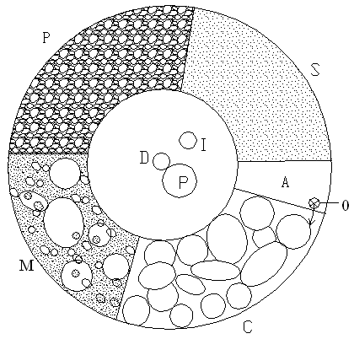
图6.1 底质对洄游影响试验桶平面图
Fig. 6.1 Plan-view of test tank of substrate effect on fish migration
注：S= 沙，P= 小卵石，C= 粗卵石，M= 混合底质，D= 排水洞，I= 进水，O= 出水，P= 水泵，A= 观察区；移走底质则可视为没有底质试验桶，移走全部结构则可视为暂养桶；圆桶直径1.8m，环道宽40cm，水深28cm。
Note: S= Sand, P= Small pebble, C= Cobble, M= Mixed substrates, D= Drain, I= Inflow, O= Outflow, P= Pump, A= Observation area; It can be used as test tank without substrate if take off all the substrates and it also can be used as rearing tank if take off all the structures; Circular tank diameter= 1.8m, Circuit width= 40cm, Water depth= 28cm.
除了在2010年使用的底质测试桶，其它的五个溪流桶横贯桶底都提供了两堆小卵石掩盖物（提供结构，低光照和低流速）以防鱼类寻求掩盖。当我们发现鱼类在整个自由胚阶段都不使用掩盖物作掩盖，我们将小卵石撤走。白天，桶底的光照强度较低（≤35lx，使用上海嘉定学联仪表厂生产的ZDS–10W–2D水下照度计测量，测量精度为4%）。

表6.2 六个试验桶在内侧、中央及外侧的平均流速和最小–最大流速（cm·s⁻¹）
Table 6.2 Mean and minimum-maximum velocities (cm·s⁻¹) at inside channel, middle channel and outside channel in six test tanks
桶编号  Tank code | 流速（Velocity）
桶编号  Tank code | 内侧 | 中央 | 外侧
桶编号  Tank code | Inside channel | Middle channel | Outside channel
桶编号  Tank code | Mean（Min –Max） | Mean（Min –Max） | Mean（Min –Max）
SWR-SUB | 3.2（1.2-4.8） | 7.5（3.9-13.5） | 22.2（13.5-35.6）
SWR-B | 3.1（2.0-5.8） | 7.8（4.0-13.5） | 21.3（15.4-38.4）
SWR-HV | 6.7（5.3-9.6） | 19.1（16.8-24.0） | 31.7（24.0-86.0）
HV-RO | 6.2（5.3-8.2） | 17.8（14.0-22.6） | 29.9（24.0-80.7）
SWR-LV | 2.0（1.2-3.9） | 4.2（2.3-6.8） | 7.1（5.2-11.1）
LV-RO | 2.2（1.2-3.9） | 4.4（2.4-6.8） | 7.7（5.3-14.0）

在2010年，我们使用两个桶来测试我们第二个假说（底质类型影响洄游，表6.1）。由于喂鱼和清扫底质桶的困难，测试鱼在两个桶每天都是更换的。其中一个溪流桶桶底是光滑的没有提供任何掩盖物（以后称为SWR-B; 表6.2; 图6.1无底质），拥有内侧平均流速为3.1 cm·s⁻¹，外侧平均流速21.3 cm·s⁻¹。另一个溪流桶拥有和桶SWR-B相似的流速（t-检验，P=0.20），水流范围为3.2–22.2 cm·s⁻¹（表6.2），但是桶底均匀铺了四等份底质斑块，有1/4沙（平均0.16 mm，范围0.09–0.25 mm），1/4小卵石（平均2.2 cm， 范围 1.4–3.2 cm），1/4粗卵石（平均 8 cm， 范围 6–12 cm），1/4混合底质（上述底质各占1/3）。每种底质径粒大小通过随机测量30颗底质颗粒的中轴，然后计算平均值来确定（Harrelson et al.，1994）。底质的命名则根据海底地质来命名（Shepard，1973）。溪流外侧的沙底质被外侧快流速冲刷走了，我们就在被冲刷的地方铺上两层小砾石（平均3.1 mm；范围2–5 mm）。每天的测试鱼我们都取自静止的暂养桶。我们混合约2 000–2 500尾暂养桶内的鱼并且随机捞取用于每天的试验。在每天的试验结束后，又将这些试验鱼放入暂养桶内。没有一尾鱼同一天内测试两次，但是有一种小小的可能，测试过的试验鱼被用于以后的试验。这随机选择和捞取程序是通过一个小捞网进行的，这样可以无选择地捞取鱼类用于每日的试验。
在2011年，我们使用四个底部光滑的桶用于测试以下三个假说：（#1）流速影响洄游强度和持续周期，（#3）暂养水流条件影响洄游，（#4）流速影响洄游的昼夜节律。其中两个是每天做换鱼试验，另两个一直不换鱼做试验。每天都换鱼试验两个桶中，有一个流速介于6.7至31.7 cm·s⁻¹大流速试验桶（以后称为SWR-HV，表6.1，表6.2，图6.1无底质），另一个为流速介于2.0至7.2 cm·s⁻¹小流速试验桶（以后称为SWR-LV，表6.1，表6.2，图6.1无底质），试验时，操作程序如2010年的两个试验桶。一直不换鱼两个试验桶中，其中一个为流速介乎6.2至29.9 cm·s⁻¹与SWR-HV相近似的高流速桶（以后称为HV-RO，表6.1，表6.2，图6.1无底质），另一个为流速介乎2.3至7.7 cm·s⁻¹与SWR-HV相近似的低流速桶（以后称为LV-RO，表6.1，表6.2，图6.1无底质）。通过比较HV-RO和LV-RO可以验证假说（#1）流速影响洄游强度和持续周期；通过HV-RO和LV-RO可以验证假说（#4）流速影响洄游的昼夜节律；通过比较LV-RO和SWR-HV，以及LV-RO和SWR-LV，我们可以验证假说（#3）暂养水流条件影响洄游。通过这些非生物环境因子的比较研究，我们就可以透过近端看远端因子在其中所起的作用。
为了刻画每条溪流，每个桶的流速都用HSLGY–Ⅱ便携式流速仪（北京中西远大科技有限公司，精度0.01 cm·s⁻¹）测量3个水深（底部以上2 cm，1/2水深，水表面以下2 cm），12个横切线和3个环切线的水深值，共计108个流速值（表6.2）。

6.2.4鱼类洄游度量
我们每日观察20尾鱼在每个试验桶内的顶游和顺游活动次数（2010年鱼类在0日龄引入，2011年鱼类在1日龄引入）。从0至20日龄，当鱼类太小、颜色太浅、溪流流速太大而不便用摄像头观察，这时鱼类从9:00至23:00每小时用肉眼观察5 min。鱼类是在8:30被引入试验桶内，经过半个小时的适应后，我们在9:00开始我们的第一次观察。在夜间（19:00–23:00）我们打开在观察区上方的一盏36 w的红色日光灯用于肉眼观察，正如Kynard et al.（2007）在密苏里河密苏里铲鲟上研究的那样。21日龄以后，我们使用摄像机每小时观察5 min连续观察24 h鱼类活动，观察时，观察区上方有红外灯照着，观察区也铺上了白色瓷砖用于增强夜间观察效果。小高首鲟直到几个月大仍看不见红外光（Loew and Sillman，1993），而且我们的观察也表明早期生活史的鳇对红外光的敏感性和高首鲟相似。
在2010年，鱼类每日进行测试，我们只在23:05饲喂试验鱼以保持底质清洁。2011年，我们饲喂试验鱼如暂养的鱼类，但是在两年期间，我们绝不在肉眼观察期间或摄像机录像期间饲喂鱼类。试验桶内的鱼类排泄物及剩余食物保证在每天新一轮试验鱼放入前用虹吸管虹吸掉了。如果在每日换鱼的桶内[为了验证假说（#2）的桶SWR-SUB和SWR-B，和为了验证假说（#3）的桶SWR-HV以及SWR-LV]死了鱼，鱼被捞走并用几乎为静水的暂养桶内的鱼替换。如果在一直不换鱼的桶内[为了验证假说（#1）、（#3）、（#4）的桶HV-RO和LV-RO]死了鱼，鱼被捞走并用几乎提供类似洄游机会的溪流桶的鱼替换。

6.2.5 发育及积温
使用Richmond and Kynard （1995）以及庄平（1999）的方法，我们鉴别了以下发育期（1）自由胚期（前期仔鱼）–未发育完全的眼球和口以及鳍褶和卵黄囊存在，（2）仔鱼期（后期仔鱼）–卵黄囊消失，鱼类外源摄食启动，鳍条和骨板出现，以及（3）稚鱼期–鱼类拥有成鱼的鳍条数，解剖镜观察颌齿消失。
为了将行为和发育相联系起来，我们计算鲟鱼的发育日龄和积温（CTU）。圆形桶内的水温是通过水温数据记录仪每隔一小时记录的，这些数据将被用于计算关键发育期的积温。积温是用每日的平均水温计算，比如，0日龄累积了0°C，1日龄累积了第一天的平均水温，2日龄累积了第一天与第二天的平均水温。

6.2.6 数据分析
通过5 min的录像记录或肉眼观察，我们将每日的洄游分成顺流洄游和顶流洄游两个类型，鱼类并非一个个识别，所以我们计数鱼类固定经过一个地方（观察区）的通过次数作为顺游通过强度的测量。我们再将每日的顺流和顶流洄游分成白天和黑夜两个部分，并且显示每尾鱼5 min内随着日龄变化每日时间序列内的净洄游次数（顺游通过次数－顶游通过次数）。一个处理的鱼类通过次数与另一个处理的鱼类通过次数的差异显著性每天通过非配对t检验进行检验（Kynard and Horgan，2002）。桶SWR-SUB和桶SWR-B，桶SWR-HV和桶HV-RO,以及桶SWR-LV和桶LV-RO之间的流速采用配对t检验进行检验。

6.3 结果与分析

6.3.1 发育及积温
鳇的大小和发育见表6.3。鳇0日龄自由胚（前期仔鱼）全长12.1 mm，自由胚经9个昼夜190.7积温（CTU）发育成摄食仔鱼（后期仔鱼），当时仔鱼全长22.1 mm。发育成摄食仔鱼每mm所需要的积温为8.6 CTU。大约到50日龄，鱼类经1 100.3 CTU后发育成稚鱼，当时全长106.8 mm。稚鱼拥有成鱼的鳍条，肛前鳍褶完全消失，颌齿也全部退化消失。
表6.3 鳇五个发育阶段的尺寸大小与积温（CTU）
Table 5.1 Summary of the size of kaluga at five development intervals and the cumulative daily temperature in degree-days (CTU)
发育阶段 | 日龄 | 全长 (cm)  (平均值±SD) | 积温（℃·d）
初孵自由胚 | 0 | 12.08 ± 0.68 | 0
洄游自由胚 | 2 | 15.64 ± 0.45 | 42.6
非洄游自由胚 | 7 | 20.78 ± 0.36 | 143.0
开口摄食仔鱼 | 9 | 22.09 ± 0.83 | 190.7
稚鱼 | 50 | 106.78 ± 9.87 | 1 100.3
注：每个阶段取样样本数N = 20
Note: Sample size for each interval is N = 20

6.3.2 洄游与昼夜活动性
自由胚在0日龄启动洄游，1日龄达到洄游高峰，继续强烈洄游至第3日龄，然后逐渐在4–6日龄下降，第7日龄停止洄游（8天洄游，图6.2 a）。早期仔鱼（9日龄）不洄游，但是它们在22日龄启动第二波洄游，仔鱼在34–36日龄达到洄游的高峰，洄游强度与早期自由胚的强度相似（每鱼每5 min洄游4次），洄游一直持续到66日龄稚鱼。
除了1，5，8和20日龄，所有自由胚及22日龄以前的仔鱼昼夜洄游均没有显著差异（P>0.373，图6.2 a）。然而，在中期仔鱼及洄游峰值期间（22–42日龄），鱼类在夜间洄游强度明显的要大于白天（P<0.01）。除了47，57与60日龄，43–66日龄晚期仔鱼及稚鱼昼夜洄游强度又变得没有差异（P>0.056）。
自由胚和直至21日龄的早期仔鱼昼夜活动强度没有显著差异，但是，随着日龄增长，从22日龄仔鱼至66日龄稚鱼，在夜间活动强度显著强于白天（25、27和57日龄例外，图6.2 b）。
图6.2 随着日龄变化鱼类顺游强度与昼夜活动图
Fig. 6.2 Graph of downstream movement intensity and diel activity with increasing age
of fish
注：a图显示的是鱼类每日昼夜净洄游次数(±95%置信区间)。正数=顺游活动；负数=顶游活动。b图显示的是鱼类昼夜总洄游次数(作为活动性测量指标)。
Note: Panel a shows the daily scaled net number of fish passes (±95% CI) for day and night. Positive numbers = downstream movement; negative numbers = upstream movement. Panel b shows scaled mean number of fish passes (±95% CI) for day and night (as a measure of activity).

6.3.3 不同水流速度对洄游的影响
桶HV-RO和桶LV-RO内试验鱼顺流向下洄游开始于0日龄。桶LV-RO内试验鱼洄游峰值出现在1日龄，继续强烈洄游至第3日龄，然后，在4–6日龄急剧下降，洄游在第7日龄终止（8天洄游）。停止洄游休息15天后，仔鱼在25日龄启动第二次洄游，在34日龄出现洄游峰值，此期洄游速度与早期自由胚的洄游速度接近。试验鱼在稚鱼期继续低强度的洄游直至66日龄——观察截止的日期（图6.3）。然而，桶HV-RO内试验鱼洄游峰值出现在4日龄，继续强烈洄游至第10日龄，然后，从11–14日龄急剧下降，在第15日龄停止洄游（16天洄游）。停止洄游休息8天后，仔鱼在24日龄启动第二次洄游，比桶LV-RO试验鱼启动第二波洄游要早一天。然后，在28日龄达到洄游峰值。此期洄游速度与桶LV-RO内的早期自由胚的洄游速度接近（4次每尾鱼每5 min），是桶HV-RO内的早期自由胚的洄游速度的二分之一。仔鱼继续洄游至54日龄稚鱼期，然后，从55–66日龄逐渐停止洄游，在试验的最后两天甚至出现微弱的顶流洄游。在两种流速条件桶下的自由胚和早期仔鱼（9–15日龄）拥有完全不同的洄游速度（P<0.001）。两个流速桶内的仔鱼经历一个可以忽略洄游速度（P>0.05）的为期8天的休息期。桶HV-RO内的24–30日龄仔鱼（除了27和29日龄）拥有桶LV-RO内相同日龄试验鱼两倍的洄游速度（P<0.048）。试验鱼在31–51日龄（P>0.065，除了32、35、41日龄）拥有几乎相同的洄游速度。桶HV-RO和桶LV-RO两个流速桶内的52–66日龄稚鱼拥有明显不一样的洄游特征（P<0.0029）。

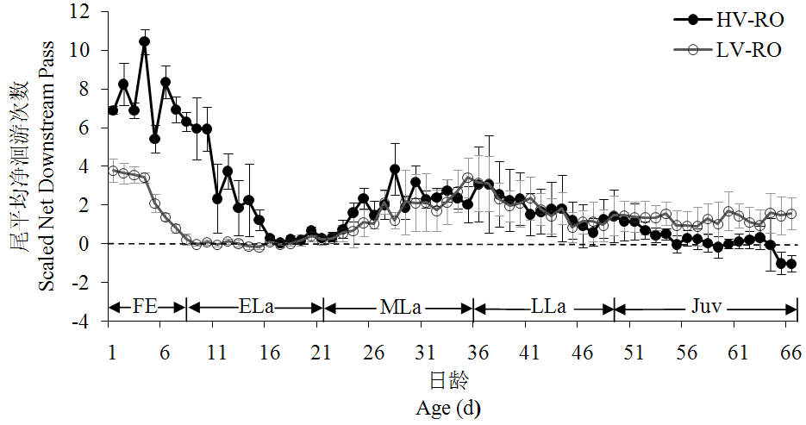
图6.3鱼类在高低流速桶内每尾鱼5min内的平均（±SD）净洄游次数
Fig. 6.3 Migration of fish around low and high velocity tank showing mean（±SD）number of fish passes per fish per 5min.
注：每个值为每日的平均洄游通过次数（正值= 顺游活动）。早期生活史缩写如下：FE=自由胚，ELa=早期仔鱼，MLa=中期仔鱼，LLa=晚期仔鱼，Juv=稚鱼。
Note: Every value is the mean daily number of fish passes (positive numbers = downstream movement). Early life stages abbreviated as follows: FE = free embryo, ELa = early larvae, MLa = middle larvae, LLa = late larvae, Juv = juvenile.

6.3.4 不同底质结构对洄游的影响
桶SWR-B和桶SWR-SUB内的早期自由胚（0–6日龄）以相同的洄游速度（P>0.79）强烈顺流向下洄游。在拥有底质的桶SWR-SUB的7–29日龄仔鱼洄游速度比没有底质的桶SWR-B要快（P<0.001）。在7–29日龄期，只有桶SWR-B的仔鱼在15日龄表现出集体休息停止洄游的行为。桶SWR-B和桶SWR-SUB内的30–45日龄仔鱼继续以相同的速度（P>0.05，除了31、36和43日龄）顺流向下洄游。从46–66日龄，试验鱼的顺流向下洄游速度明显变缓，但是没有底质桶SWR-B的洄游速度在大多数日龄明显地比有底质桶SWR-SUB要快（图6.4）。

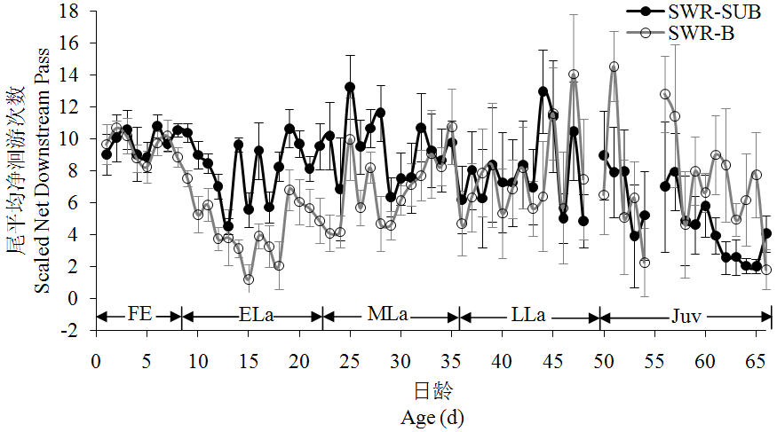
图6.4鱼类在有底质和光滑底部桶内每尾鱼5min内的平均（±SD）净洄游次数
Fig. 6.4 Migration of fish with substrate and bare bottom showing mean（±SD）number of fish passes per fish per 5 min
注：每个值为每日的平均洄游通过次数（正值= 顺游活动），早期生活史缩写同图6.3。
Note: Every value is the mean number of daily fish passes (positive numbers = downstream movement). Early life stages abbreviation is the same as Fig. 6.3.

6.3.5 不同暂养水流条件对洄游的影响
桶HV-RO和桶SWR-HV内鱼类从1–14日龄有着相似的洄游速度（P>0.085，除了第5和12日龄）。然后，从15–66日龄（除了19和49日龄），桶SWR-HV内鱼类的顺流向下洄游速度明显快于桶HV-RO内鱼类（P<0.008）。桶HV-RO内鱼类在55日龄几乎停止顺流向下洄游，而桶SWR-HV鱼类直到66日龄还没停止洄游（图6.5 a）。
桶LV-RO和桶SWR-LV内鱼类在1–10日龄有着相似的平均洄游通过次数（P>0.056）。两个桶内的洄游通过次数在11–15日龄——停止洄游休息行为为主导时，有着明显不同。16–32日龄，两个桶内的鱼类又开始洄游并有着相似的洄游速度（P>0.104，除了29日龄）。然后从33–45日龄，两个桶内的鱼类进行着有较大变幅的洄游，但是大多数日龄有着相似的洄游速度。自从46日龄，桶SWR-LV内鱼类停止顺流向下洄游，甚至出现微弱的顶流洄游行为直至66日龄，表现出一个与桶LV-RO鱼类极有差异的洄游特征，桶LV-RO鱼类则继续着缓慢的顺流向下洄游（图6.5 b）。
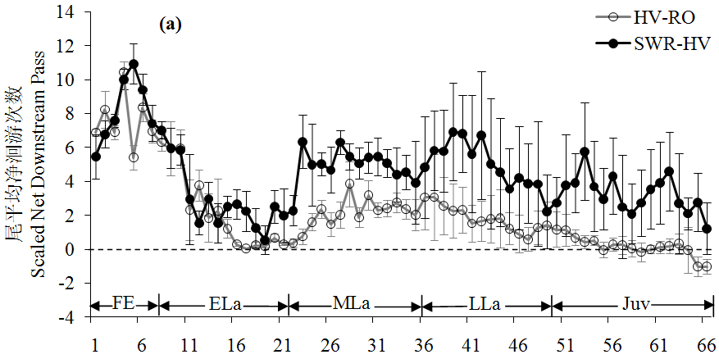
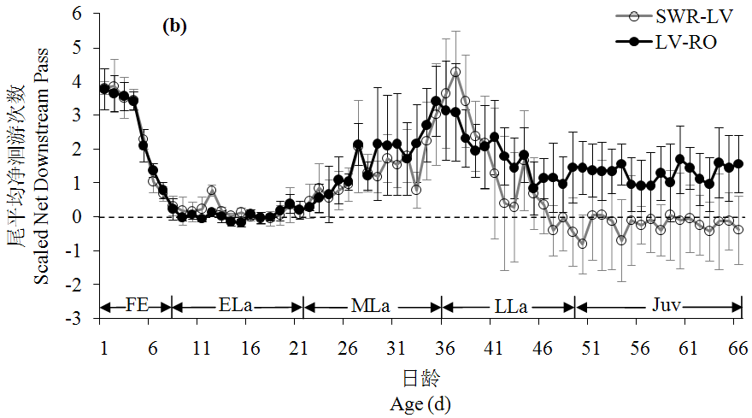
图6.5鱼类每天被换桶和鱼类一直不被换桶内每尾鱼5min内的平均（±SD）净洄游次数
（a为高流速桶，b为低流速桶）
Fig. 6.5 Migration of fish when fish were changed daily vs. fish not changed showing the
mean（±SD）number of fish passes per fish per 5 min in (a) high velocity or (b) low velocity
注：每个值为每日的平均洄游通过次数（正值= 顺游活动），早期生活史缩写同图6.3。
Note: Every value is the mean number of daily fish passes (positive numbers = downstream movement). Early life stages abbreviation is the same as Fig. 6.3.

6.3.6 流速影响昼夜洄游节律
从1–32日龄，桶HV-RO内鱼类白天和黑夜有着相似的洄游速度（P>0.054，除了9、10、12、13和28日龄）。然后，一个更加积极的夜行洄游出现在33–51日龄（P<0.015）。在52日龄，当鱼类发展成稚鱼，一个昼夜洄游速度相似的洄游特征又出现了，并且这一特征持续至66日龄（P>0.064，除了58日龄；图6.6 a）。
从1–22日龄，桶LV-RO内鱼类白天和黑夜有着相似的洄游速度（P>0.373，除了1、5、8和20日龄）。然后，一个更加积极的夜间洄游在23–42日龄出现（P<0.01）。除了47、57和60日龄，从43–66日龄，一个昼夜洄游速度相似的洄游特征出现了（P>0.056，图6.6 b）。

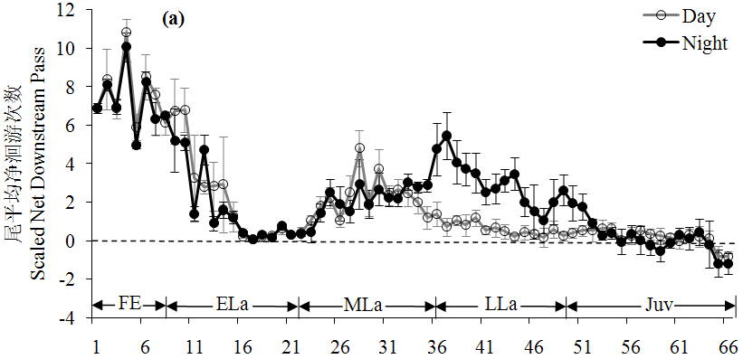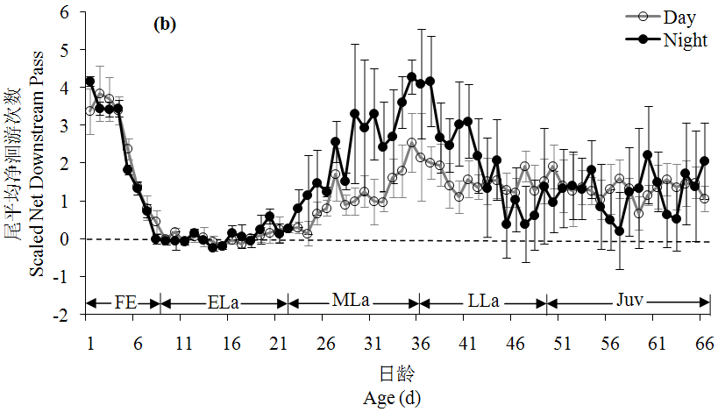
图6.6鱼类在白天和黑夜每尾鱼5min内的平均（±SD）净洄游次数
（a为高流速桶，b为低流速桶）
Fig. 6.6 Migration of fish during the day vs. night showing the mean（±SD）number of fish passes per fish per 5 min in (a) high velocity or (b) low velocity.
注：每个值为每日的平均洄游通过次数（正值= 顺游活动），早期生活史缩写同图6.3。
Note: Every value is the mean number of daily fish passes (positive numbers = downstream movement). Early life stages abbreviation is the same as Fig. 6.3.

6.4 讨论

6.4.1 洄游与昼夜活动性
早期生活史鳇的洄游特征大体上与Zhuang et al.（2003）观察的相似，但在几个细节上完全不同。Zhuang et al.（2003）观察到的自由胚也启动了洄游，只不过洄游时间（3 d）比我们观察到的（8 d）要短。还有Zhuang et al.（2003）发现早期仔鱼启动为期8天的第二次洄游，不像我们观察到的自中期仔鱼启动的长时间二次洄游，洄游直到66日龄（我们观察截止的时间）还没有停止。此外，Zhuang et al.（2003）观察到的仔鱼洄游并不像我们观察到的二次洄游在34–36日龄有一个强烈的洄游波峰。这样，两个群体的自由胚启动了首次洄游，仔鱼启动了第二次洄游。但是，自由胚和仔鱼洄游的周期在两个群体间截然不同。鳇在洄游特征上的这一系列差异表明两个群体的鳇可能来源于两个不同的种群。
在36日龄以前，鳇每日活动性与顺流洄游变化趋势相一致。36日龄以后，鱼类活动性增加，但是顺流洄游次数下降，同样的情形也发生在库特奈河高首鲟（Kynard et al.，2010）身上。可能这是鱼类更有能力抵抗水流并且能够顶游摄食的原因。
对于昼夜活动性，我们研究的鳇在22日龄开始增加夜间活动性，这一行为一直维持到42日龄，而Zhuang et al.（2003）观察到的仔鱼在10日龄就开始增加了夜间活动性，这一行为维持到18日龄。这些行为差异进一步表明我们研究的鳇与Zhuang et al.（2003）研究的鳇可能来源于两个不同的种群。

6.4.2 不同水流速度对洄游的影响
水流速度对自由胚的洄游有着较大影响。我们发现洄游强度与水流速度存在着正相关，较快的水流速度甚至延迟晚期自由胚和早期仔鱼停止洄游的时间，产生一个更长周期的洄游。这种现象也发现于密苏里铲鲟身上（Kynard et al.，2002a；Kynard et al.，2007）。我们的水流速度在两个处理间非常不一样（高流速桶内的主流平均流速为29.9 cm·s⁻¹，低流速桶内的主流平均流速为7.2 cm·s⁻¹）。在这样的流速里面，未发育完全、游泳能力弱的自由胚靠向上游动往下漂游行为顺流向下洄游，但是他们的洄游速度由水流速度控制。
自由胚进行的洄游行为是主动洄游还是被动洄游？这个问题被经常涉及和讨论（Kynard et al.，2002b；Kynard and Parker，2005；Kynard et al.，2007）。如果自由胚只能随着水流移动以及没有足够的游泳能力来改变水流可能携带它们的去向，那么自由胚就会出现被动洄游。显然，鳇和很多其它鲟鱼自由胚能够游泳，并且它们的向上游泳行为在保证自由胚顺流向下洄游过程中保持着重要作用。特别是当自由胚被卷入到漩涡中时，它们的连续游泳行为将使得它们游回河道主流。特别有趣的是我们研究的鳇自由胚似乎可以调节自身的洄游速度或周期，使得在不同流速下具备相同的洄游距离。无独有偶，密西西比铲鲟在5–12 cm·s⁻¹ 或4–9 cm·s⁻¹的溪流中的洄游速度也相同（Kynard et al.，2002a）。哥伦比亚河高首鲟自由胚在8 cm·s⁻¹的流速中洄游1天，然而在2 cm·s⁻¹的流速中洄游3天（Brannon et al.，1985），萨克拉门托河高首鲟高首鲟自由胚在3.5 cm·s⁻¹的平均流速中洄游2天（Kynard and Parker，2005）。在我们的研究中，强烈洄游的鳇自由胚在29.9 cm·s⁻¹主流流速中的洄游速度只有在7.2 cm·s⁻¹主流流速中的两倍。这样，在流速和洄游速度二者间并非是线性关系。我们的研究以及其它人的研究表明洄游的自由胚放置在不同流速中可以调节自身的洄游速度，这也表明鱼类可能迁移了相似的距离。
与低流速下9–15日龄早期仔鱼相比，高流速下的此期仔鱼并没有停止洄游休息。这个阶段的仔鱼依然发育未完全、拥有较弱的游泳能力，所以不能有效地抵抗高流速。16–23日龄的早期仔鱼在两个流速下有着相似的停止洄游休息期，这表明仔鱼发育至此期，在高流速下也可以停止洄游休息好。23–30日龄仔鱼在HV-RO高流速桶内的洄游速度是在LV-RO低流速桶的两倍，这表明中期仔鱼可能需要一个较高的流速——刺激流速来刺激产生高强度的的洄游。对库特奈河高首鲟来说，刺激其产生高强度仔鱼期洄游的有效刺激流速 ≥15 cm·s⁻¹（Kynard B未发表资料）。31–51日龄仔鱼无论在低流速或高流速有着同样的洄游速度，这表明这些晚期仔鱼依然有洄游相同距离的本能。
当鱼类在50日龄发育成稚鱼，52–60日龄鱼类在HV-RO高流速桶逐渐停止洄游，而相同日龄的稚鱼在LV-RO低流速桶依然持续着低强度的洄游。这些差异可能依然跟流速的差异有关——高流速可能刺激稚鱼停止洄游休息，然而低流速可能是一个无效的刺激。如果是这样的情况，那么对鳇而言，刺激稚鱼洄游停止休息的有效刺激流速就介于7.2 cm·s⁻¹和< 29.9 cm·s⁻¹两者之间。这些结果给我们暗示当我们进行增殖放流时，最好放流仔鱼而不是放流稚鲟（10 cm）这样保证放流的鱼保持洄游并找到合适的摄食场所。

6.4.3不同底质结构对洄游的影响
由于强烈的散布洄游，鳇早期自由胚并没有显示出对底质结构的偏好。这与自由胚要寻求掩盖物掩蔽不散布的鲟鱼不同，例如高首鲟（Kynard and Parker，2005）和大西洋鲟（Gessner et al.，2009）。鳇晚期自由胚和早期仔鱼经历了一个喜欢平坦开阔底部并在平坦开阔底部休息的简短时期，并在SWR-B桶进行较低强度洄游。这个结果可以解释为早期摄食仔鱼拥有保护它们的柔软腹部免遭石质底部损害的本能（顾孝良等，2008）。30–45日龄鳇仔鱼像墨西哥湾鲟（Kynard and Parker，2004）和库特奈河高首鲟（Kynard et al.，2010）一样共享底部摄食和洄游生活。这样，在SWR-SUB桶内底部摄食的鳇像在平坦底的SWR-B桶内的仔鱼一样能够发现平坦的底部栖息地（沙以及小卵石），并且这样使得两个桶内的仔鱼有着相似的洄游速度。在SWR-SUB桶内的46–66日龄晚期仔鱼及早期稚鱼开始寻求一个合适的天然底质来摄食，并且拥有较低强度的洄游。综上所述，底质类型确实影响着晚期自由胚、仔鱼和稚鱼的洄游速度。大碎石底质减慢仔鱼期库特奈河高首鲟的洄游速度（Kynard B未发表资料）。这些结果给我们暗示当我们进行增殖放流时，放流的仔鱼和稚鲟最好放在底质为沙或小卵石（2.2 cm）的河道里面。

6.4.4不同暂养水流条件对洄游的影响
鱼类侧线的主要作用是感知方位和水流。中华鲟在头部和腹部的侧线在仔鱼阶段形成于12-18日龄（柴毅，2006）。鳇生长速度像中华鲟那么快，所以，1–14日龄自由胚和早期仔鱼拥有未发育完全的侧线。这或许正好解释了此期鳇为什么在桶SWR-HV和桶HV-RO有着相似的洄游速度。从15日龄开始，与桶HV-RO内可以洄游鱼类相比，放在暂养桶内没有洄游机会的桶SWR-HV鱼类开始加快洄游速度，表现出强烈的补偿性洄游。这一现象表明在静止水体条件的鱼类的洄游本能得到了增强，它们的洄游在高流速条件下极易被激发。这一情形并未在桶SWR-LV鱼类身上出现，在这种低流速条件下，在静水条件下饲养的鱼类在整个试验期间并未表现出补偿性洄游。所以，对饲养在静水或低流速条件下的鱼类而言，存在着一个大于7.2 cm·s⁻¹小于31.7 cm·s⁻¹的激发流速，使得鱼类放置在此流速条件下表现出强烈的补偿性洄游。补偿洄游的出现表明放流的鱼从小饲养的水流环境并未影响其洄游本能，静水饲养的鱼照样适合于放流，只不过放流的鱼以处于洄游期的仔鱼为好，而不是非洄游或者低强度洄游的稚鱼，这样有利于最大化分散放流的鱼而减少放流鱼对食物的竞争。

6.4.5流速影响昼夜洄游节律
桶HV-RO鱼类的洄游速度从33–52日龄显示出明显不同的昼夜差异，而桶LV-RO鱼类的洄游速度在23–43日龄拥有明显的昼夜差异。两个桶内的鱼类的洄游速度昼夜差异周期都是20天，但是这一昼夜差异特征在快流速桶鱼类出现得稍微要晚些。并且，在我们行为试验期间，我们发现两个流速处理桶内的鱼类的生长和发育不一致——HV-RO桶内鱼类一开始比LV-RO桶内鱼类生长慢些，然后随着日龄增长，比LV-RO桶内鱼类生长快些。我们推测认为正是高流速桶内鱼类的慢生长与发育导致了其昼夜洄游差异特征比低流速桶出现的要慢些。这样，流速间接地影响到昼夜洄游特征的启动。在Zhuang et al.（2003）对鳇的研究中，自由胚以及7–9日龄仔鱼拥有相似的洄游速度。然而，在10–16日龄，仔鱼绝大多数洄游通过次数是顺流向下洄游，并且明显的是在夜间进行顺流向下洄游。自17–28（观察结束）日龄，一些顺流向下洄游发生在夜间，但是更多的顶流向上洄游发生在白天。在其它自由胚是洄游性的鲟鱼中（Kynard et al.，2002b；Zhuang et al.，2002；Kynard and Parker，2004），昼夜洄游特征差异只是在自由胚阶段出现。

6.4.6 总结
目前的研究拓展了我们对早期生活史鳇行为洄游以及影响洄游的环境因素的认知，并且揭示了来自不同亲本的后代在行为特别是洄游上的差异。我们也许并不知晓这些本能行为的适应意义,但是管理者在利用养殖的稚鱼用于放流时必须得确保这些放流的鲟鱼来自同一种群。如果放流的鱼类是来自不同的种群，放流鱼将含有两个种群的基因，并且这些细粒度洄游行为适应将会丢失，从而产生不适应环境的幼鲟。

第7章 鳇个体发育行为特征的适应与实践意义探讨

7.1 鳇个体发育行为特征的适应意义探讨

7.1.1 鳇个体发育行为的进化适应意义
进化适应是自然界对生物中广泛存在的变异进行选择的结果。自然选择使生
物具有与环境相适应的外表形态结构，并且把它自己所携带的基因传给后代，这些基因进一步的繁殖，使适应环境的种群扩大并巩固下来。鱼类形态结构的适应，首先表现在体形。为适应水中生活，鱼的体形普遍为纺锤形，两头尖而中间凸，使其在水中不致于头尾过重而沉入水底。鲢、鳙的头虽大，但脑腔仅占头腔的1/10，头部多脂肪而使其比重轻，头虽大而轻。而生活在洞穴中的鳗鲡和黄鳝，为能迅速自如的出入洞穴，身体变成圆简形。鳐栖居于水底而身体变成平扁，所以这些都是体形对环境适应的结果。鱼类为了自如地停留在任何一处静止的水体中，为了保持平衡和游泳，鳍的变化起着极为重要的作用。
鳇个体发育行为也是进化适应的产物。在强大的自然选择面前，鳇必须进化出有利于其生存与繁衍的生活策略。譬如，鳇繁殖江段有着强大的敌害摄食压力，那么在这一自然选择下，鳇直接进化出向上游动被动漂移散布的生活策略。尽管随着种群的不同，向上游动被动漂移散布持续的时间不尽相同，但它们却始终保持着向上游动被动漂移散布的进化方向，这样刚孵化出膜的仔鱼才不致于在产卵场被敌害鱼类摄食。再譬如，鳇仔稚鱼喜欢待在沙质或小卵石（直径2.2 cm）底上面，这也是在进化过程中为了避免粗糙底质对腹部的伤害形成的长期适应。还比如，鳇的趋光性与对白色底质的偏好性，这些行为都是在进化中为了提高其存活度而保存下来的。趋光行为一方面可以诱使仔鱼离开水底向上游动，另一方面也使得仔鱼在热量的效应下获得更多的食物。白色底质偏好则使得仔鱼可以更加容易识别细小的食饵。鳇在早期选择水表层分布也是在进化中寻求快速散布，以及获得更多天然饵料的一种适应。
纵观上述进化适应，鳇行为策略主要是解决以下基本的生存问题：（1）寻找和获得适当的食物；（2）逃避敌害；（3）生殖繁衍。行为的进化就是为了不断地满足上述之目的。

7.1.2 鳇个体发育行为的生态适应意义

7.1.2.1 孵出期（0日龄）
刚出膜的鳇仔鱼全长11–12 mm，其行为特征表现出强烈的趋光性，出膜后立即摆动尾部游向水体的上层，尾部短暂停止摆动，身体则下沉，接着又靠尾部摆动使身体保持在水面上层，尾部不停地作间歇性的摆动，循环往复。仔鱼在向水面游动的同时，也随江水向下游漂流，开始了洄游的历程。这些习性见于多种鲟鱼，其中有俄罗斯鲟（Kynard et al.，2002b）、中华鲟（Zhuang et al.，2002）、施氏鲟（Zhuang et al.，2003）、西伯利亚鲟（黄晓荣，2003）、密苏里铲鲟和密西西比铲鲟（Kynard et al.，2002a）。这些仔鱼所表现出的向上游动被动漂流的习性，多半与产卵场的强大敌害摄食压力相关。也就是说在敌害压力这一强大的自然选择面前，鳇及上述鲟鱼的仔鱼进化出一孵出就逃离产卵场的行为。而作为弱小的仔鱼，逃离产卵场的最为省力且有效的方式莫过于通过循环往复的间歇性向水体上层游动被水流携带着被动漂移扩散。鳇这一间歇性向水体上层游动被水流携带着被动漂移扩散的现象也被尼克尔斯基（1960）所记录，他称之为“曝光现象”。

7.1.2.2 前期仔鱼（1–8日龄）
第1–3日龄的鳇前期仔鱼仍表现出强烈的趋光性和游向水体表面的现象，4–6日龄前期仔鱼有少量的钻洞现象，但统计并不显著，依然表现出强烈的趋光性和游向水体表面现象。7–8日龄仔鱼依然表现出强烈的趋光性与游向水体表明的现象。前期仔鱼在1–3日龄强烈洄游，4–6日龄逐渐减弱，至第7日龄洄游基本停止，前期仔鱼有8天处于洄游期，只有第8天仔鱼停止洄游处于休息期。1–7日龄前期仔鱼为了逃避产卵场附近的强大摄食压力，为了强烈洄游而表现出趋光性和游向水体表明的现象这比较容易理解，但停止洄游的8日龄仔鱼依然表现出趋光性和游向水体表面似乎显得没有必要，据我们推测，这与仔鱼马上要开口有关——趋光和游向水体表面可以更加清晰和更多地捕捉到浮游动物，因为根据浮游动物的嗜热效应，在热源充足的水体表面，可以富集更多的浮游动物。这也算是仔鱼长期进化对摄食产生的一种需求。

7.1.2.3 后期仔鱼（9–49日龄）
9–34日龄后期仔鱼强烈趋光，35–49日龄微弱趋光，而9–37日龄的后期仔鱼游泳离底高度基本都在1.5m以上，38–49日龄游泳离底高度基本都在0.5–1m。以上说明趋光和游泳离底高度二者还是基本吻合的。但9–49日龄全部偏好白色底质说明后期仔鱼在摄食中还是习惯性利用明亮的背景色来摄取食物。9–21日龄后期仔鱼停止洄游休息，从22日龄开始启动第二波洄游（第一波洄游在初孵仔鱼启动），34–36日龄达到洄游的高峰，45–49日龄处于低强度的洄游中，这与趋光性也是基本吻合的，前期趋光是为向上游泳散布，后期趋光兼顾摄食和向上游泳散布。总之，后期仔鱼是仔鱼趋光性、分布水层逐渐变化的时期。

7.1.2.4 稚鱼（50日龄以后）
鳇稚鱼在50–56日龄微弱趋光，57–60日龄完全不趋光，但是50–60日龄依然喜欢白色底质。50–60日龄稚鱼游泳高度在离底0.5m左右，但50–66日龄稚鱼还处于低强度的向下洄游过程中。以上表明稚鱼已经稳定栖息在河流底部，稚鱼洄游不通过趋光向上游动往下散布这一机制进行，稚鱼可能根据河底食物的多寡来决定向下洄游的强度。但无论如何，稚鱼还是喜欢通过白色背景来分辨获取食物。

7.2 鳇个体发育行为特征的实践意义探讨

7.2.1 对野外栖息地保护的实践意义

7.2.1.1 对产卵场的保护
产卵场是包括鳇在内的所有鲟鱼完成生活史、并实现种群增殖最重要的栖息场所。对产卵场的保护对资源增殖可以达到立竿见影的效果，因此，很多学者（危起伟，2003；石振广，2008；王成友，2012）都认为对鲟鱼产卵场的保护至关重要。如很多鲟鱼那样，鳇产的也是沉粘性卵（张觉民等，1994；石振广，2008），这意味着受精卵就地粘附在砂砾上孵化。在鳇的繁殖季节保护好产卵场，不但保护好了亲鱼，而且保护好了数量巨大的受精卵。那么如何实现产卵场的有效保护呢？首先，得实现在产卵场停止捕捞，据我们的实地调查这基本的要求在鳇的主产区抚远江段并未有效贯彻实行。现有的禁渔周期很短，仅从每年的6月11日开始至7月15日结束。所以，新的法律法规有必要重新制定并得到认真贯彻执行。新的法律法规可以考虑建立产卵场保护区，避免对亲鱼的破坏。也许这较难执行，但最起码禁渔期可以延长一点，从6月1日至7月15日（石振广，2008），以有利于鳇的自然繁殖免受干扰。其次，做好渔民转产就业的相关配套措施。此外，为了保护产卵场的受精卵，有必要对敌害鱼类进行定点清除。尽管目前没有证据表明产卵场的受精卵及仔鱼被哪些鱼类摄食，但我们可以参考长江中中华鲟受精卵的敌害鱼类，进行有针对性的清除。这些鱼类有鲿科鱼类和鲶科鱼类（虞功亮等，2002；Zhuang et al.，2003）。对产卵场的保护还包括避免在产卵场挖沙，挖沙将直接破坏产卵场的基质，不利于鳇产卵，在繁殖季节挖沙将直接损害到受精卵，使得受精卵破坏或无法正常孵化。对产卵场的保护还可延伸到定位产卵区，避免在产卵区进行大规模的航运，避免噪声对产卵繁殖活动的影响，或者螺旋桨直接伤害到鲟鱼（Watanabe et al.，2008）。

7.2.1.2 对摄食场的保护
摄食场又称育肥场或肥育场，虽然与产卵场相比不如产卵场重要，但也是鱼类种群增长、延续的重要栖息地。对鳇的个体发育行为学研究表明鳇在8–23日龄迎来休息期（停止洄游），此期它们完完全全待在摄食栖息地上肥育生长，根据此期鳇对水深的选择，推测这类摄食栖息地为沙洲、河漫滩。这些地方流速缓慢、水体温暖、有机质丰富，适合仔鱼快速肥育生长，以快速获得避敌能力提高种群生存率。如果以测得的河流主干道0.31 cm·s⁻¹进行推算，产卵场以下214 km即为仔鱼的主要摄食肥育场。通过google earth 对黑龙江流域形态的观察得知，抚远县乌苏里江入口（据抚远县城约50 km）以下至阿穆尔河畔共青城（据抚远县城约300 km）均为发育良好的河漫滩和沙洲。24日龄以后，仔鱼继续洄游，由于仔鱼发展了边洄游边摄食的生活方式，所以仔鱼在洄游中可以继续摄食生长。在55日龄，仔鱼发展成稚鱼时，稚鱼又迎来了休息期（在6.2–29.9 cm·s⁻¹流速状态下），根据河流主干道0.31 cm·s⁻¹进行推算，产卵场以下1 071 km即为稚鱼的摄食场，而这恰恰就是黑龙江河口。所以在摄食场的保护上，我们一来要保护好产卵场以下的沙洲和河漫滩，二来要保护好河口。避免在这些地方使用张网及流刺网进行捕捞，以保护这些早期资源免遭破坏。

7.2.1.3 对洄游通道的保护
截至目前为止，黑龙江主河道没有修建大坝（陈细华，2007），这极大保障了鳇的畅通无阻。如果，今后在黑龙江中下游修建大坝，这将从根本上不利于该物种及其它多种洄游鱼类的保护。所以，今后一定要保障黑龙江的畅通无阻。在黑龙江下游建坝更会给该物种带来毁灭性的打击，这一经验与教训在长江中华鲟身上已经得到了验证。在建坝方面，我国政府必须慎重，并且要合理要求俄罗斯也不要在黑龙江主干道上建坝。

7.2.2 对苗种培育的实践意义
无论是鲟科鱼类的人工增殖放流，还是发展鲟鱼养殖业，都需要大批量的鲟鱼苗。而鱼类早期阶段苗种培育成活率低下，是国内外普遍存在的难题，我国水产科技工作者十分重视鱼类苗种培育技术的改进，因为某些鱼类的苗种不能形成规模化生产一直是制约我国水产养殖业发展的瓶颈因子。从“六五”时期开始，国家重点科技攻关计划中都有攻克鱼类苗种培育难关的相关专题，在“九五”国家重点科技攻关计划中专门列出的专题是“96–008–01–01，水产优良养殖对象苗种繁育关键技术的研究”，这足以看出政府对这一研究领域的重视程度（庄平，1999）。然而，长期以来，我国鱼苗苗种培育技术的研究在很大程度上是靠经验的积累。近年来，虽然我国学者已开始注意研究仔鱼的生物学和生态学，但大量的工作局限于对鱼卵和仔稚鱼的分类、分布和形态习性的描述，即使在生产经验丰富的淡水鱼类培育方面，也还缺乏系统的基础理论研究来进一步指导和推动生产的发展（殷名称，1991）。我们试图利用鳇个体发育行为学的研究结果来指导改进其苗种培育技术。
个体发育行为学表明鳇在0–34日龄强烈喜好明亮区，35–56日龄微弱喜好明亮区（差异不明显），57–60日龄完全不喜好明亮区或暗区。从0–60日龄，鳇始终喜好白色底质。0–2日龄自由胚只利用开阔地，洞穴利用率最高是3–6日龄，但是喜好程度依然没有达到明显的程度。7日龄及更大自由胚、所有仔鱼以及稚鱼都强烈喜好开阔栖息地。0–8日龄与24–54日龄洄游。这些研究结果表明鳇自由胚与仔鱼培育过程中适宜给予一定强度的光照，光诱试验表明100–500 lx即可。除9–23日龄外，其它时间适宜给予一定的水流刺激，水流刺激以不超过仔鱼及稚鱼对水流的抵抗为好，在以前的鱼苗培育中，由于不了解这一习性，往往忽视这一个可能十分重要的环节。与中华鲟和施氏鲟的培育要求不同（庄平，1999），在自由胚至早期稚鱼的整个培育过程中，鳇不适宜给予底质做掩盖，培育桶底面最好保持清洁、平坦，而且底质最好为浅亮色，便于仔鱼及稚鱼摄食。
利用仔鱼的趋光本能，我们还可以在夜间对仔鱼进行分级处理，这样可以减少分级处理的时间。还可以利用其趋光本能在夜间进行投饵或排污，具体的光诱条件，试验表明100–500 lx比较合适。
此外，在鱼苗培育中，我们还发现仔鱼开口摄食后的一周，仔鱼迎来死亡高峰，这是由于其迎来了其摄食的不可逆点所致。所以在开口摄食期开口是关键，否则仔鱼将迎来摄食的不可逆点。关于仔鱼开口，我们当时是每天饲喂六次，为了降低仔鱼迎来不可逆点的数量，建议开口阶段最好每天饲喂十二次，并且保证食饵均匀分散到几乎所有的仔鱼都能摄取到。

7.2.3 对增殖放流的实践意义

7.2.3.1 关于人工放流的地点
鱼类的人工增殖放流已有许多年的历史，有成功的经验，也有失败的教训。
由于不同的鱼类有不同的生物学习性，放流技术也应针对其生物学特点进行。放流地点的选择是鱼类人工增殖放流技术的一个主要环节。一般来讲，放流地点的选择首先从两个方面来考虑（庄平，1999）。第一，从鱼类以后的回归洄游考虑。研究证实，有些人工放流的鲑鳟鱼类由于缺少生活史中在产卵场孵化和生活的这一重要环节，以至在性成熟后不知道返回故里（homing）进行生殖洄游。然而有些人工增殖放流对象却能顺利返回，如西鲱等鱼类。有些研究者认为，放流仔鱼应在产卵场进行，这样有利于日后的生殖洄游。第二，从适于放流对象的环节条件来考虑，尽量选择适合放流仔稚鱼生活条件的地点，如饵料、温度、水质、敌害等。对于第一点，人工放流的鳇能否回归故里，现有的资料无法确切地回答，这里暂且放置这个问题，不作讨论。我们将讨论的重点单纯地放在第二点，即选择合适的放流环节条件。要讨论这个问题，又离不开放流时鱼苗的规格大小。我们现以放流5–8 cm的鳇仔鱼为例，讨论放流地点的确定。5–8 cm的鳇大概是孵出后23–36日龄，这样年龄的仔鱼有两种，一种是Zhuang et al.（2003）研究的非洄游仔鱼，另一种是我们所研究的洄游性的仔鱼。目前，我国能捕捞并繁殖鳇的地方就局限在抚远县，抚远以下的江段就属于俄罗斯的国境，放流地点又不太可能在俄罗斯进行。所以我们要充分利用两个种群的鳇的不同特点有针对性地进行放流。具体到非洄游性的仔鱼，我们可以将放流大的地点安排在抚远以上的勤得利、肇兴和萝北，甚至嘉荫和逊克，具体地点则安排在这些大地点的沙滩、沙洲上分散进行，减少摄食竞争的同时增殖中游的渔业资源。如果是洄游性的仔鱼，放流地点可就近在抚远县放流，具体地点可以就近选择在产卵场附近河流底部流速大于30 cm·s⁻¹的河段进行。根据我们研究的结果洄游性仔鱼会加速往下洄游，越早放流就越有可能使放流仔鱼加入到野生仔鱼的队伍中。但是很多时候，我们无法区分要放流的仔鱼究竟是洄游性的还是非洄游性的，这时为保险起见，我们还是建议将放流地点选择在抚远县附近河流底部流速大于30 cm·s⁻¹的河段进行，这样有利于洄游性的仔鱼在洄游过程中找到合适的摄食场。

7.2.3.2 关于人工放流的规格
人工放流鱼苗究竟多大的规格合适，很难作出简单肯定的回答，因为这一问题跟回归洄游、敌害和养殖成本等诸多因素密切相关。如果从回归洄游及养殖成本的角度考虑，应该越早越好，选择在产卵场实施放流，从理论上讲是对回归洄游有利的，从适应野外自然条件来讲也是有利的，因为鱼苗的日龄越小越易适应外界环境。但是开口前仔鱼易受侵害，而且还要过开口摄食关，因此放流仔鱼的成活率会受到一定的影响。如果不考虑回归洄游的因素（因为这一因素对鳇是否有影响，目前还无法证实），鳇苗的放流应选择在开口摄食以后。综合考虑敌害因素，养殖成本与洄游因素，我们选择5–8 cm（23–36日龄）的仔鱼进行放流，因为此时的仔鱼已经有较发达的骨板，这样可以大大增强对敌害摄食的抵御。并且此期的仔鱼如果是洄游性的种群还依然具备洄游特征。但放流5–8 cm的仔鱼，其成活率究竟如何，尚需人工标志放流进行效果评价。

图 版
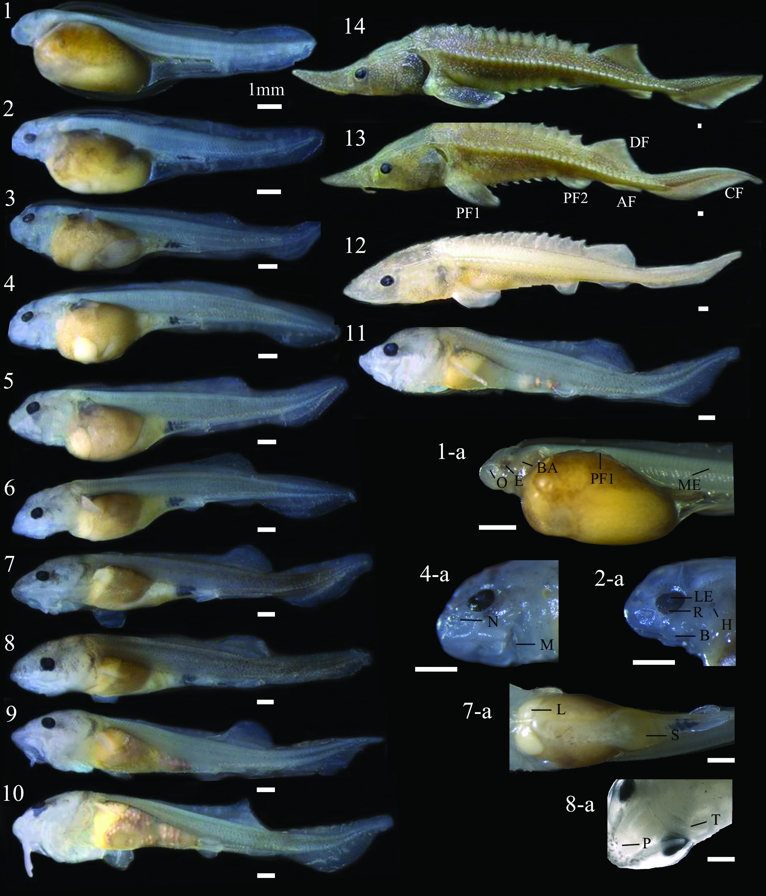

图版Ⅰ 鳇的胚后发育
1. 0日龄前期仔鱼；2. 1日龄前期仔鱼；3. 2日龄前期仔鱼；4. 3日龄前期仔鱼；5. 4日龄前期仔鱼；6. 5日龄前期仔鱼；7. 6日龄前期仔鱼；8. 7日龄前期仔鱼；9. 8日龄前期仔鱼；10. 9日龄后期仔鱼；11. 10日龄后期仔鱼；12. 21日龄后期仔鱼；13. 50日龄稚鱼；14. 60日龄稚鱼
O：嗅囊；E：眼睛；BA：鳃弓；ME：肌节；PF1：胸鳍；B：吻须；R：视网膜；H：听囊；LE：晶状体；M：口；N：鼻孔；L：肝脏；S：胃；P：陷器；T：齿；PF2：腹鳍；AF：臀鳍；DF：背鳍；CF：尾鳍

PlateⅠ Postembryonic development of Kaluga, Huso dauricus
1. Hatching stage prelarvae; 2. 1 day age prelarvae; 3. 2 day age prelarvae; 4. 3 day age prelarvae; 5. 4 day age prelarvae; 6. 5 day age prelarvae; 7. 6 day age prelarvae; 8. 7 day age prelarvae; 9. 8 day age prelarvae; 10. 9 day age postlarvae; 11. 10 day age postlarvae; 12. 21 day age postlarvae; 13. 50 day age juvenile; 14. 60 day age juvenile
O: Olfactory organ; E: Eye; BA: Branchial arch; ME: Myomere; PF1: Posterior fin; B: Barbell; R: Retina; H: Hearing; LE: Lens; M: Mouth; N: Nostril; L: Liver; S: Stomach; P: Pigment; T: Teeth; PF2: Pelvic fin; AF: Anal fin; DF: Dorsal fin; CF: Caudal fin

参考文献
- 柴毅，谢从新，危起伟，刘能玉．鱼类行为学研究进展．水利渔业，2006，26（3）：1–2
- 柴毅．中华鲟感觉器官的早期发育及其行为机能研究．[博士学位论文]．武汉：华中农业大学，2006
- 陈细华．鲟形目鱼类生物学与资源现状．北京：海洋出版社，2007，1–203
- 董崇智，姜作发．黑龙江·绥芬河·兴凯湖渔业资源．哈尔滨：黑龙江科学技术出版社，2004，1–247
- 冯春雷，李志国，黄洪亮，张勋，陈雪忠．鱼类行为研究在捕捞中的应用．大连水产学院学报，2009，24（2）：166–170
- 顾孝连，庄平，章龙珍，张涛，石小涛，赵峰，刘健．长江口中华鲟幼鱼对底质的选择．生态学杂志，2008，27（2）：213–217
- 何大仁，蔡厚才．鱼类行为学．厦门：厦门大学出版社，1998，1–388
- 何姗．徽水河光唇鱼的生活史策略研究．[硕士学位论文]．芜湖：安徽师范大学，2011
- 黄权，周景祥，刘春力，陈勇．鸭绿江花羔红点鲑、细鳞鱼和长白哲罗鱼的繁殖策略比较研究．吉林农业大学学报，2001，23（2）：93–95
- 黄晓荣．两种鲟科鱼类早期发育阶段实验行为学的比较研究．［硕士学位论文］．上海：上海水产大学，2003
- 李波，王云山．鳇人工繁殖技术规程及注意事项．黑龙江水产，2003，（5（总第97期））：1–2
- 李红敬．黑斑原鮡个体生物学及种群生态研究．[博士学位论文]．武汉：华中农业大学，2009
- 李文龙，刘建魁．鳇大水面养殖技术．内陆水产，2007，32（6）
- 李孝珠．池沼公鱼雌雄差异及其早期生物学性状研究．[硕士学位论文]．新乡：河南师范大学，2011
- 刘洪柏，宋苏祥，孙大江，范兆廷，贾世杰，苏辉．施氏鲟的胚胎及胚后发育研究．中国水产科学，2000，7（3）：5–10
- 尼克尔斯基（高蚰译）．黑龙江流域鱼类（第一版）．北京：科学出版社，1960，1–472
- 任慕连．黑龙江鱼类．哈尔滨：黑龙江人民出版社出版，1981，5–7
- 石振广．鳇人工繁殖和养殖关键技术研究．［博士学位论文］．青岛：中国海洋大学，2008
- 万年春．鳇苗种培育技术研究．中国水产．2011，（2）：42–43
- 王成友. 长江中华鲟生殖洄游和栖息地选择．[博士学位论文]．武汉：华中农业大学，2012
- 王炬光．乌伦古湖白斑狗鱼年龄、生长和繁殖生物学研究．[硕士学位论文]．武汉：华中农业大学，2011
- 王云山，石振广，李文龙，胡光源．鳇生物学及人工繁殖技术．内陆水产，2001，（11）：25–26
- 危起伟．中华鲟繁殖行为生态学与资源评估．［博士学位论文］．武汉：中国科学院水生生物研究所，2003
- 辛玉文．鳇仔稚鱼培育技术．北京水产，2005，（5）：48–50
- 熊飞．青海湖裸鲤繁殖群体生物学．[硕士学位论文]．武汉：华中农业大学，2003
- 闫新刚，黄硕琳，唐建业，刘艳红．当前黑龙江渔业管理中存在的问题与建议．上海水产大学学报，2008，17（3）：367–370
- 殷名称．鱼类生态学．北京：中国农业出版社，1995
- 殷名称．鱼类早期生活史阶段的自然死亡．水生生物学报，1996，20（4）：363–372
- 殷名称．鱼类早期生活史研究与其进展．水产学报，1991，15（4）：348–358
- 虞功亮，刘军，许蕴圲，常剑波．葛洲坝下游江段中华鲟产卵场食卵鱼类资源量估算. 水生生物学报，2002，（6）：591–599
- 张辉．中华鲟自然繁殖的非生物环境．[博士学位论文]．武汉：华中农业大学，2009
- 张觉民，李怀明，董崇智，夏重志，黄智弘，姜作发．黑龙江省鱼类志．哈尔滨：黑龙江科学技术出版社出版，1994，1–275
- 章龙珍，宋超，庄平，张涛，王斌，黄晓荣．西伯利亚鲟（F2）胚后发育的形态观察．水产学报，2009，33（5）：755–761
- 郑怀平．鱼类早期生活史的营养与摄食．盐城工学院学报．1999，12（3）：63–66
- 朱存良．鱼类行为生态学研究进展．北京水产，2007，（1）：20–24
- 庄平．鲟科鱼类个体发育行为学及其在进化与实践上的意义．[博士学位论文]．武汉：中国科学院水生生物研究所，1999
- Auer N A, Baker E A. Duration and drift of larval lake sturgeon in the Sturgeon River, Michigan. J Appl Ichthyol, 2002, 18(4-6): 557–564
- Babiker Y, Gideiri A. The behaviour and neouroanatomy of same developing teleost fishes. J Zool, 1966, 149(2): 215–241
- Beatty J. The proximate/ultimate distinction in the multiple careers of Ernst Mayr. Biol Philos, 1994, 9: 333–356
- Bemis W E, Kynard B. Sturgeon rivers: an introduction to acipenseriform biogeography and life history. Environ Biol Fish, 1997, 48: 167–183
- Braaten P J, Fuller D B, Lott R D, Ruggles M P, Holm R J. Spatial distribution of drifting pallid sturgeon larvae in the Missouri River inferred from two net designs and multiple sampling locations. N Am J Fish Manage, 2010, 30: 1062–1074
- Brannon E, Brewer S, Miller M, Setter A, Utter F, Hershberger W. Columbia River white sturgeon (Acipenser transmontanus) early life history and genetics study (Final Rept). Bonneville Power Admin, Portland, 1985
- Brown C, Laland K, Krause J. Fish cognition and behavior. Blackwell Publishing Ltd, 2006, 1–328
- Caroffino D C, Sutton T M, Daugherty D J. Assessment of the vertical distribution of larval lake sturgeon drift in the Peshtigo River, Wisconsin, USA. J Appl Ichthyol, 2009, 25: 14–17
- Francis, R C. Causes, proximate and ultimate. Biol Philos, 1990, 5: 401–415
- Fretwell S D, Lucas H L. On territorial behavior and other factors influencing habitat distribution in birds (I. Theoretical development). Acta Biotheor, 1968, 19: 16–36
- Frissell C A, Liss W L, Warren C E, Hurley M D. A hierarchial framework for stream habitat classification: viewing streams in a watershed context. Environ Manage, 1986, 10: 199–214
- Fuller D B, Holte L D, Lott R D, Viste W, Brandt T F, Legare R G. Drift dynamics of larval pallid sturgeon and shovelnose sturgeon in a natural side channel of the upper Missouri River, Montana. N Am J Fish Manage, 2008, 28: 808–826
- Gerbilskiy N L. Ways of development of the intraspecies biological differentiation, types of anadromous migrants, and a question of migration impulse in sturgeons. Uchenye Zapiski Leningradskogo Gosudarstvennogo Universiteta, 1957, 228: 11–31 (in Russian)
- Gessner J, Kamerichs C M, Kloas W, Wuertz S. Behavioural and physiological responses in early life phases of Atlantic sturgeon (Acipenser oxyrinchus Mitchill 1815) towards different substrates. J Appl Ichthyol, 2009, 25(s2): 83–90
- Gisbert E, Ruban G I. Ontogenetic behavior of Siberian sturgeon, Acipenser baerii: A synthesis between laboratory tests and field data. Environ Biol Fish, 2003, 67: 311–319
- Grande L，Bemis W E. Osteology and phylogenetic relationships of fossil and recent Paddlefishes (Polyodontidae) with comments on the interrelationships of Acipenseriformes. J Vertebr Paleontol, 1991, 11(1): 1–121
- Grande L，Bemis W E. Early development of the Actinopterygian head. I. External development and staging of the paddlefish Polyodon spathula. J Morphol, 1992, 213: 47–83
- Gross M R, Repka J, Robertson C T, Secor D H, Winkle W V. Sturgeon conservation： insights from elasticity analysis. Am Fish Soc Symp, 2002, 28: 13–30
- Harrelson C C, Rawlins C L, Potyondy J P. Stream channel reference sites: an illustrated guide to field technique. U.S. Forest Service, Rocky Mountain Forest and Range Experiment Station, General Technical Report RM-245, Fort Collins, Colorado, 1994
- Hoar W S, Randall D J. The physiology of developing fish. Part A: eggs and larve (Fish physiology, Vol. 11A). Toronto: Academic Press, 1988, 1–546
- Huntingford F A. Development of behaviour in fishes．In: Pitcher T J(ed.)，The behaviour of teleost fishes (First edition). London & Sydney: Croom Helm Ltd., 1986, 47–60
- Immelmann K. Introduction to ethology. New York: Academic Press Inc, 1979, 71–120
- Jobling M. Environmental biology of fishes (First edition). London: Chaoman & Hall, 1995, 1–455
- Jonsson L. Chemical stimuli: role in the behavior of fishes. In: Ali M A (ed.). Environmental Physiology of Fishes. New York: Pienum Press, 1980, 353–368
- Krykhtin M L, Svirskii V G. Endemic sturgeons of the Amur River: kaluga, Huso dauricus, and Amur sturgeon, Acipenser schrenckii. Environ Biol Fish, 1997, 48: 231–239
- Kynard B, Henyey E, Horgan M. Ontogenetic behavior, migration, and social behavior of pallid sturgeon, Scaphirhynchus albus, and shovelnose sturgeon, S. platorynchus, with notes on the adaptive significance of body color. Environ Biol Fish, 2002a, 63(4): 389–403
- Kynard B, Horgan M. Ontogenetic behavior and migration of Atlantic sturgeon, Acipenser oxyrinchus oxyrinchus, and shortnose sturgeon, A. brevirostrum, with notes on social behavior. Environ Biol Fish, 2002, 63(2): 137–150
- Kynard B, Parker E, Kynard B. Ontogenetic behavior of Kootenai River White Sturgeon, Acipenser transmontanus, with a note on body color: A laboratory study. Environ Biol Fish, 2010, 88: 65–77
- Kynard B, Parker E, Parker T. Behavior of early life intervals of Klamath River green sturgeon, Acipensermedirostris, with a note on body color. Environ Biol Fish, 2005, 72(1): 85–97
- Kynard B, Parker E. Ontogenetic behavior and dispersal of Sacramento River white sturgeon, Acipenser transmontanus, with a note on body color. Environ Biol Fish, 2005, 74: 19–30
- Kynard B, Parker E. Ontogenetic behavior and migration of Gulf of Mexico sturgeon, Acipenser oxyrinchus desotoi, with notes on body color and development. Environ Biol Fish, 2004, 70(1): 43–55
- Kynard B, Zhuang P, Zhang L, Zhang T, Zhang Z. Ontogenetic behavior and migration of Volga River Russian sturgeon, Acipenser gueldenstaedtii, with a note on adaptive significance of body color. Environ Biol Fish, 2002b, 65(4): 411–421
- Kynard B, Zhuang P, Zhang T, Zhang L. Ontogenetic behavior and migration of Dabry's sturgeon, Acipenser dabryanus, from the Yangtze River, with notes on body color and development rate. Environ Biol Fish, 2003, 66: 27–36
- Kynard B. Life history, latitudinal patterns, and status of the shortnose sturgeon, Acipenser brevirostrum. Environ Biol Fish, 1997, 48(1-4): 319–334
- Li W, Shi Z, Wang Y, Liu J, Qiu S, Lu H, Han J. Report on first time reproductive success from full life-cycle culture of Kaluga sturgeon females (Huso dauricus). J Appl Ichthyol, 2011, 27: 550–553
- Loew E R, Sillman A J. Age-related changes in the visual pigments of the white sturgeons (Acipenser transmontanus). Can J Zool, 1993, 71: 1552–1557
- McDowall R M. Diadromy in fishes. Migrations between freshwater and marine environments. London: Croom Helm, 1988, 1–308
- McDowall R M. Diadromy: origins and definition of terminology. Copeia, 1992, 248–251
- McDowall R M. On amphidromy, a distinct form of diadromy in aquatic organisms. Fish Fish, 2007, 8: 1–13
- McEnroe M, Cech J J. Osmoregulation in juvenile and adult white sturgeon, Acipenser transmontanus. Environ Biol Fish, 1985, 14: 23–40
- McEnroe M., Cech JJ. Osmoregulation in white sturgeon: life history aspects. Am Fish Soc Symp, 1987, 1: 191–196.
- Miller T J, Crowder L B, Rice J A．Ontogenetic changes in behavioural and histologyical measures of visual acuity in three species of fish. Environ Biol Fish, 1993, 37(1): 1–8
- Myers G S. Usage of anadromous, catadromous and allied terms for migratory fishes. Copeia, 1949, 89–97
- Nechayev I V, Pavlov D S, Labas Y, Legkiy B P. Dynamics of catecholamines in early ontogeny and development of behavioral reactions in juvenile Aequidens pulcher (Cichlidae). J Ichthyol, 1992, 32(2): 61–82
- Nikolskii G V. Fishes of the Amur River basin. Beijing: Science Press, 1960, 1–472
- Novomodny G, Sharov P, Zolotukhin S. Amur Fish: Wealth and crisis. In: Augerot X, Martin D, Sharov P. (ed.). Vladivostok: WWF RFE, Vladivostok, Russia, 2004, 1–51
- Paddlefishes (Polyodontidae) with comments on the interrelationships of Acipenseriformes. J Vertebr Paleontol, 1991, 11(s001): 1–121
- Parsley M J, Anders P J, Miller A I, Beckman L G, McCabe G T Jr. Recovery of white sturgeon populations through natural production: understanding the influence of abiotic and biotic factors on spawning and subsequent recruitment. Am Fish Soc Symp, 2002, 28: 55–66
- Peter R E. The brain and feeding behavior. In: Hoar W S, Randall D J, Brett J R(eds). Fish physiology. Vol. Ⅷ. New York: Academic Press Inc, 1979, 121–161
- Polyaninova, A A, Kashentseva L N, Malinovskaya L V, Molodtsova A I, Smirnova, L V. Feeding conditions for sturgeons (Acipenseridae) in the Caspian Sea. J Appl Ichthyol, 1999, 15: 293–294.
- Reynolds W. Temperature as a proximate factor in orientation behavior. J Fish Res Board Can, 1977, 34: 734–739
- Richmond A M, Kynard B. Ontogenetic behavior of shortnose sturgeon, Acipenser revirostrum. Copeia, 1995, (1): 172–182
- Rochard E, Castelnaud G, Lepage M. Sturgeon (Pisces Acipenseridae): threats and prospects. J Fish Biol,·1990, 37(Suppl A): 123–132
- Shepard F P. Submarine geology (3rd ed). New York : Harper & Row, 1973, l–517
- Shmigirilov A P, Mednikova A A, Israel J A. Comparison of biology of the Sakhalin sturgeon, Amur sturgeon, and kaluga from the Amur River, Sea of Okhotsk, and Sea of Japan biogeographic Province. Environ Biol Fish, 2007, 79: 383–395
- Sokal R R, Rohlf F J. Biometry(2nd edn). New York: WH Freeman and Company, 1981, 1–859
- The Federal Interagency Stream Restoration Working Group. Stream corridor restoration-principles, processes and practices. 2001
- Thorpe J E, Mangel M, Metcalfe N B, Huntingford F A. Modelling the proximate basis of salmonid life-history variation, with application to Atlantic salmon, Salmo salar L. Evol Ecol, 1998, 12: 581–599
- Watanabe Y, Wei Q, Yang D, Chen X, Du H, Yang J, Sato K, Naito Y, Miyazaki N. Swimming behavior in relation to buoyancy in an open swimbladder fish, the Chinese sturgeon. J Zool, 2008, 275: 381–390
- Wei Q W, Ke F E, Zhang J, Zhuang P, Luo J, Zhou R, Yang W. Biology, fisheries, and conservation of sturgeons and paddlefish in China. Environ Biol Fish, 1997, 48: 241–255
- Wei Q W, Kynard B, Yang D G, Chen X H, Du H, Shen L, Zhang H. Using drift nets to capture early life stages and monitor spawning of the Yangtze River Chinese sturgeon (Acipenser sinensis). J Appl Ichthyol, 2009, 25: 100–106
- Wei Q, Ruban G. Huso dauricus. In: IUCN 2012 IUCN Red List of Threatened Species. Version 2012.1. <www.iucnredlist.org>. Downloaded on 23 September 2012, 2010
- Wootton R J. Introduction: tactics and strategies, in fish reproduction. 1984, 1–12
- Yamahira K. Proximate factors influencing spawning site specificity of the puffer fish Takifugu niphobles. Mar Ecol-Prog Ser, 1997, 147, 11–19
- Zhuang P, Kynard B, Zhang L, Zhang T, Cao W. Comparative ontogenetic behavior and migration of kaluga, Huso Dauricus, and Amur sturgeon, Acipenser Schrenckii, from the Amur River. Environ Biol Fish, 2003, 66(1): 37–48
- Zhuang P, Kynard B, Zhang L, Zhang T, Cao W. Ontogenetic behavior and migration of Chinese sturgeon, Acipenser sinensis. Environ Biol Fish, 2002, 65: 83–97

致 谢
本研究及学位论文是在我的导师危起伟教授的亲切关怀和悉心指导下完成的。他严肃的科学态度，严谨的治学精神，精益求精的工作作风，深深地感染和激励着我。从课题的选择到项目的最终完成，危老师都始终给予我细心的指导和不懈的支持。六年来，危老师不仅在学业上给我以精心指导，同时还在思想、生活上给我以无微不至的关怀，虽有时严厉却甚是真情，在此谨向危老师致以诚挚的谢意和崇高的敬意。
在此，我还要感谢课题组的杜浩副研究员、张辉副研究员、李罗新工程师、沈丽助理研究员、刘志刚工程师、张书环助理研究员、甘芳助理研究员（目前调至人事处）、吴湘香师姐（目前调入资环室）、高宇鹏工程师、周运涛工程师、吴金明助理研究员、周琼女士、黄瑾女士、李曼女士、胡志华先生、涂新智先生、杨猛先生、王科斌先生，是你们在需要之时给我以工作、学习与生活上的帮助与支持。
本论文的顺利完成离不开长江大学的柴毅副教授，是她在紧要关头提供了试验所必须的人员。借此感谢王欢，乐红、袁金宇、刘晶、林镜、陈杰、官鑫鑫、曾飞等人。当然本论文试验的完成还多亏华中农业大学水产学院硕士研究生李乾坤，是他在紧要关头帮助我度过论文试验的难关。还有太湖基地的李远、熊伟、张祖成、陈忠絮、胡超、王义辉、谭从刚，是你们在需要的时候提供了帮助与支持。特别要感谢的是太湖的孙勇虎先生和周师傅，你们一个在紧急用车的时候提供了默默无闻的帮助，一个在每逢生活起居时给予细心的提醒。
感谢美国国家地理署洄游鱼类研究中心的Boyd Kynard 教授/博士在毕业论文及所涉及试验中给予的指导。是他在文字、思路上的细心帮助才使得关乎毕业的论文得以及时的投稿。
感谢06级师兄师姐孙庆亮、刘向伟、邹远超、张艳珍、邱实，同门王成友、杨璐，08级师弟刘猛、李伟、王崇瑞、靳建波，09级师弟妹李雷、施德亮、成为为，10级的师弟妹梁志强、薛超、孙立元、史玲玲、骆慧，11级的师弟妹谢晓、王恒、任泷、杨晓鸽，12级的霍来江、李君轶、席萌丹、辛苗苗。感谢同学赵建华、周勇、李波、郑鹏飞、孟晓亮、田辉伍、邓华堂、肖艺、岳刚毅、吴勤超、呼光富、叶欢、刘涛、冯宪斌、李茜等。感谢你们在本人学习、生活上的陪伴和试验过程中的帮助。
更要感谢我的女友胡佳，是你的陪伴与鼓励伴我度过这些艰难的岁月。还有我敬爱的廖娘、胡叔，没有你们的支持与鼓励，难以想象我会走的这么踏实与义无反顾。感谢我的父母在我们生活上无微不至的照顾，以及学业上一如既往的支持，你们的养育之恩、涌泉难报。
感谢所有支持我、帮助我那些叫得出名字与叫不出名字的人，愿你们一生平安！
最后，我要感谢华中农业大学给我追逐科研高峰的机会，感谢中国水产科学研
究院长江水产研究所给我梦想得以实现的舞台，感谢濒危鱼类保护课题组提供的科
研动力与团结精神，感谢国家自然基金、农业部等相关单位提供的资金支持。


二零一三年四月二十五日于武汉

附录Ⅰ 攻读学位论文期间撰写和发表的学术论文及专利
- Yanhua Li, Body Kynard, Qiwei Wei, Hui Zhang, Hao Du, Qiankun Li. Ontogenetic behavior and migration of kaluga, Huso dauricus. Environmental biology of fishes. Minor revision
- Y.H. LI, B. KYNARD, Q.W. WEI, H.ZHANG, H. DU, Q.K. LI. Effects of substrate and water velocity on migration by early-life stages of kaluga Huso dauricus: An artificial stream study. Journal of Applied Ichthyology. Accepted
- 李艳华，危起伟，王成友，杜浩，张辉，沈丽，吴金明. 鳇配后发育的形态观察. 中国水产科学， 2013，20(3)：585–591
- H. Zhang,Q. W. Wei ,H. Du, L. Shen, Y. H. Li, Y. Zhao. Is there evidence that the Chinese paddlefish (Psephurus gladius) still survives in the upper Yangtze River? Concerns inferred from hydroacoustic and capture surveys, 2006–2008. Journal of Applied Ichthyology. 2009, S2 (25): 95–99.
- H. Du, Q. W. Wei, H. Zhang, Z. Liu, C. Wang, Y. Li. Bottom substrate attributes relative to bedform morphology of spawning site of Chinese sturgeon Acipenser sinensis below the Gezhouba dam. Journal of Applied Ichthyology. 2011, 27(2): 257–262.
- 专利：实用新型专利名称“用于水生动物栖息水层与垂直迁移行为的试验装置”。发明人：李艳华、危起伟、张辉、杜浩、李罗新、沈丽. 专利号：201020585434

附录Ⅱ 攻读博士期间主要参加的科研项目和撰写的报告
- 2006～2008长江上游珍稀特有鱼类国家级自然保护区水生生物与自然环境综合调查（农业部渔业局/三峡总公司）；
- 2007～2008 长江上游白鲟试验性捕捞（农业部／中国长江三峡工程开发总公司）；
- 2008～2009四川省岷江宜宾段电站工程规划对长江上游珍稀特有鱼类国家级自然保护区水生生态影响评价（中广核能源开发有限责任公司）；
- 2008 青海湖鱼类资源水声学探测（青海湖裸鲤救护中心）；
- 2009 三峡工程珍稀鱼类保护生态补偿2009年度增殖放流项目（农业部水生野生动植物保护办公室）；
- 2009 长江十年期禁渔可行性调查（长江水产研究所）；
- 2010 达氏鲟种质资源国家标准（农业部渔业局）；
- 2010～2011 “948”鱼类行为学研究方法及其实践应用技术（农业部科技教育司/农业部财务司）。

